ELEC 374 | Digital Systems Engineering

Final Report

April 5, 2020

Department of Electrical and Computer Engineering

Daniyal Maniar | 20064993

Hermann Krohn | 20057435

Group: 7

Professor: Ahmad Afsahi, P.Eng

# Abstract

We were tasked to design, simulate, implement and verify a Simple RISC computer. The computer consisted of RISC processor, an external memory unit, and Input/output functionality. The computer had to be designed in a Hardware description language of choice. As a group we decided to implement the computer in the Verilog description language. The system was designed to be implemented on the DEO board, but due to COVID-19 measures, we were not able to implement it on the board.

Our design is similar to the project specifications that were provided. Some improvements included:

* A completely modular design that could facilitate:
  + Any 2N bit size design (16, 32, 64, 128, etc)
  + Any amount of registers (as long as the number of registers isn’t above the bit threshold)
  + Any size of RAM
* A dual bus lines system for HI/LO registers to test higher bit count operations
  + Interchange system to switch values between bus lines
* A unique register multiplexer design
* Faster addition algorithm
* Faster multiplication algorithm
* Faster division algorithm

The processor contains an ALU unit, a register file, a select and encode unit, a CON_FF unit, 7 utility registers, and a data path to connect all the modules. The ram of choice is a synchronous ram specification.

Table of Contents

Abstract i

Project Specification 1

Project Design and Implementation 1

Evaluation Result 1

Maximum frequency of operation 1

Percentage of chip area 1

Discussion 1

Conclusion 1

Future Work 1

Appendix I – Code, Wave forms, & Memory Dumps 2

Register 2

Register Test Bench 2

Register Waveform 3

Register File Testbench 3

Register File Waveform 4

Register Multiplexer 4

ALU 5

ALU Result Selector 6

CLA Adder 6

CLA Full Adder 7

CLA Adder Testbench 7

CLA Adder Waveform 7

Subtract 8

Not 8

Multiply 9

Division 10

Shift Right 11

Shift left 11

Rotate Right 11

Rotate Left 11

Datapath 12

MDR 13

MDR Testbench 13

MDR Waveform 14

CON_FF 14

RAM 15

RAM Waveform 16

Select and Encode 16

Select and Encode Testbench 17

Select and Encode Waveform 17

LD Testbench 18

LD Waveform 19

LD Case 1 19

LD Case 2 21

LDI Testbench 23

LDI Waveform 24

LDI Case 1 24

LDI Case 2 26

ST Testbench 28

ST Waveform 29

ST Case 1 29

ST Case 2 31

ADDI Testbench 33

ADDI Waveform 34

ANDI Testbench 35

ANDI Waveform 36

ORI Testbench 37

ORI Waveform 38

Branch Testbench 39

Branch Waveform 40

Branch Case 1 40

Branch Case 2 41

Branch Case 3 42

Branch Case 4 43

JR Testbench 44

JR Waveform 45

JAL Testbench 46

JAL Waveform 47

MFHI Testbench 48

MFHI Waveform 49

MFLO Testbench 50

MFLO Waveform 51

Input Testbench 52

Input Waveform 53

Output Testbench 54

Output Waveform 55

# Project Specification

# Project Design and Implementation

# Evaluation Result

## Maximum frequency of operation

Based upon our individually set design constraints, the maximum frequency achieved by our design is 20 ns which amounts to a 50 MHz clock speed.

## Percentage of chip area

We can see based on the compilation report that the processor used only 7,177 out of the 15,408 logic elements available.

|  |  |  |
| --- | --- | --- |
| Total amount of logic elements user | Total amount of logic elements available | Percentage of chip area used |
| 7,177 | 15,408 | 46.58% |

# Discussion

# Conclusion

# Future Work

# Appendix I – Code, Wave forms, & Memory Dumps

Register

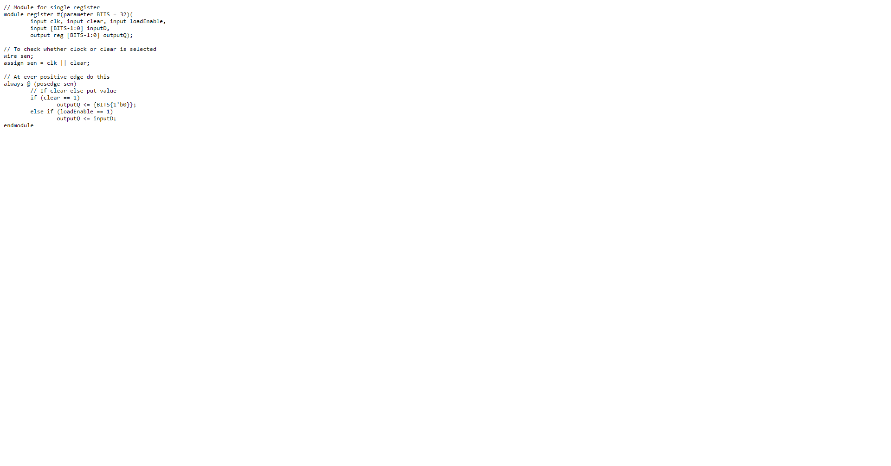

## Register Test Bench

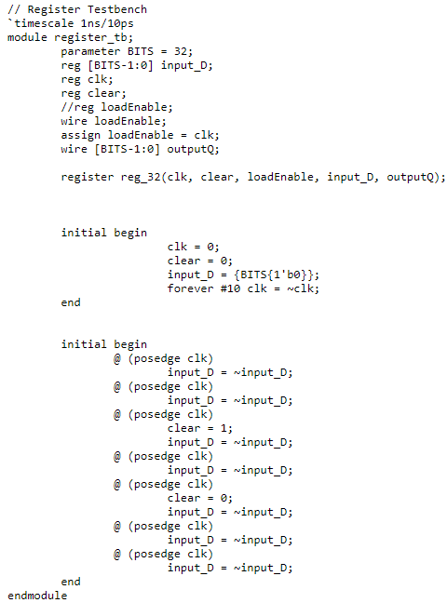

## Register Waveform

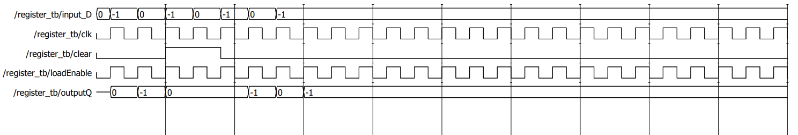

Register File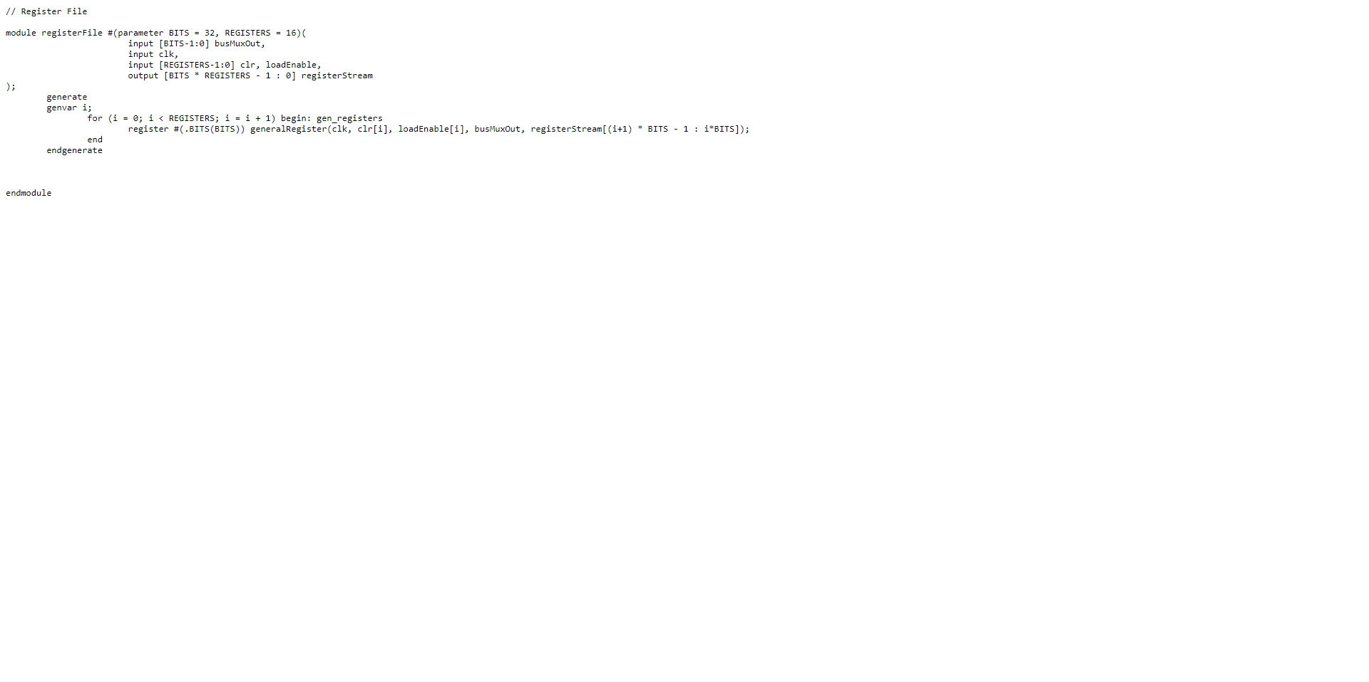

## Register File Testbench

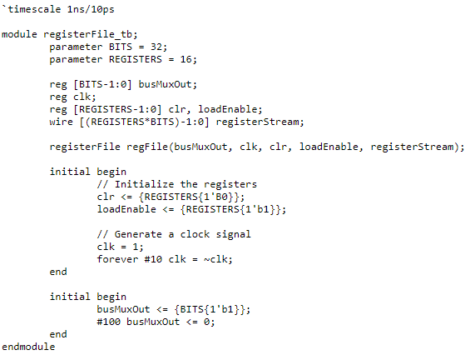

## Register File Waveform

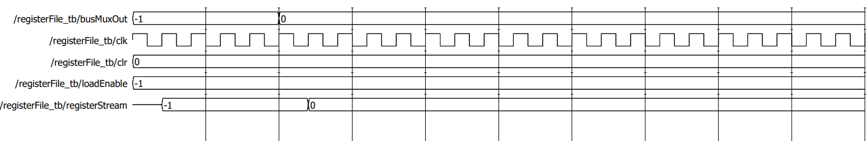

Register Multiplexer

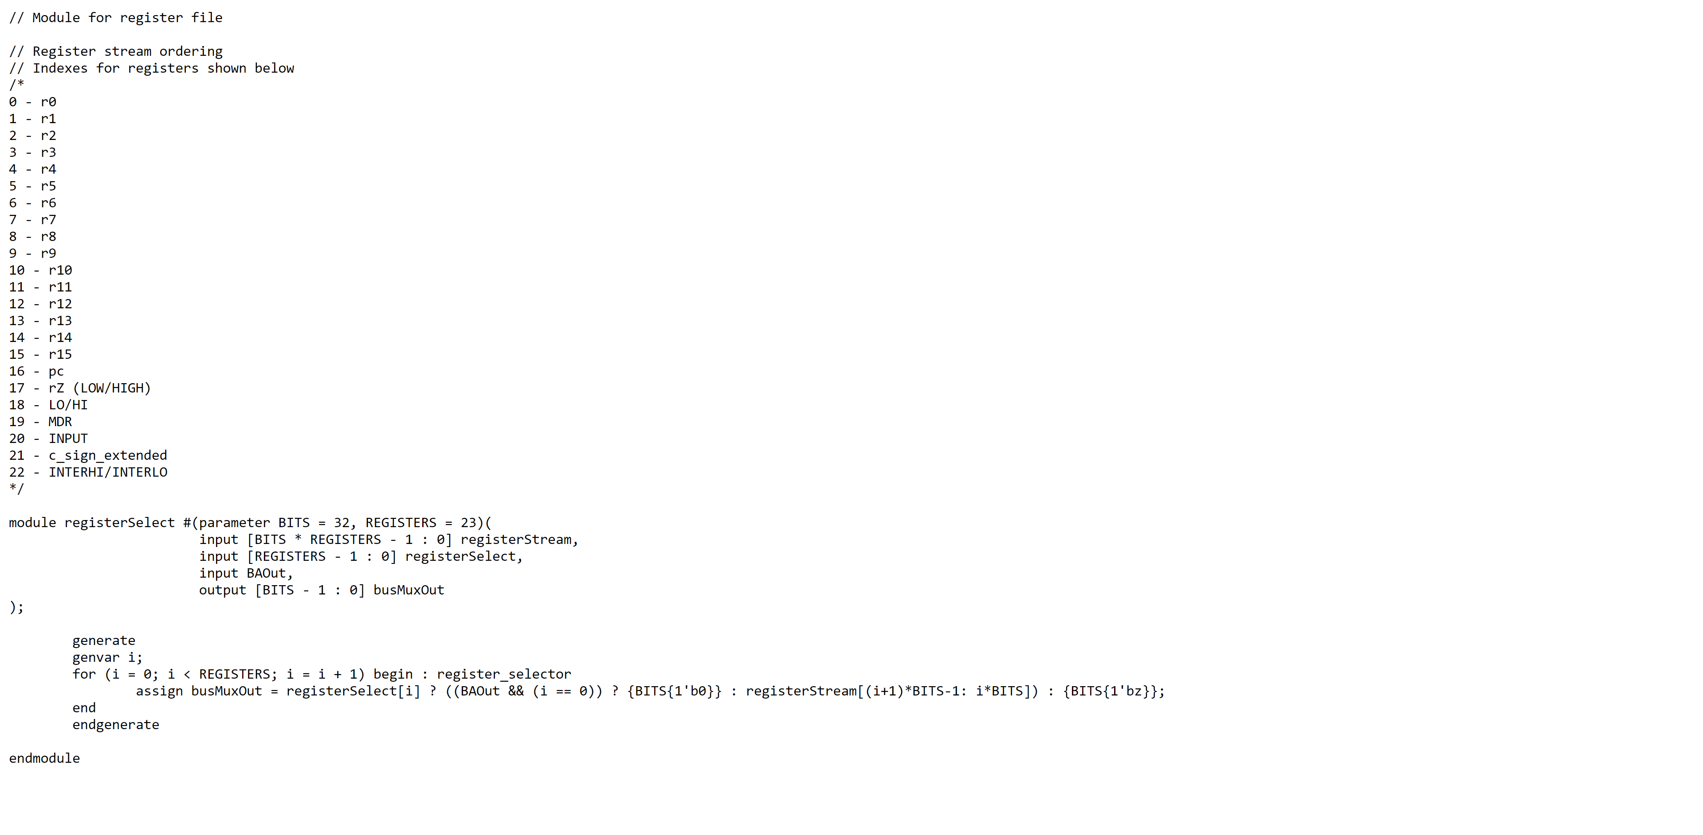

ALU

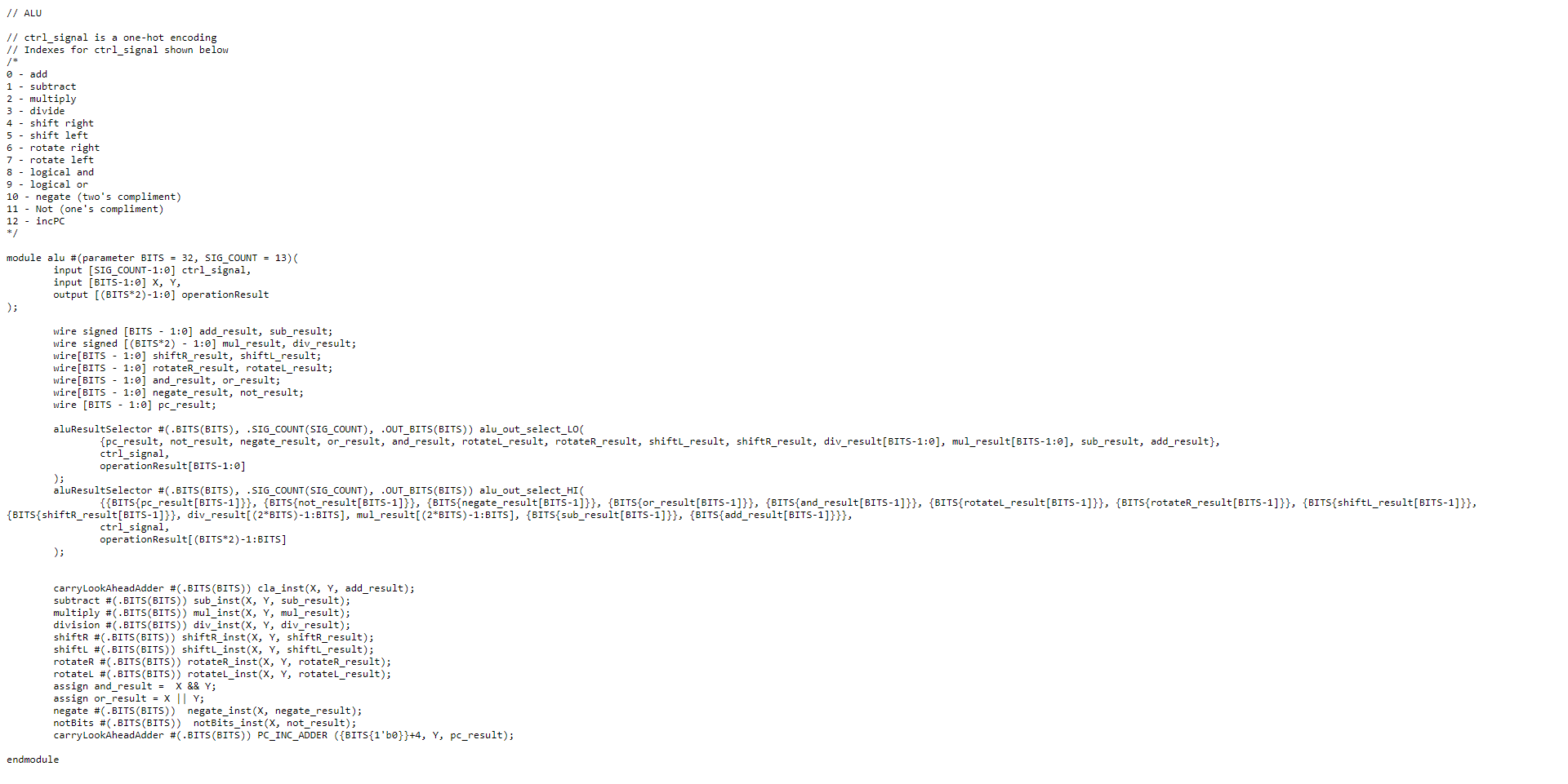

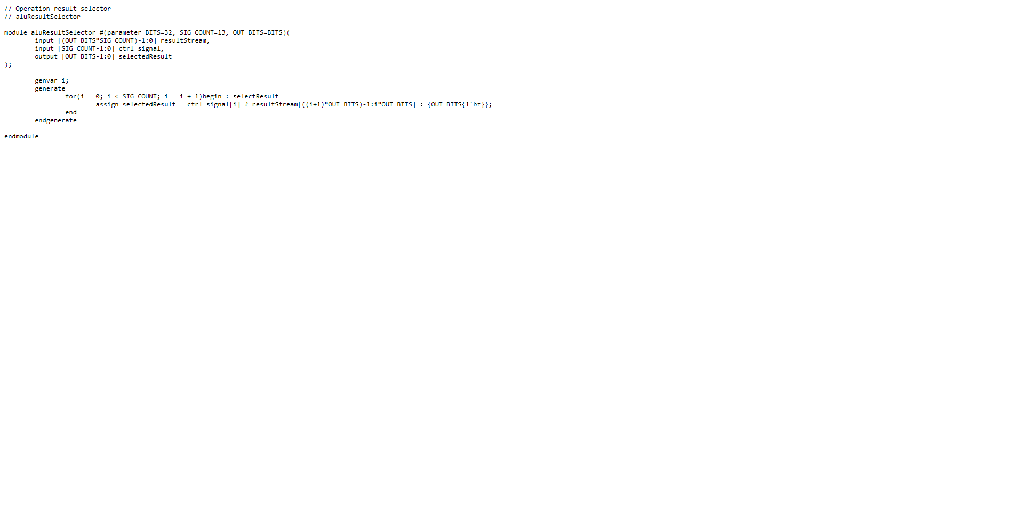ALU Result Selector

CLA Adder

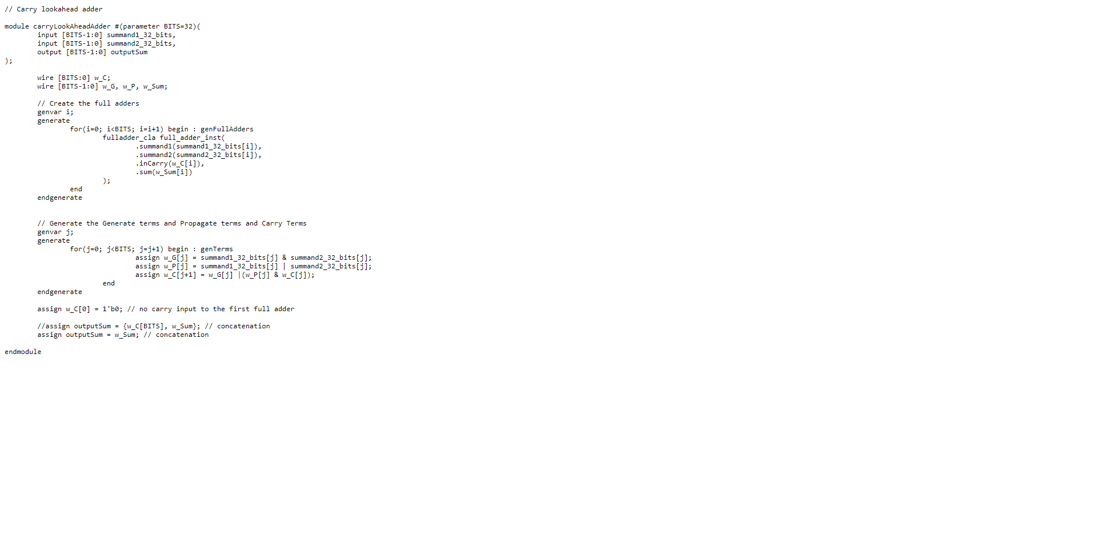

CLA Full Adder

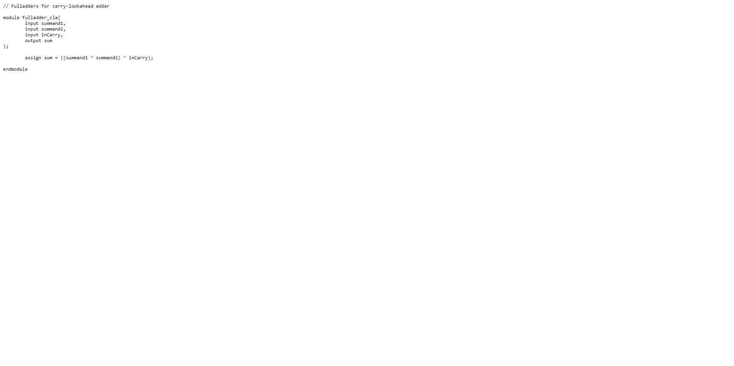

CLA Adder Testbench

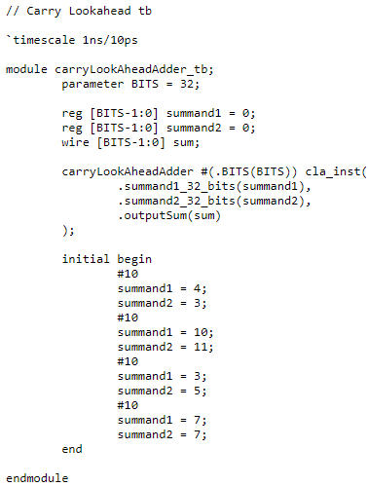

CLA Adder Waveform

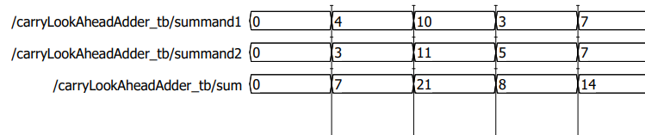

Subtract

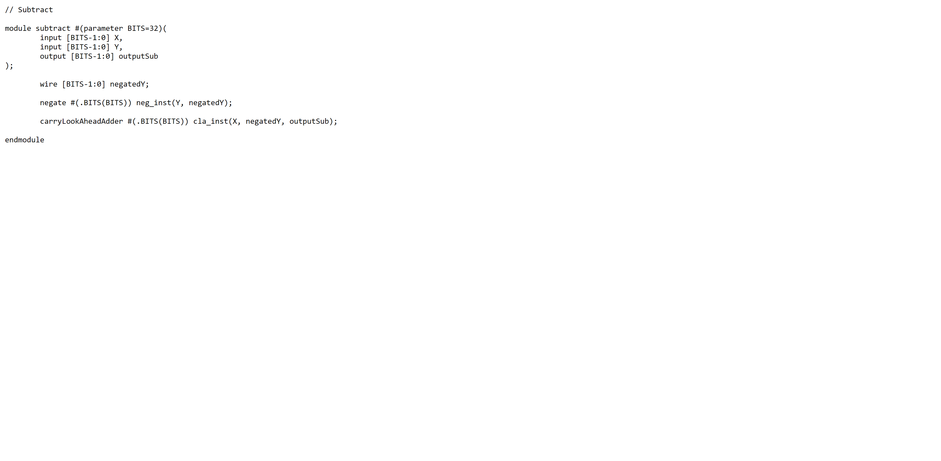

Negate

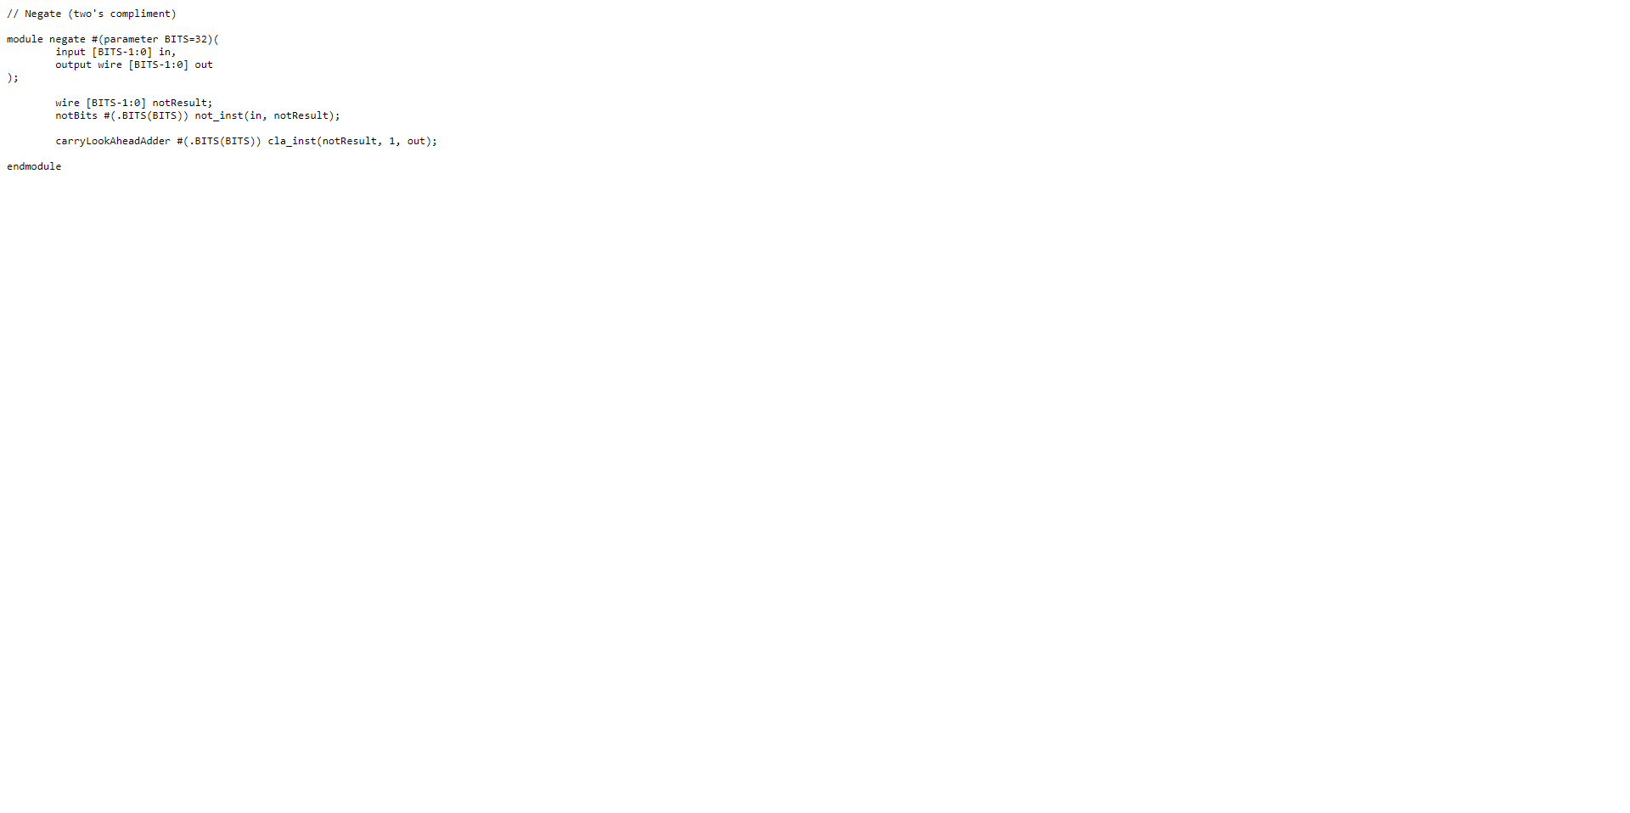

Not

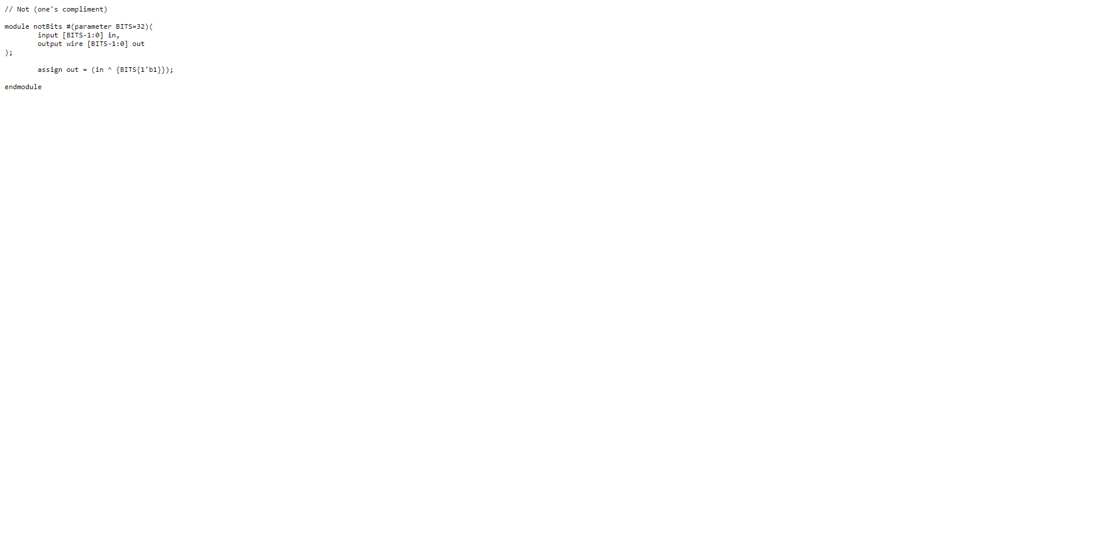

Multiply

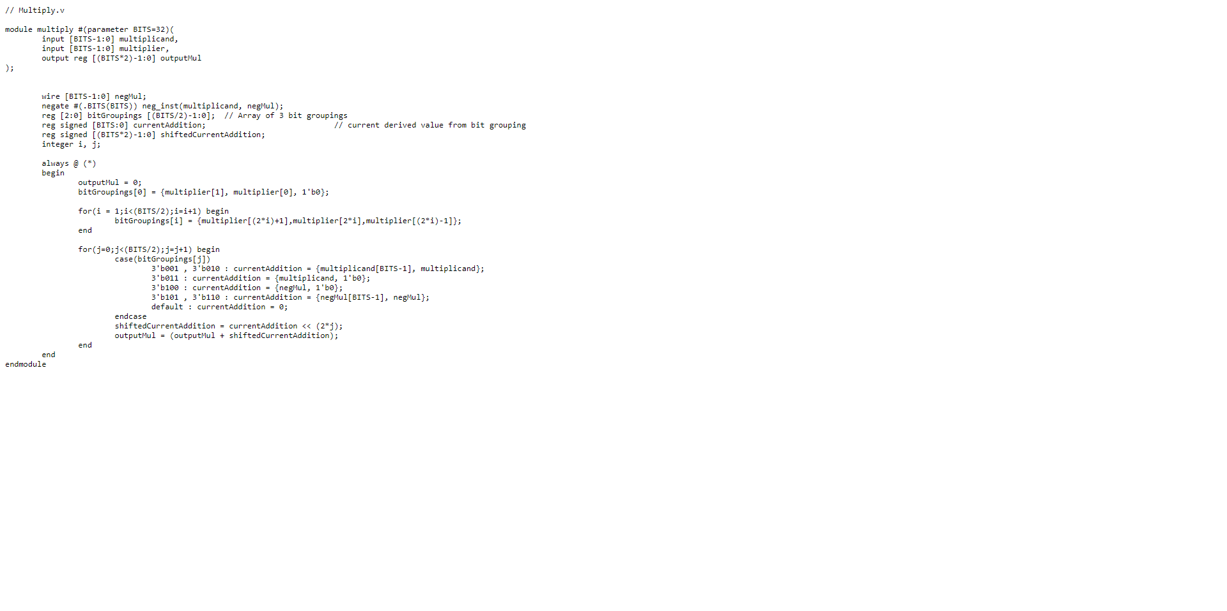

Division

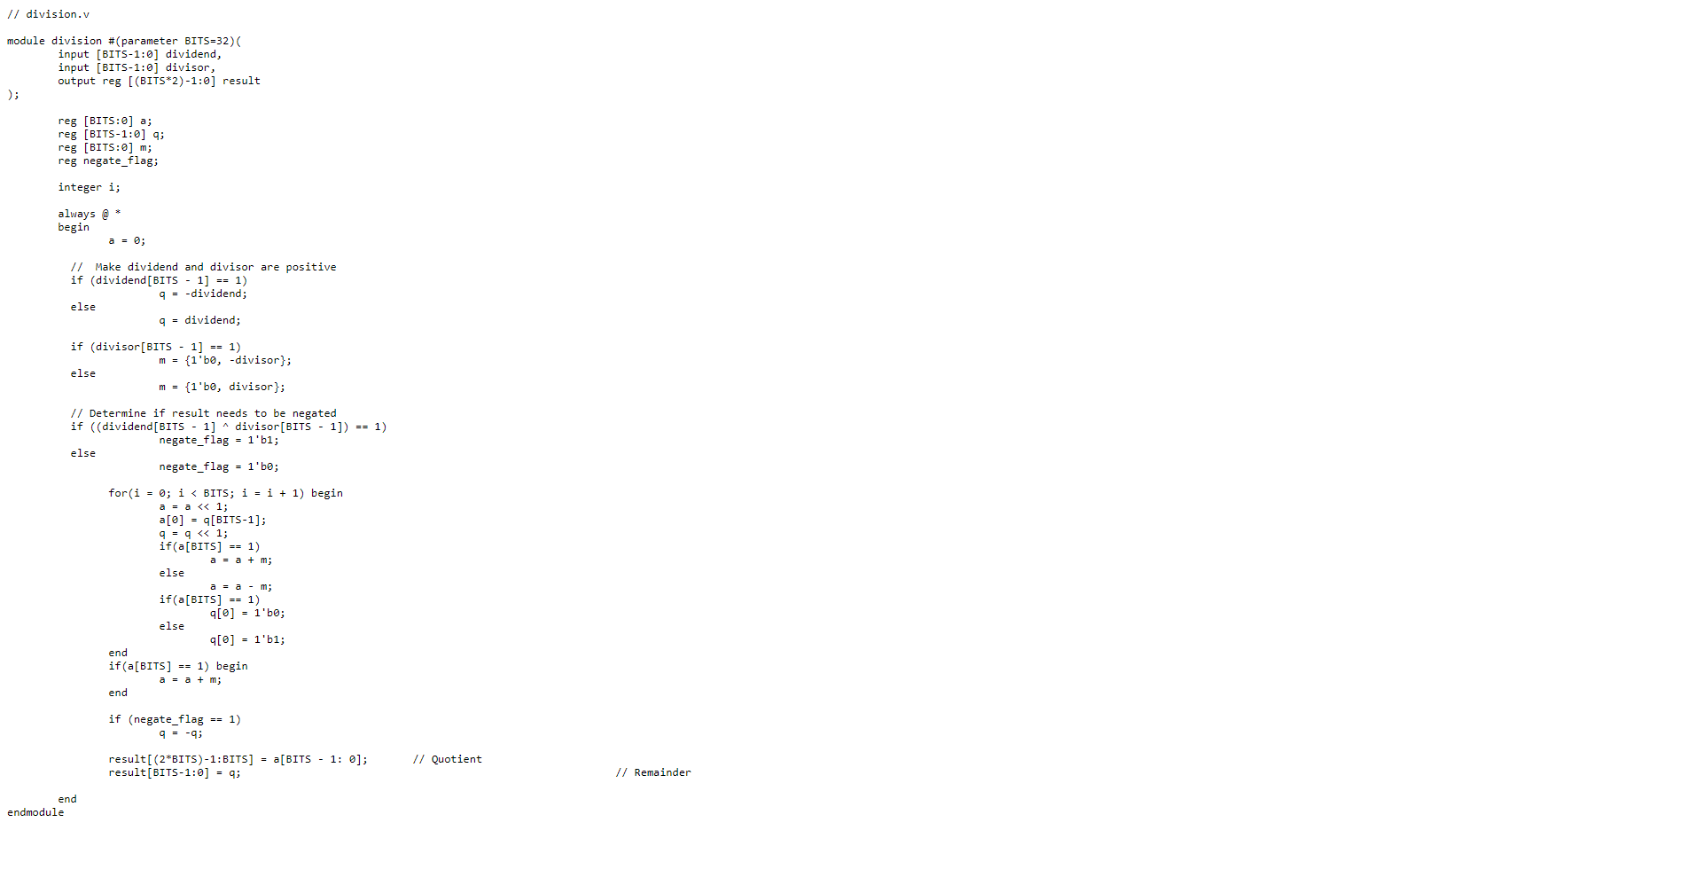

Shift Right

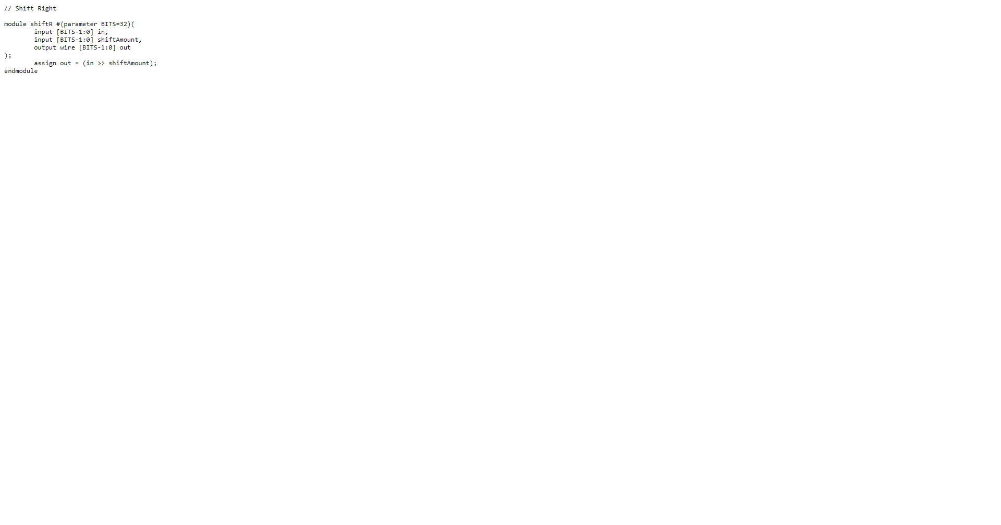

Shift left

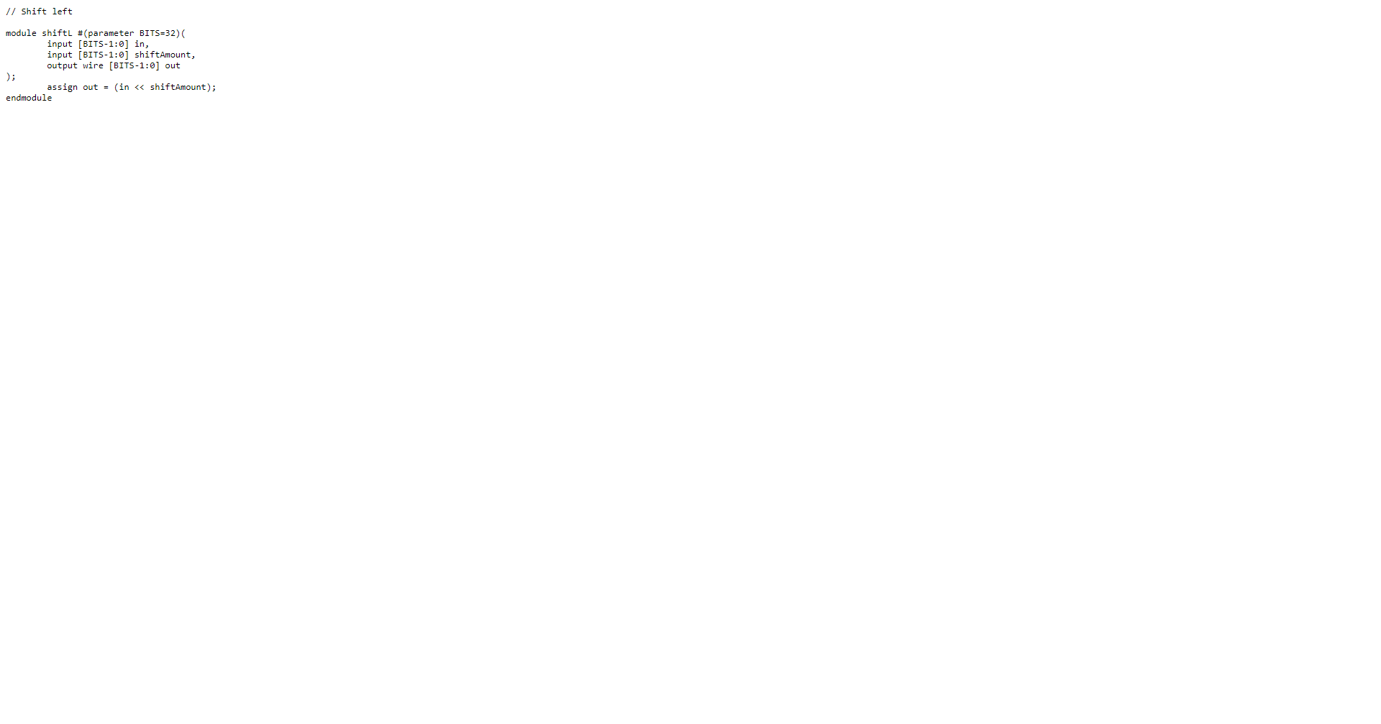

Rotate Right

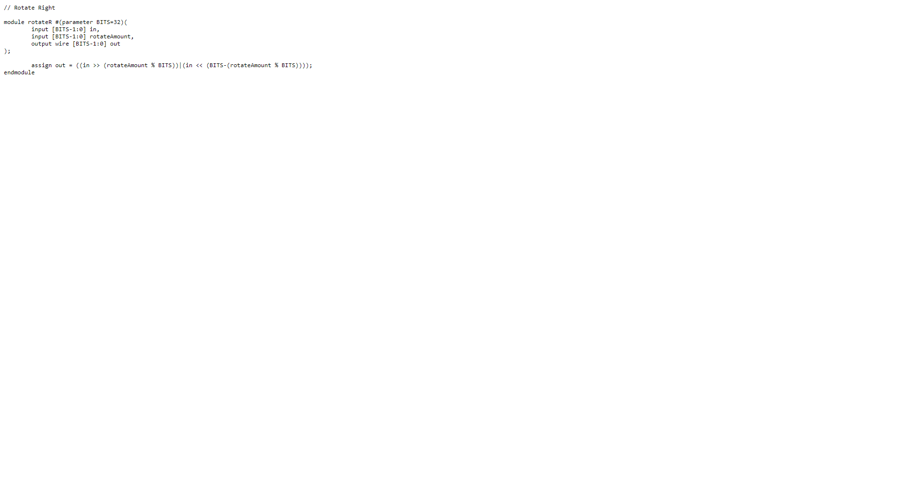

Rotate Left

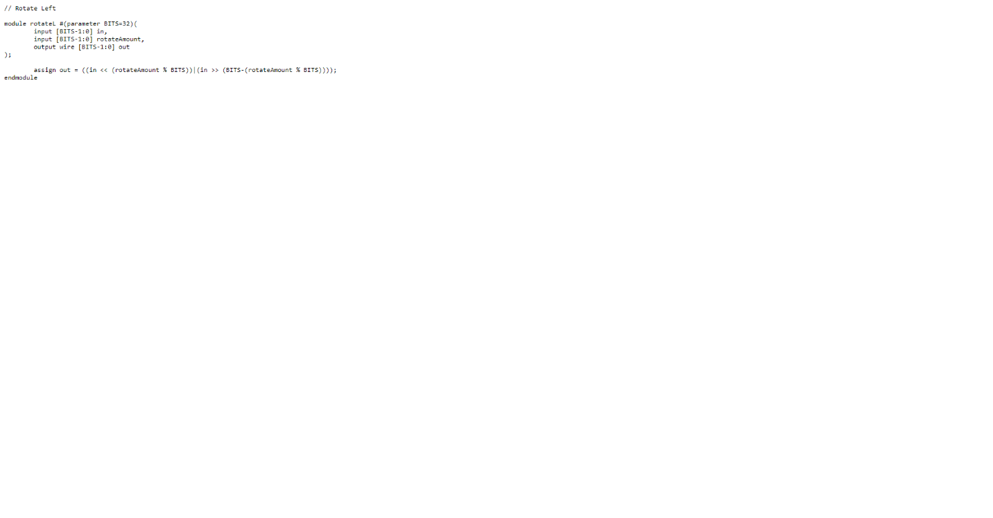

Datapath

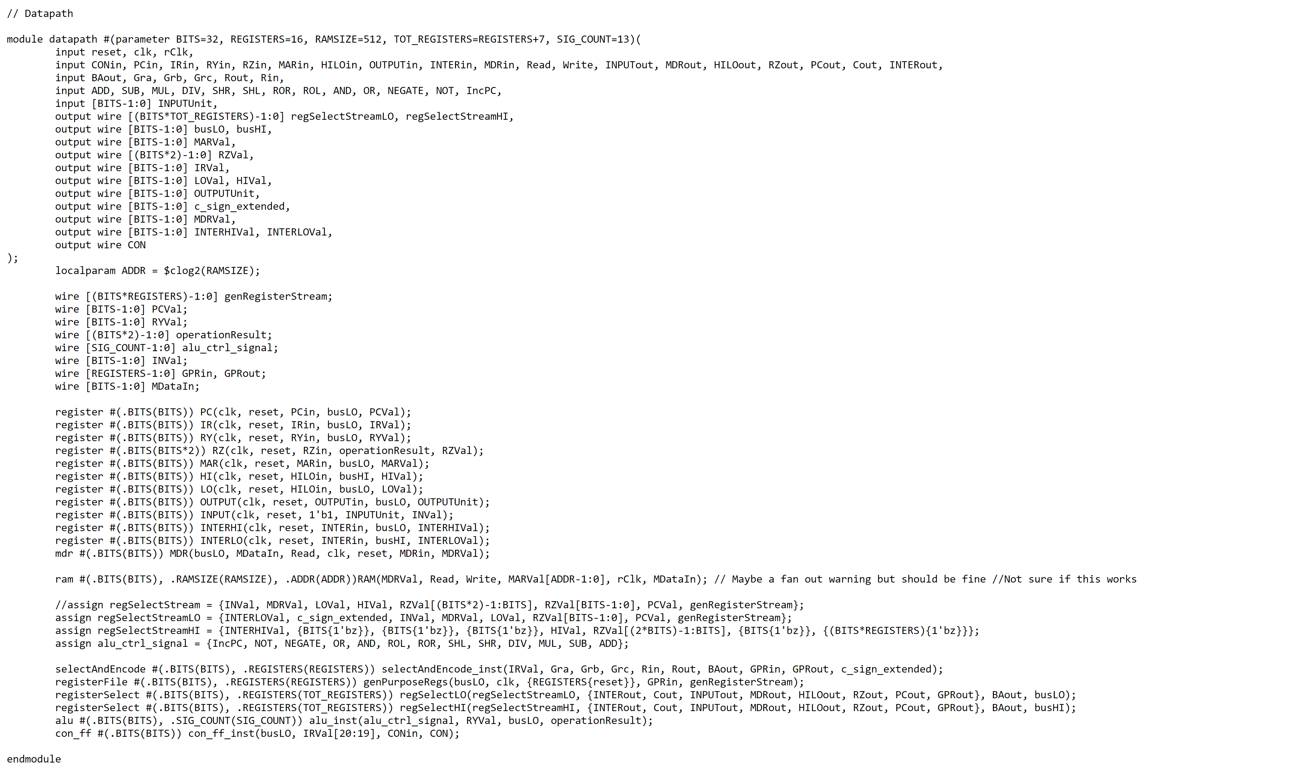

MDR

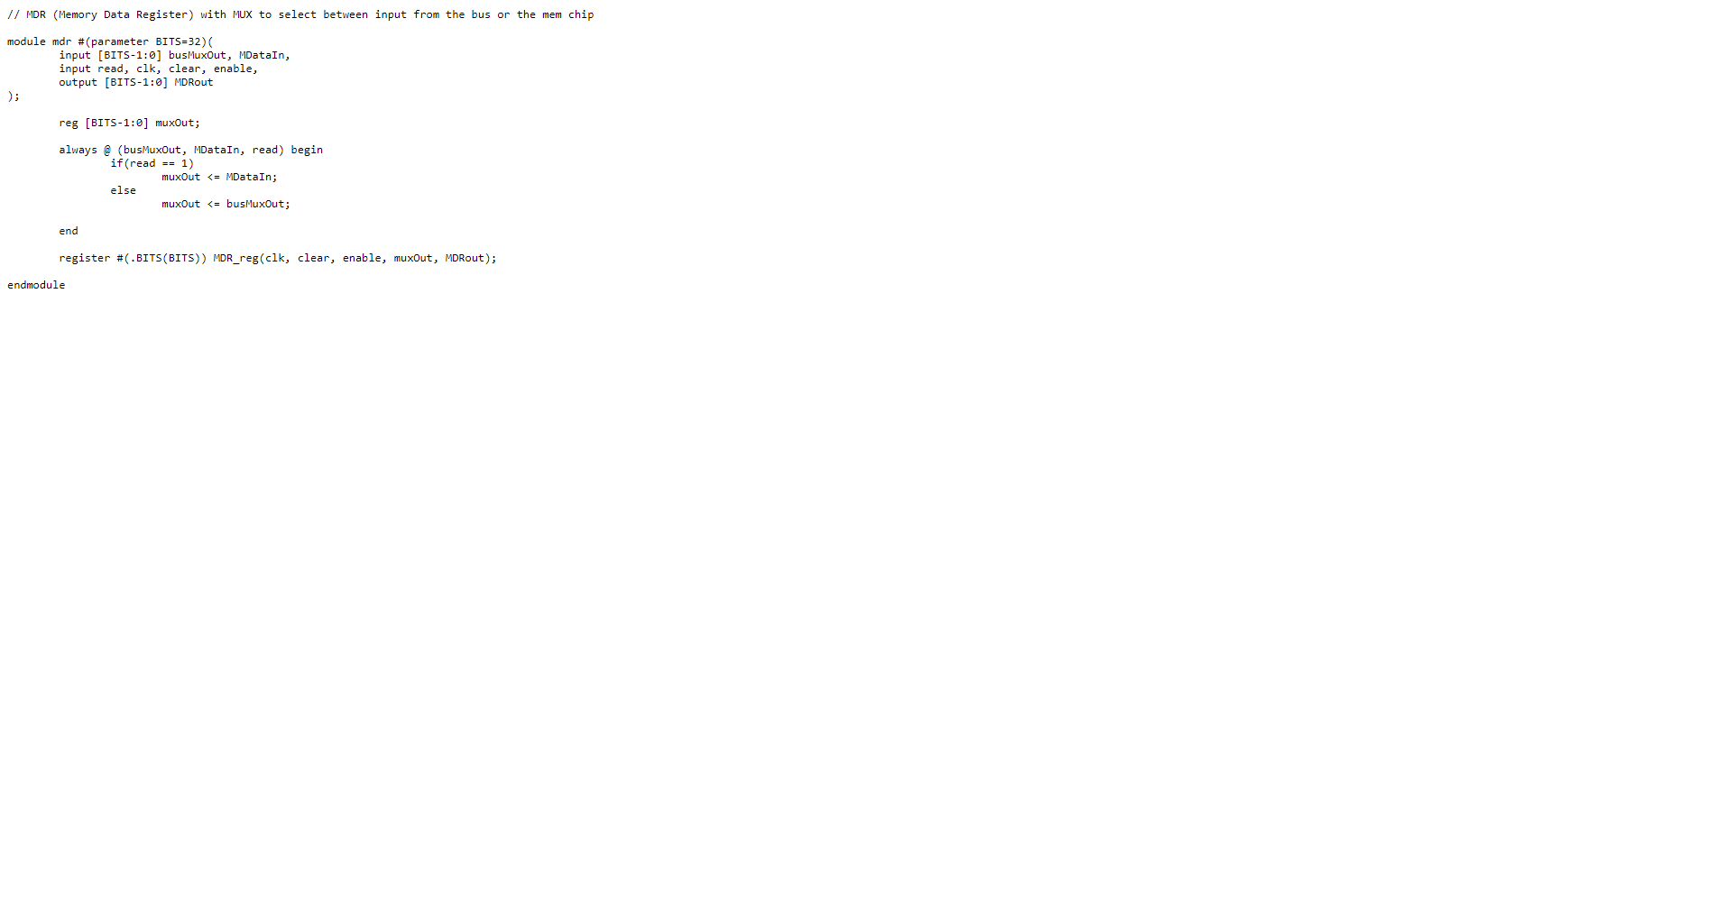

MDR Testbench

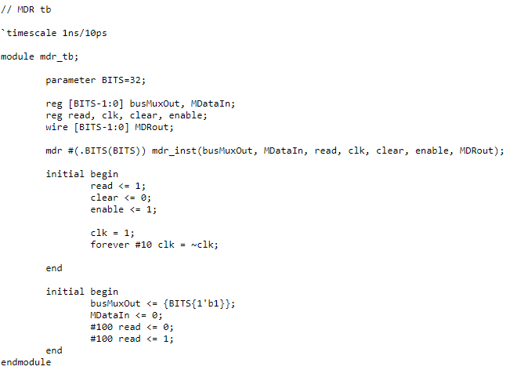

MDR Waveform

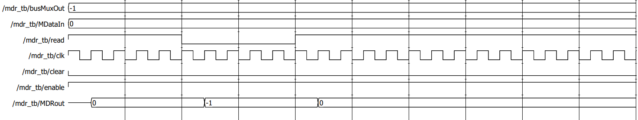

CON_FF

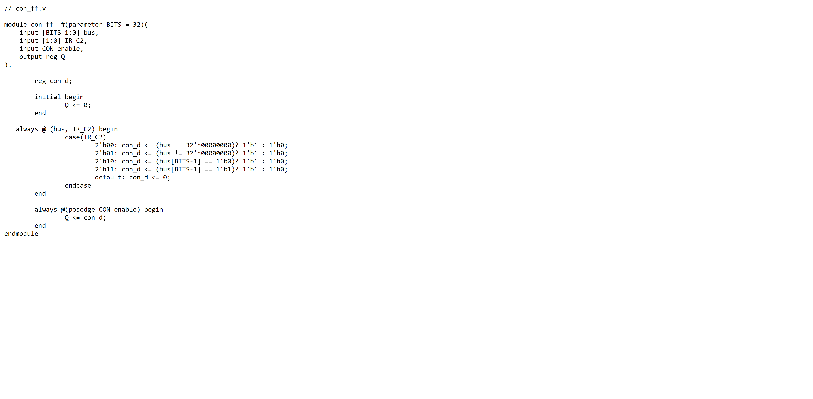

RAM

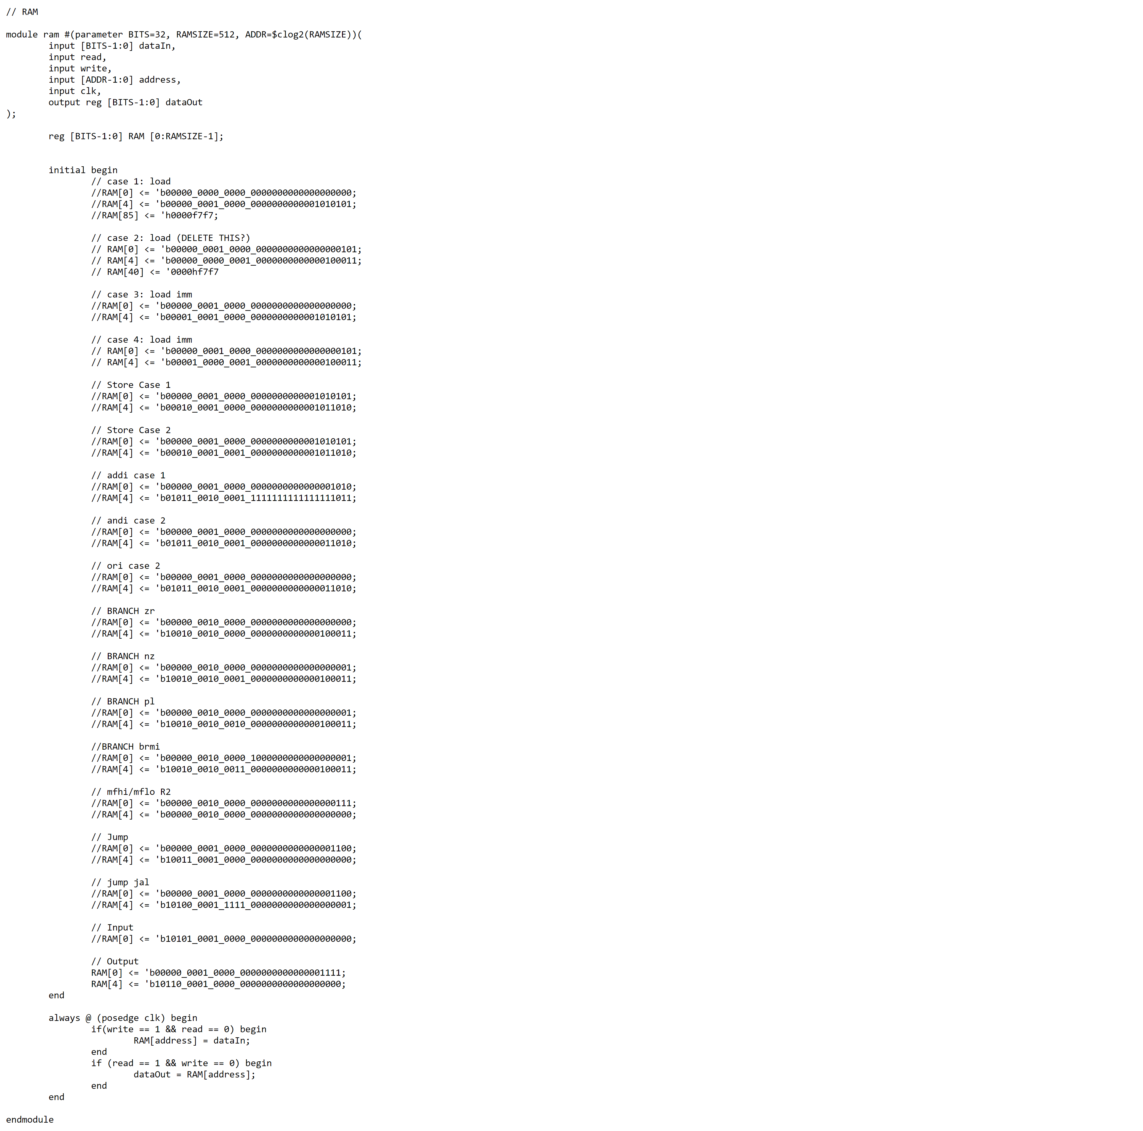

RAM Testbench

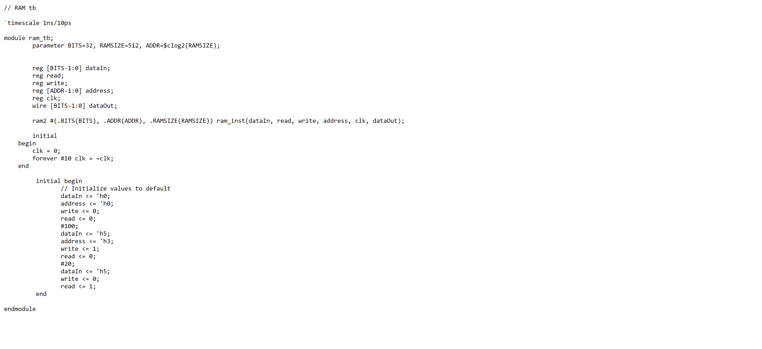

RAM Waveform

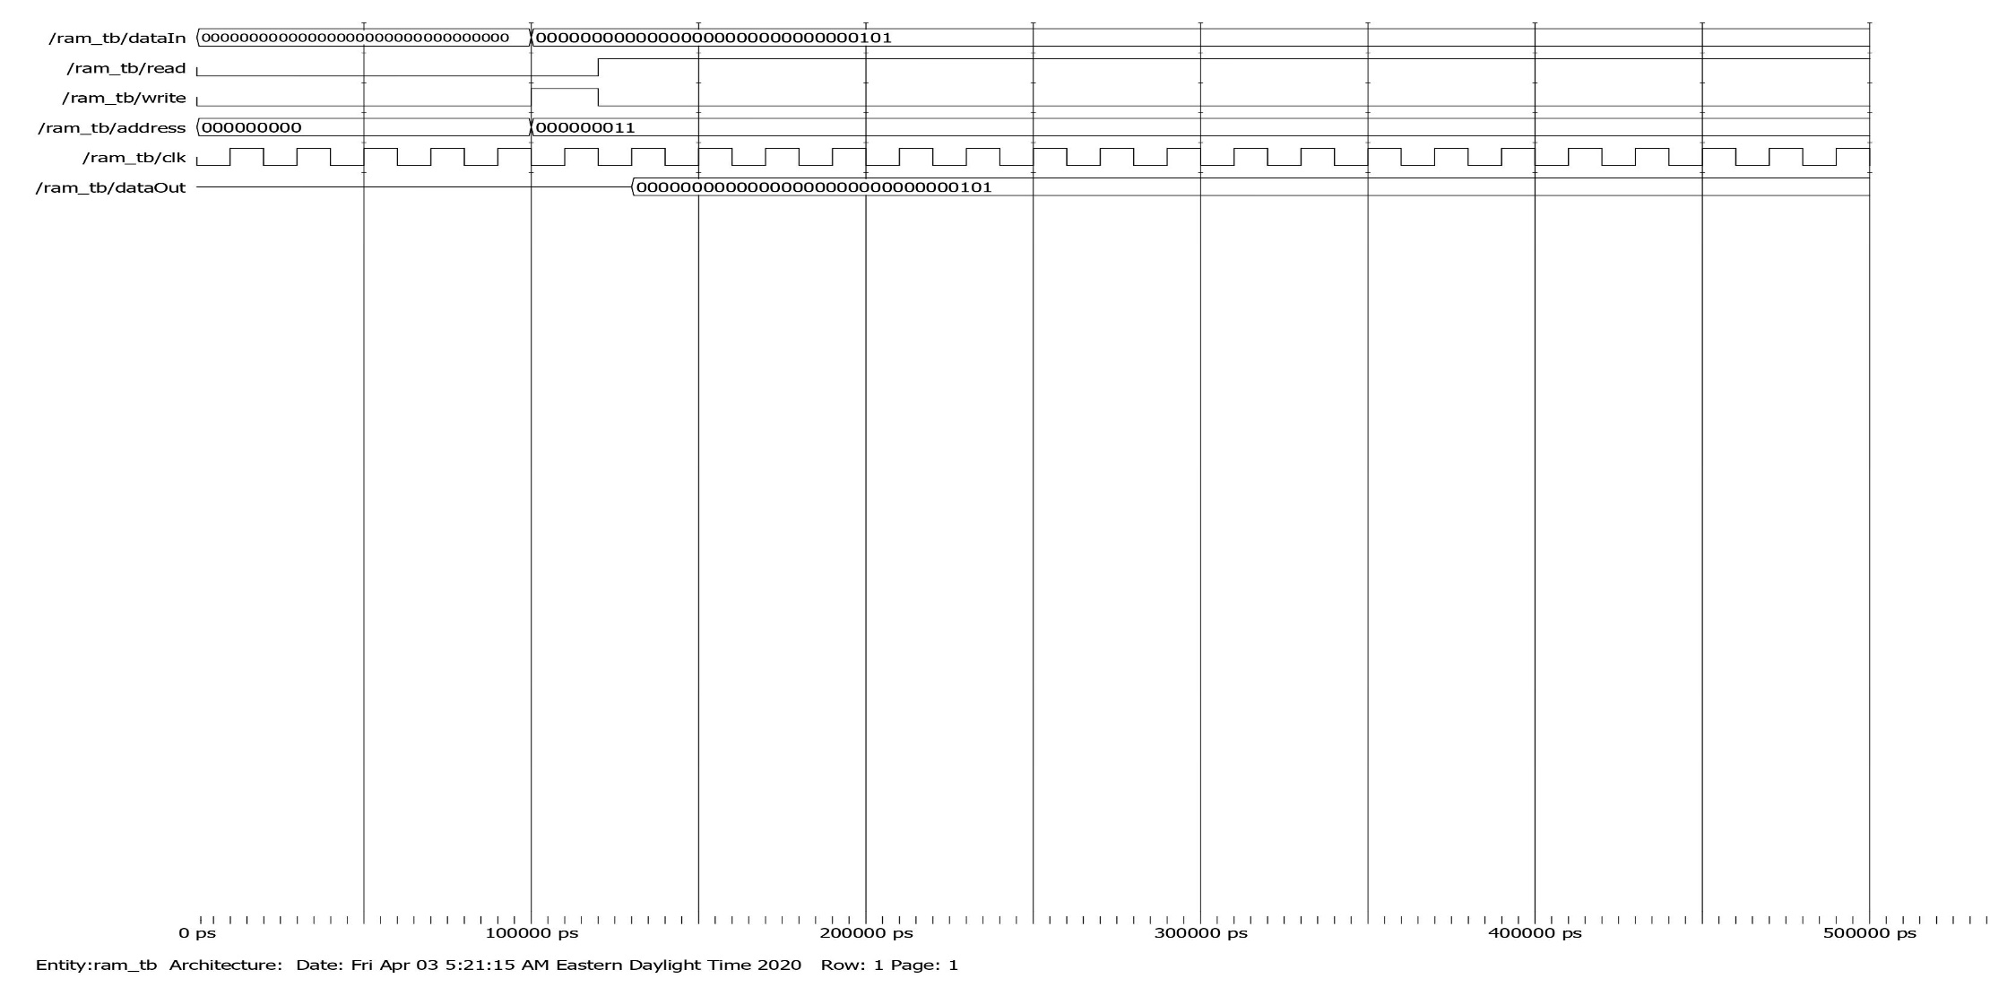

Select and Encode

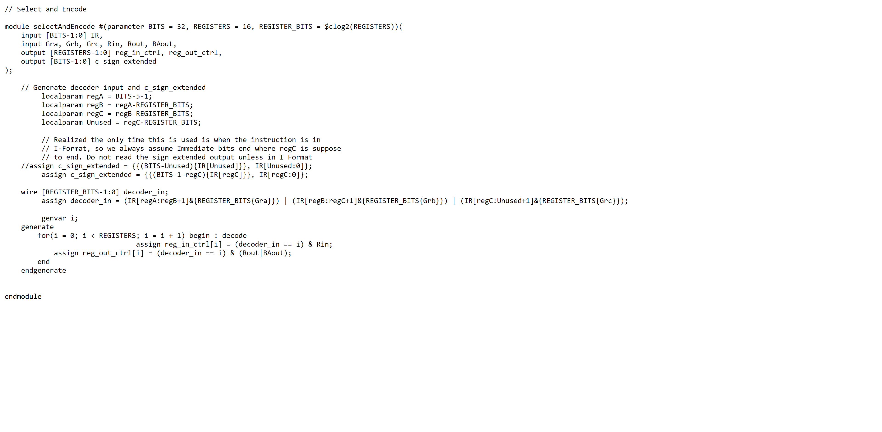

Select and Encode Testbench

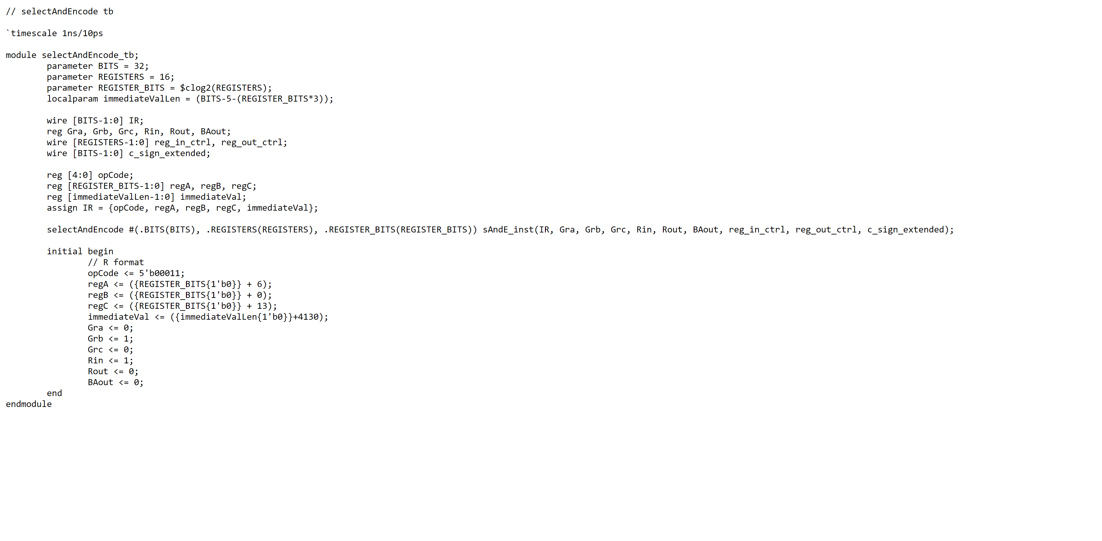

Select and Encode Waveform

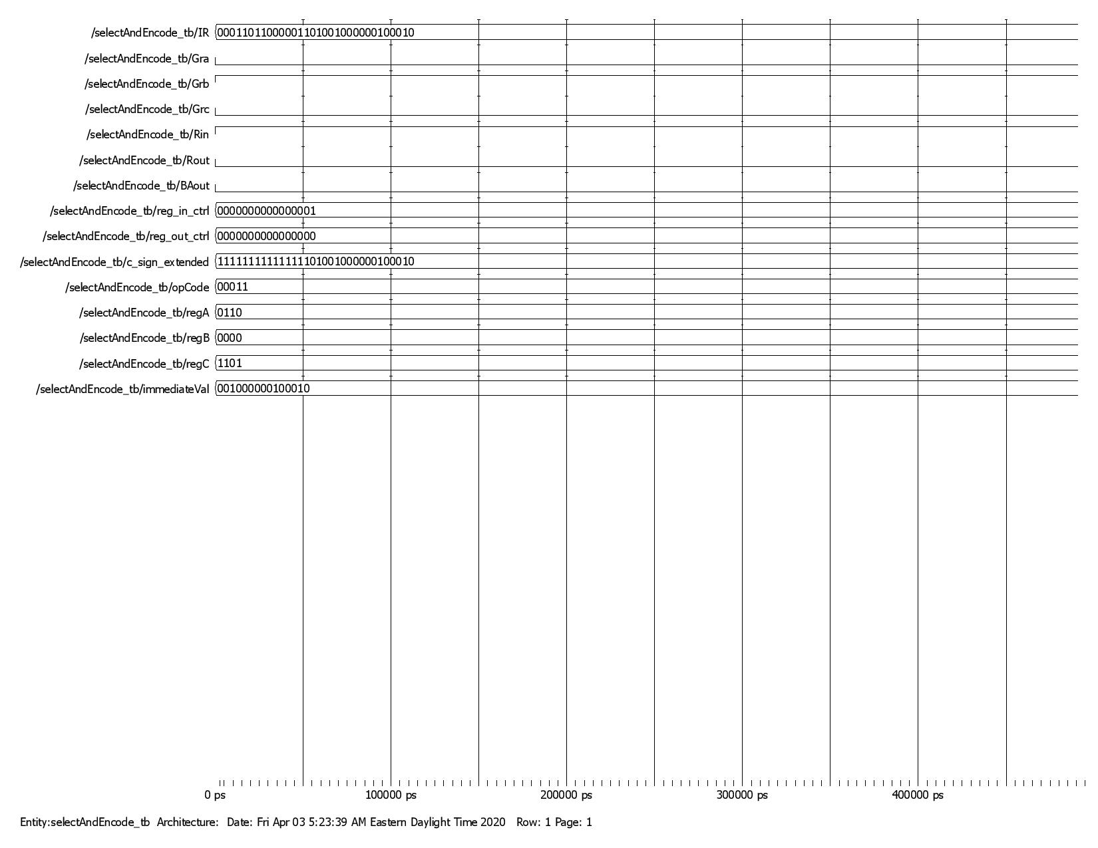

LD Testbench

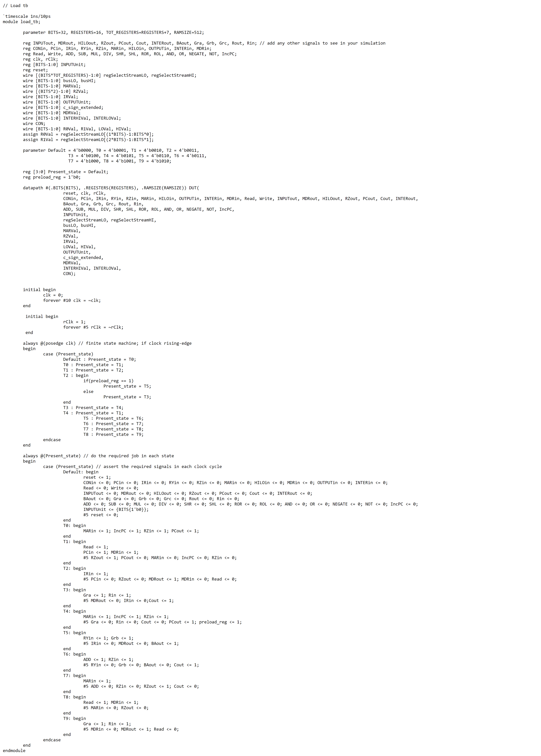

LD Waveform

LD Case 1

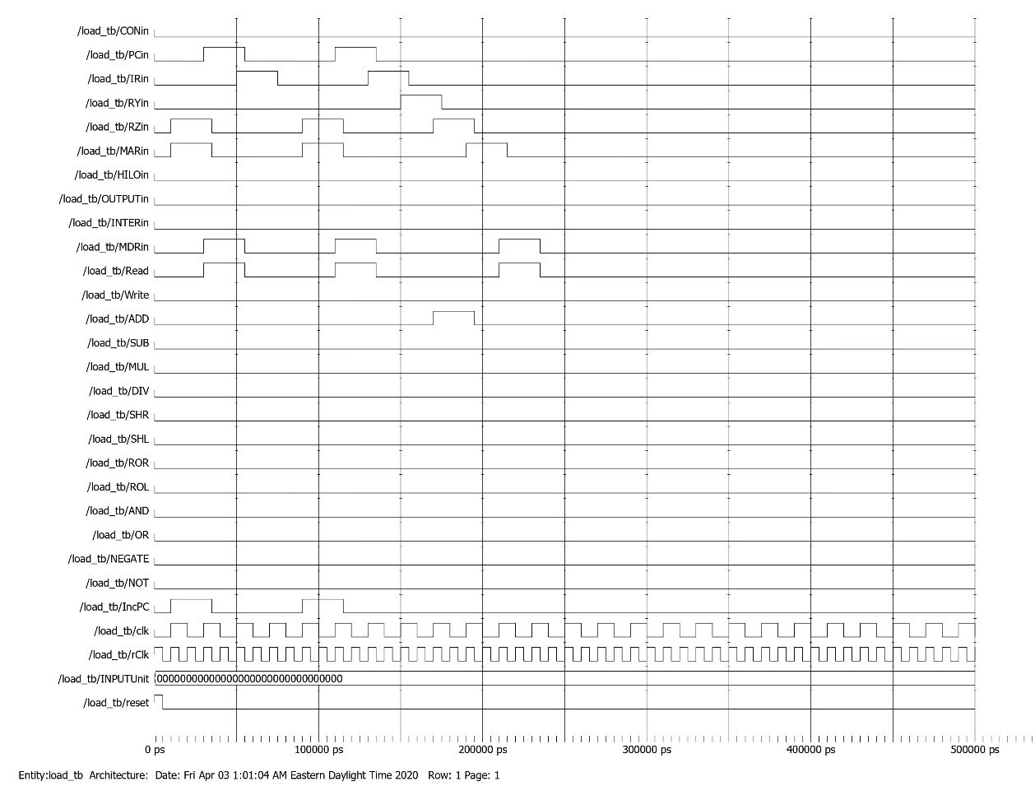

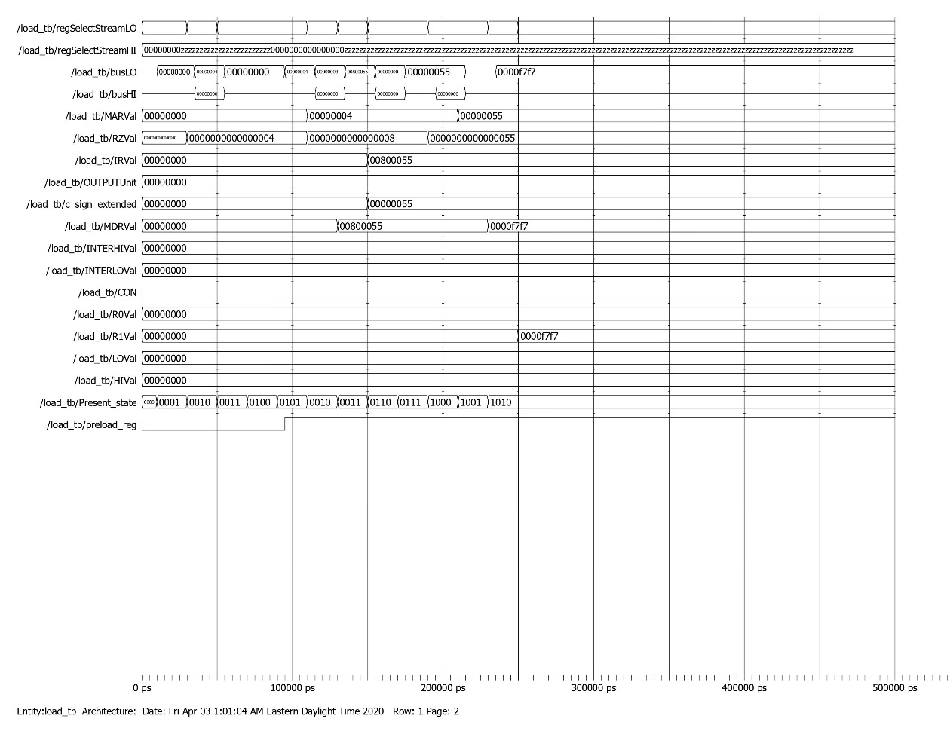

*Memory dump before LD Case 1*

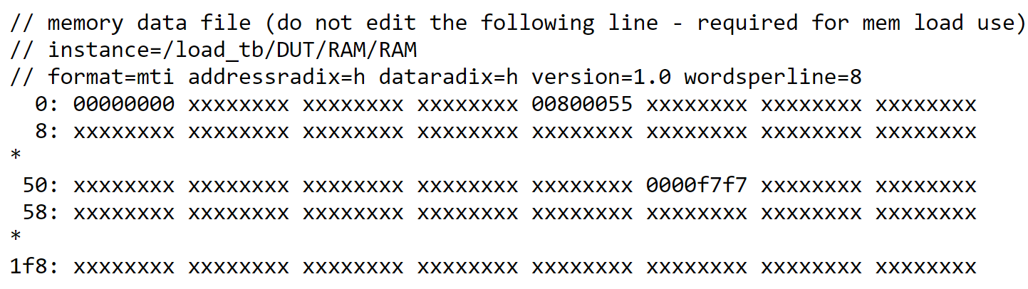

LD Case 2

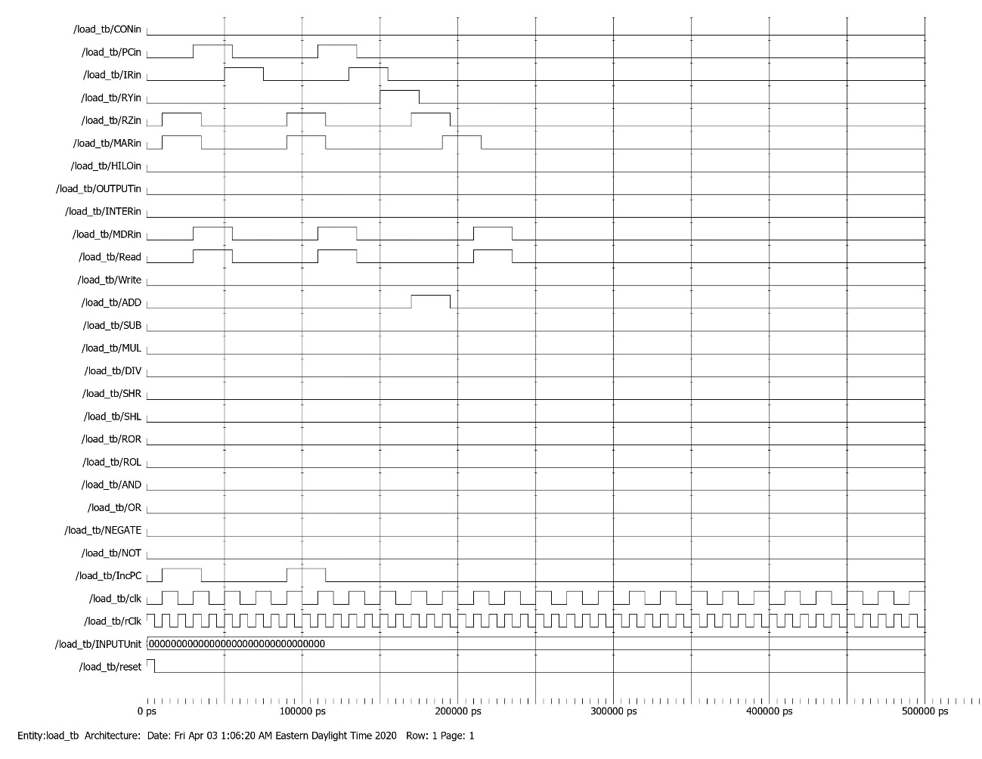

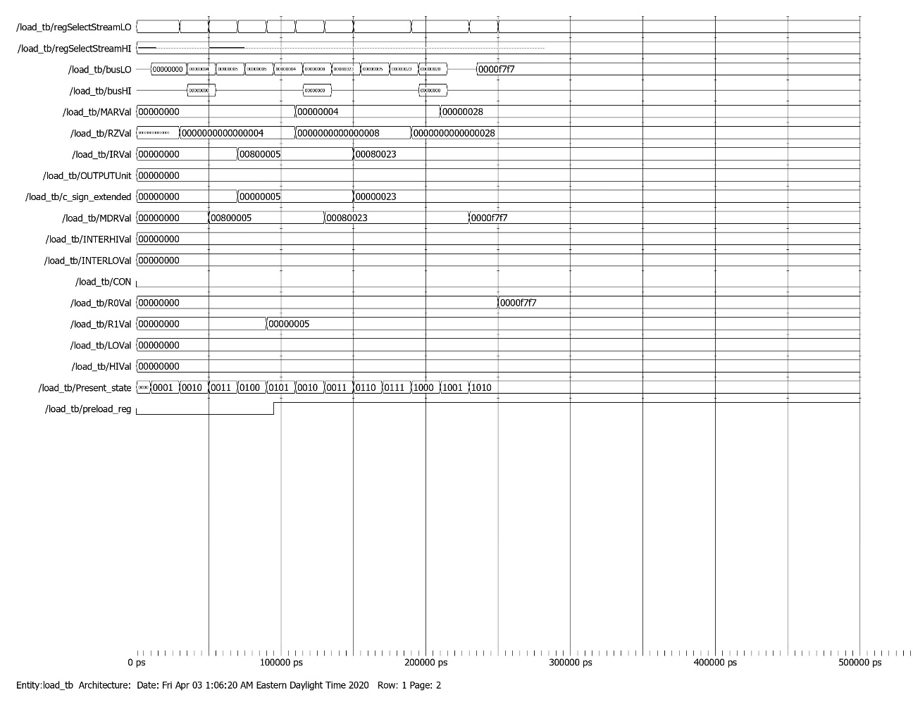

*Memory dump before LD Case 2*

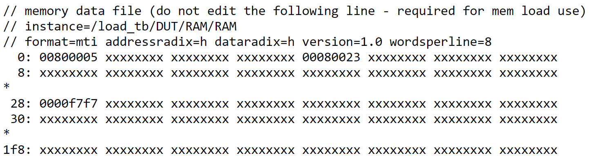

LDI Testbench

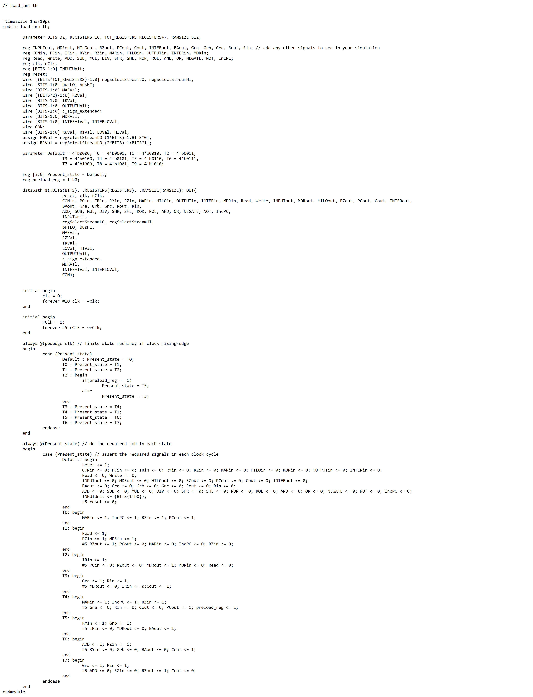

LDI Waveform

LDI Case 1

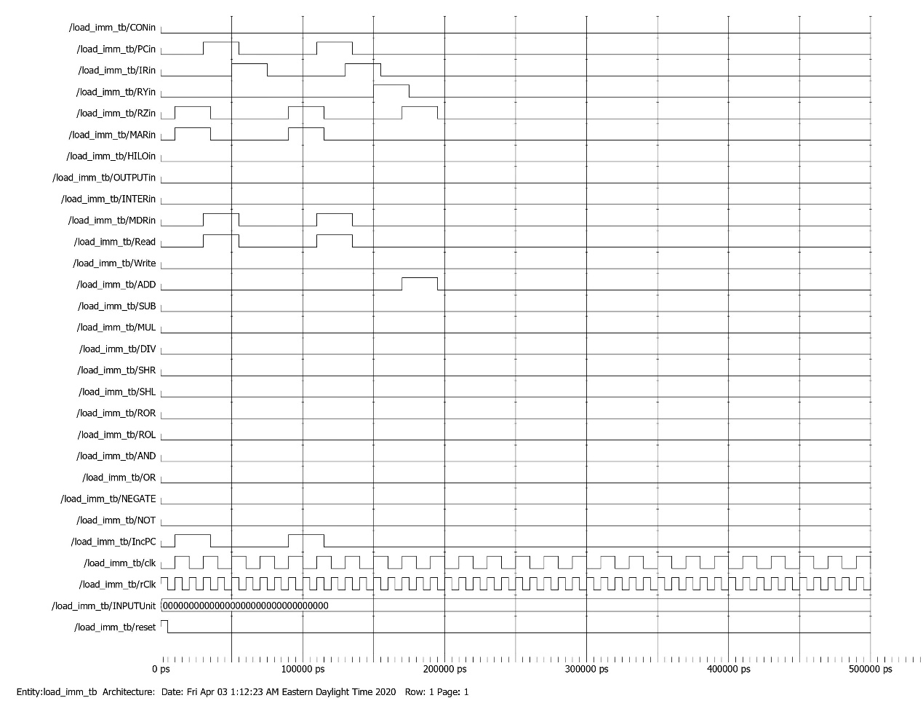

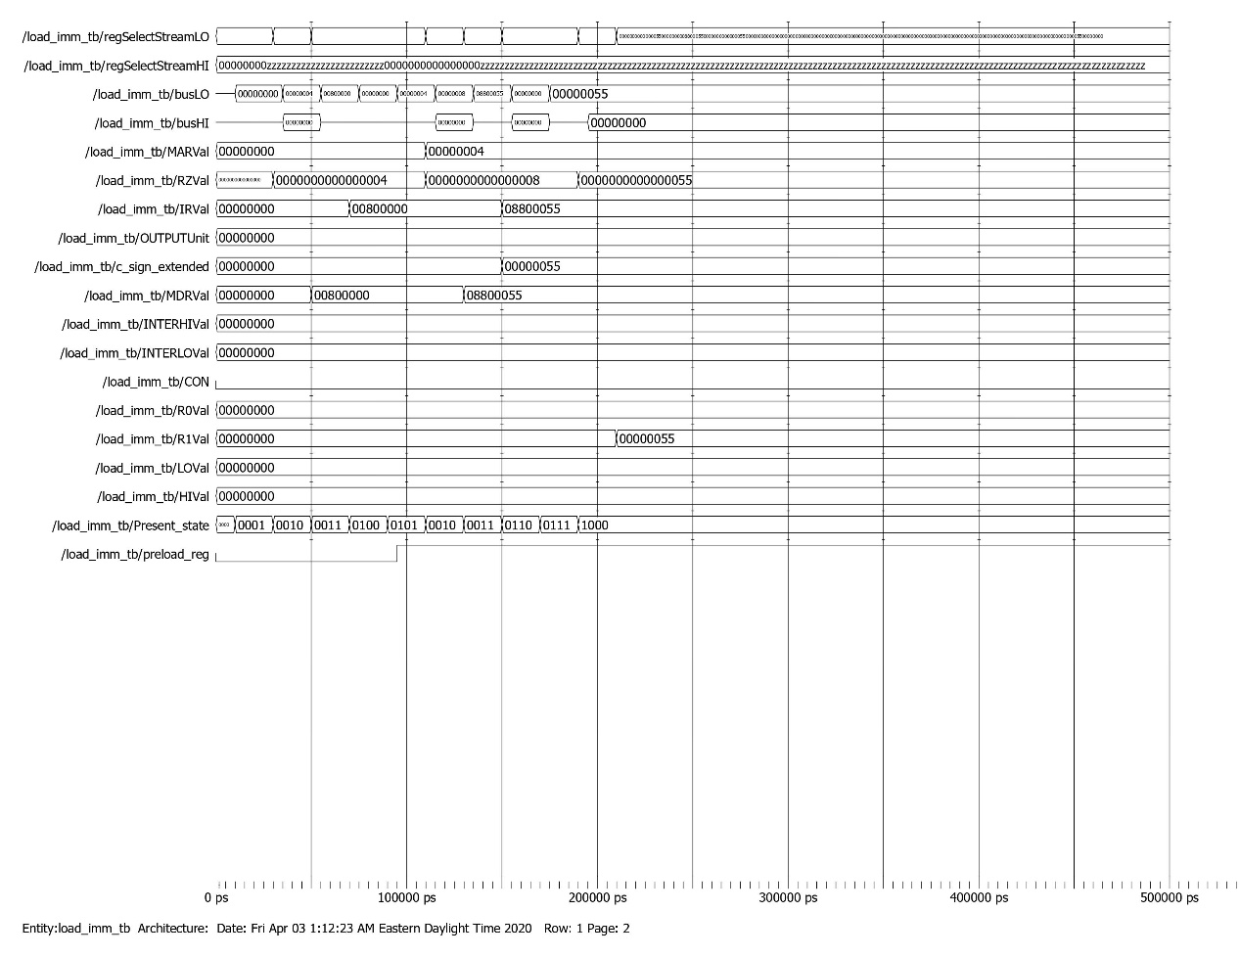

*Memory dump before LDI Case 1*

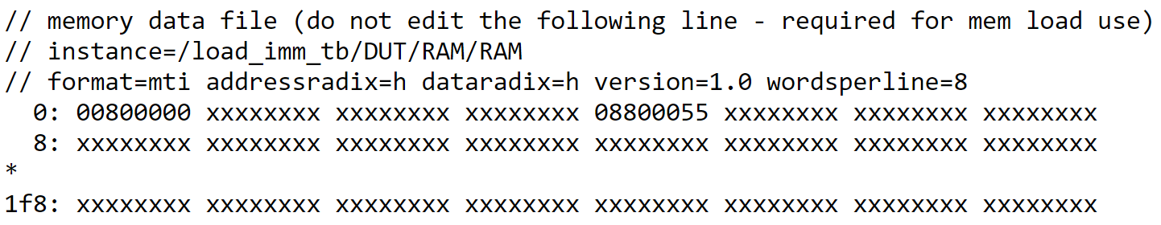

LDI Case 2

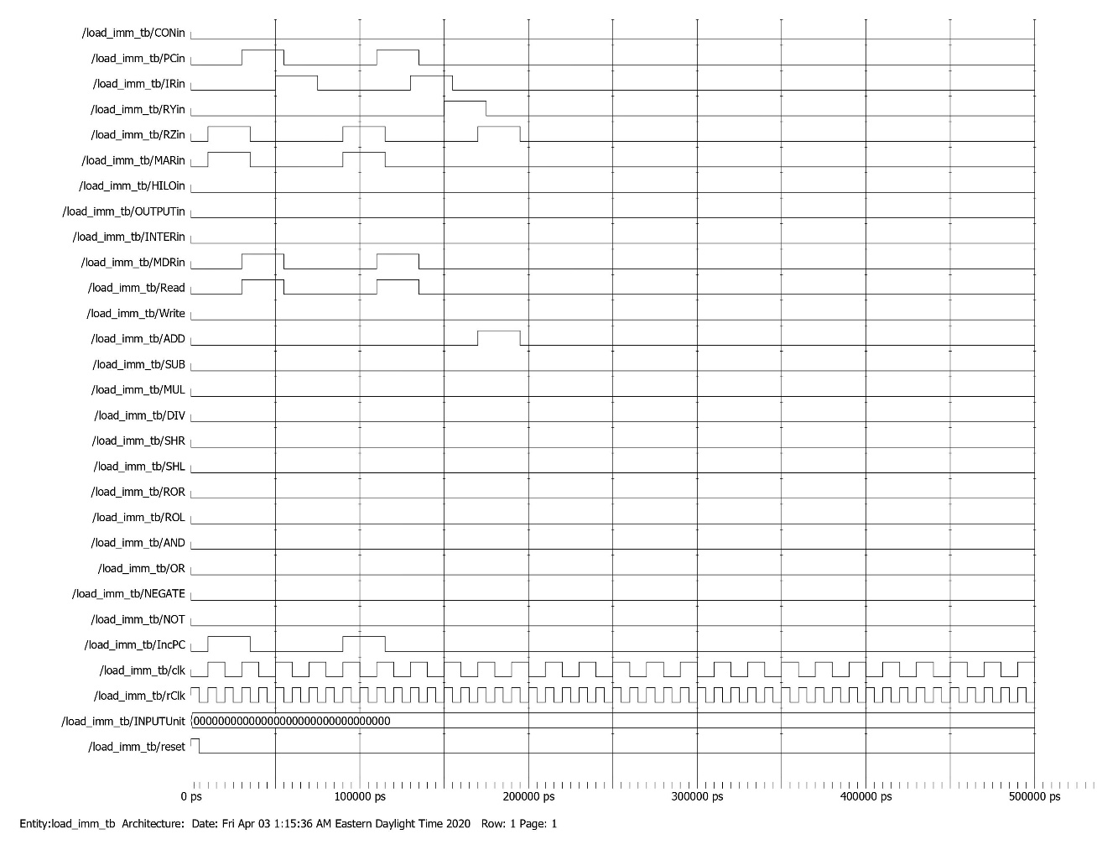

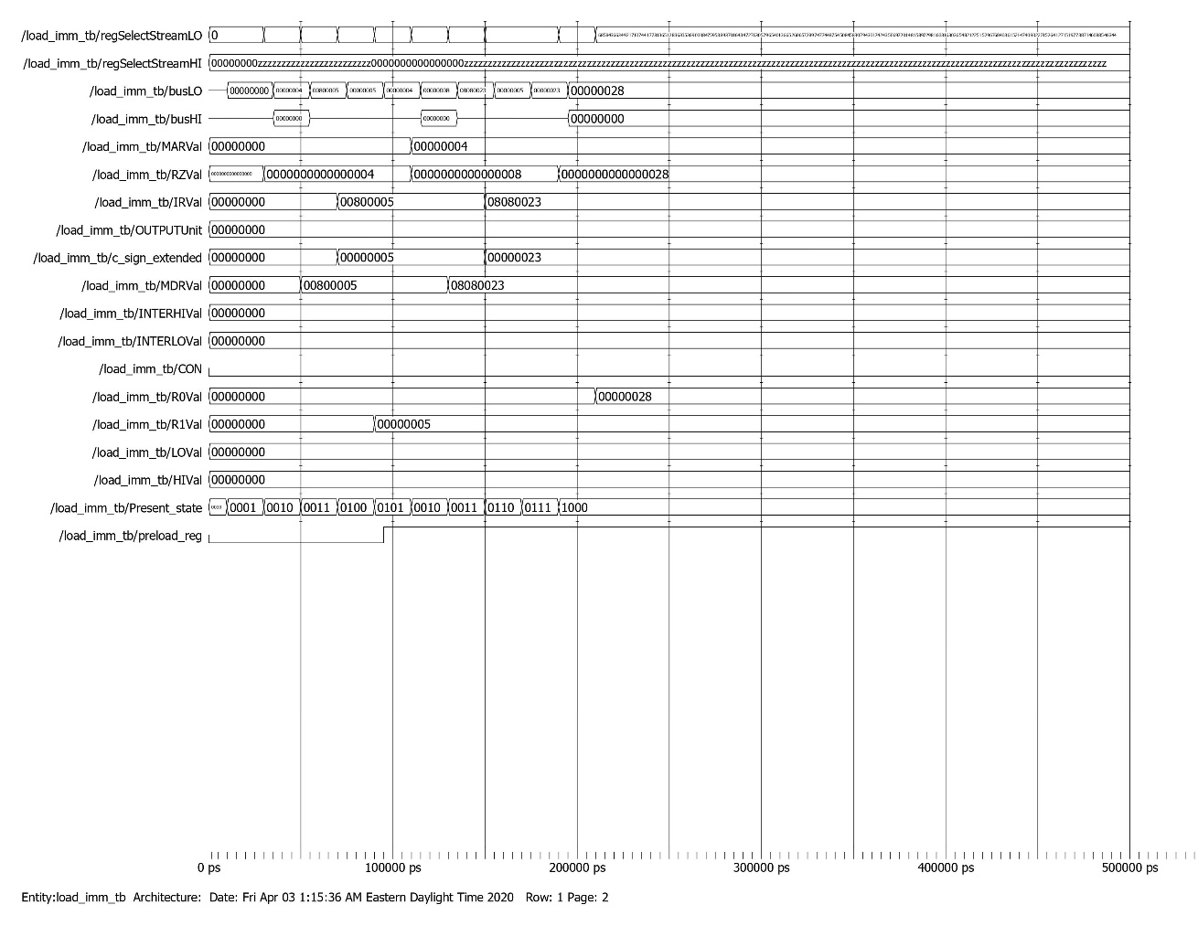

*Memory dump before LD Case 2*

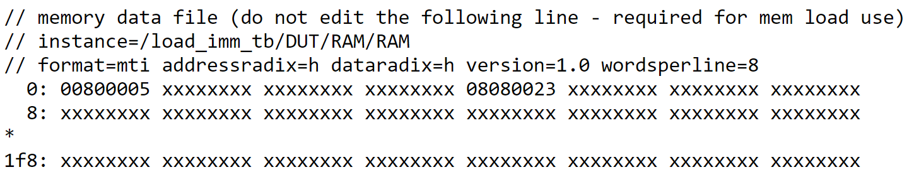

ST Testbench

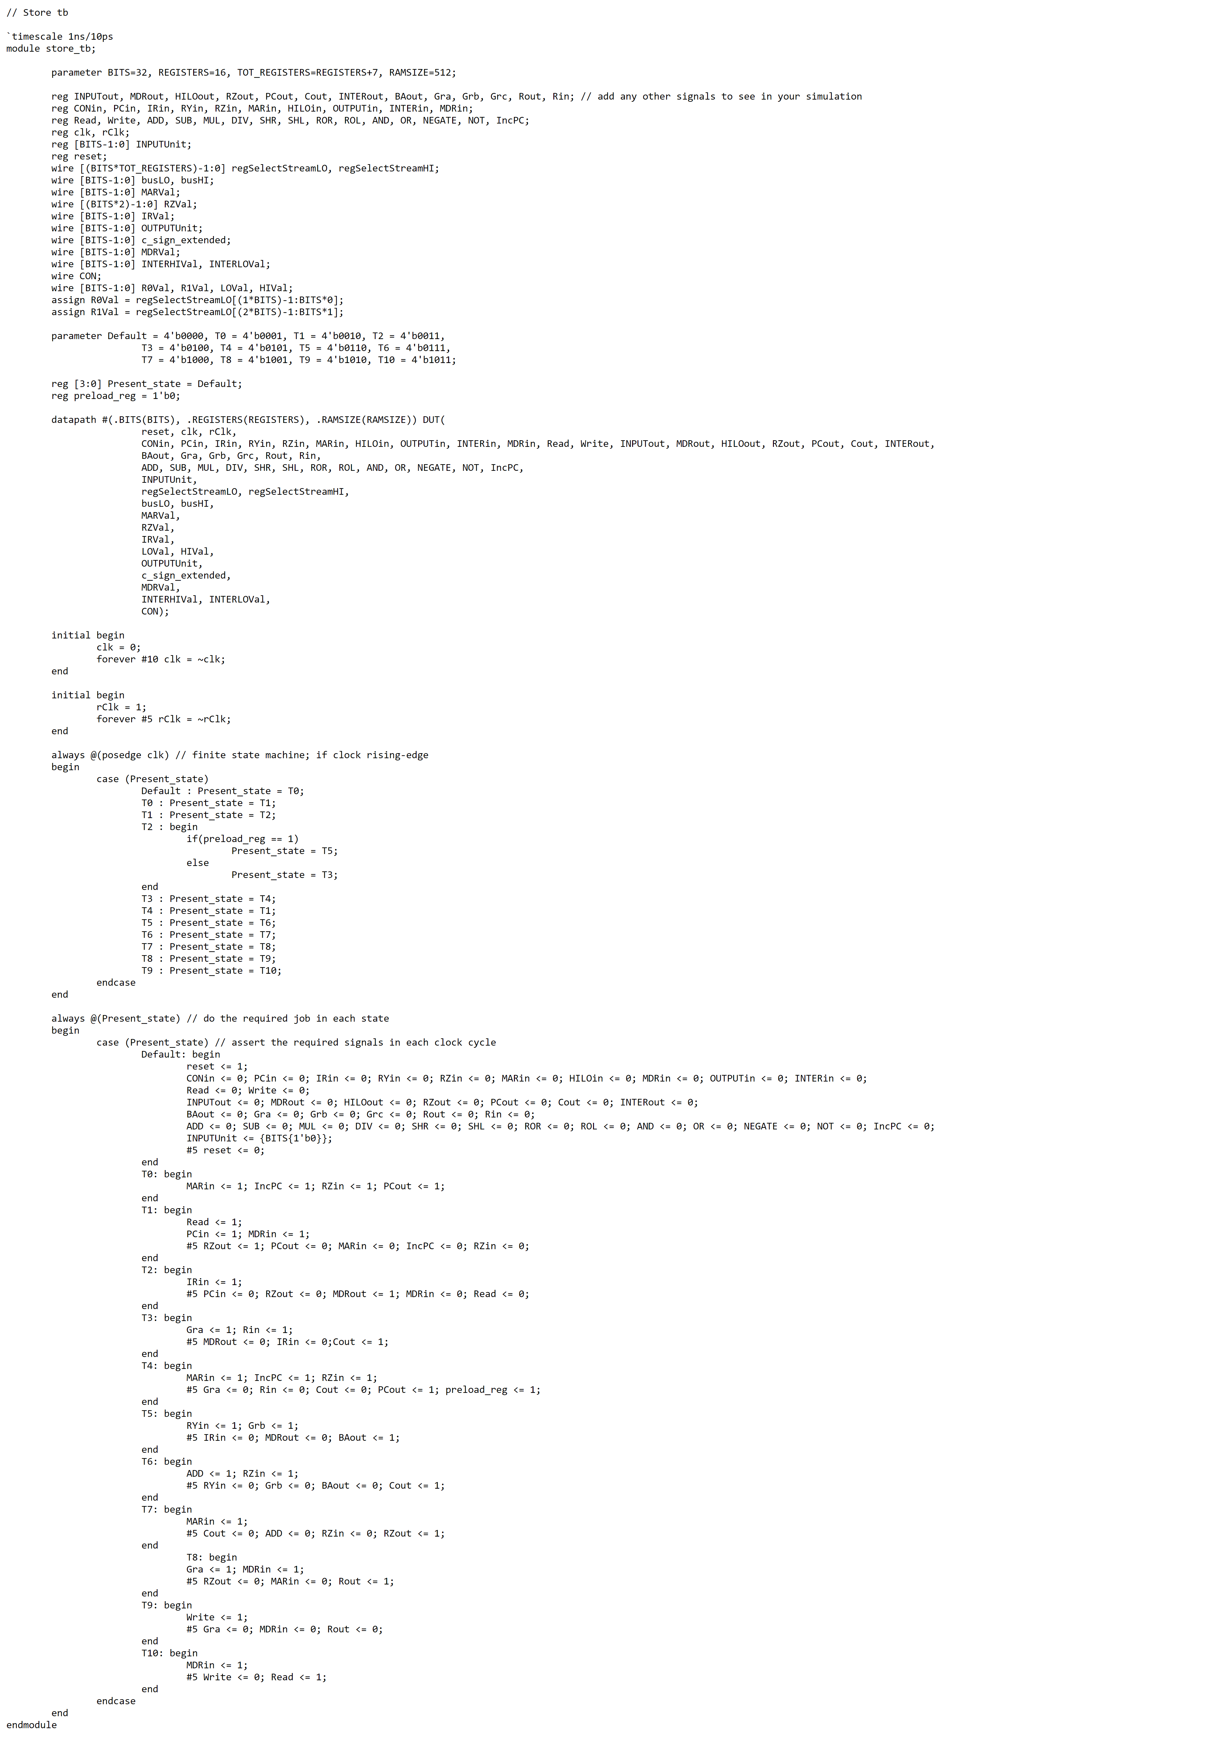

ST Waveform

ST Case 1

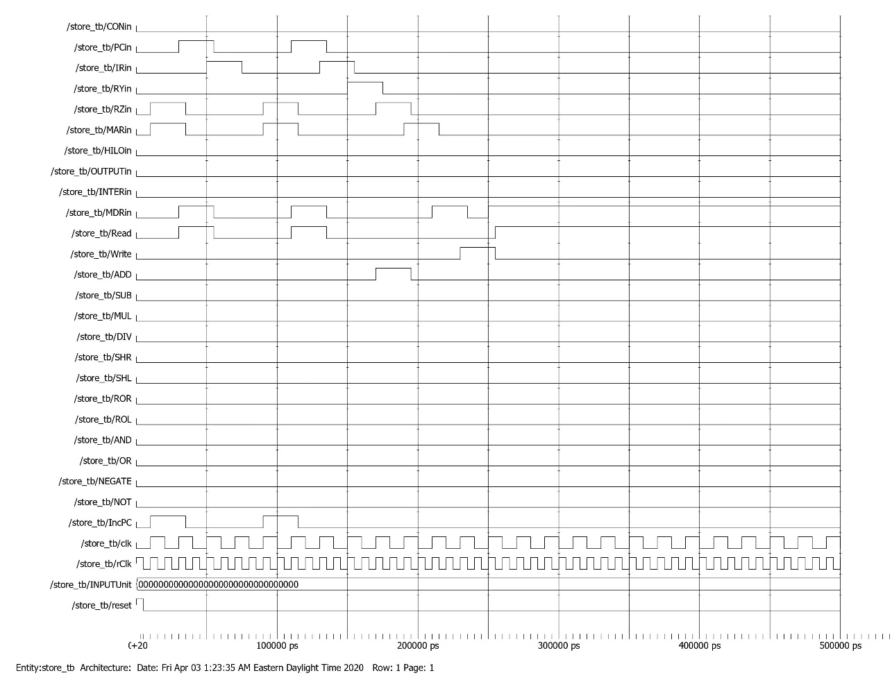

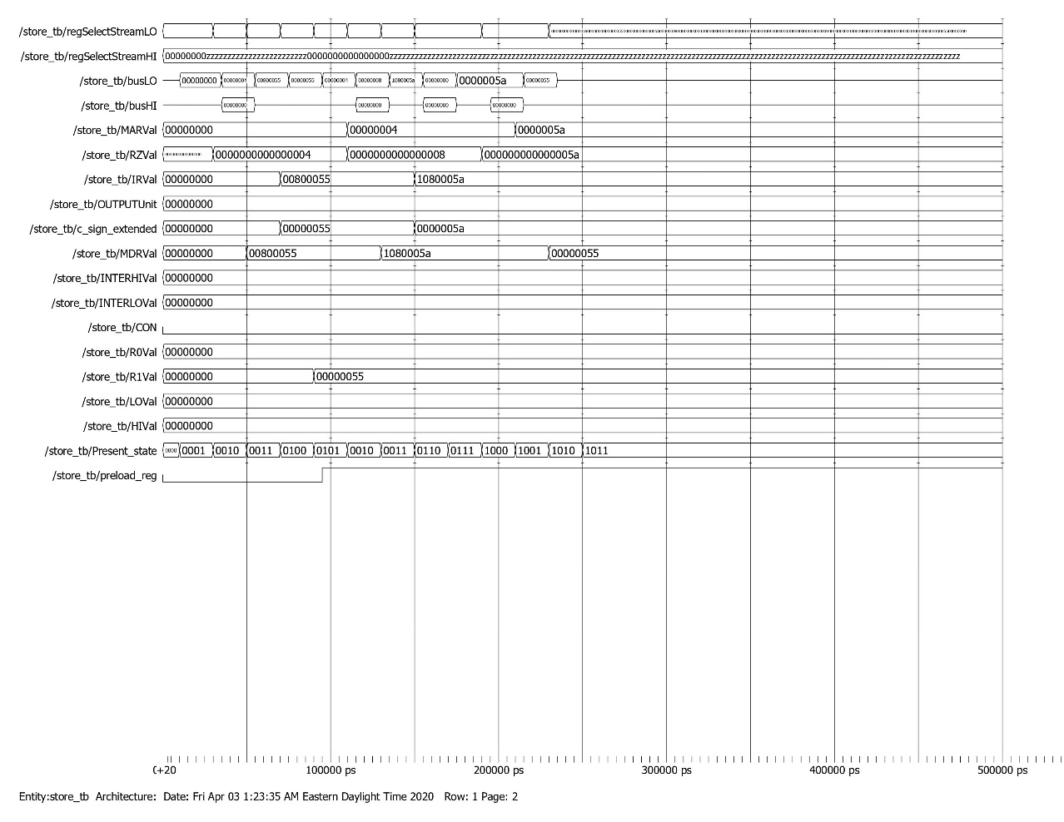

*Memory dump before ST Case 1*

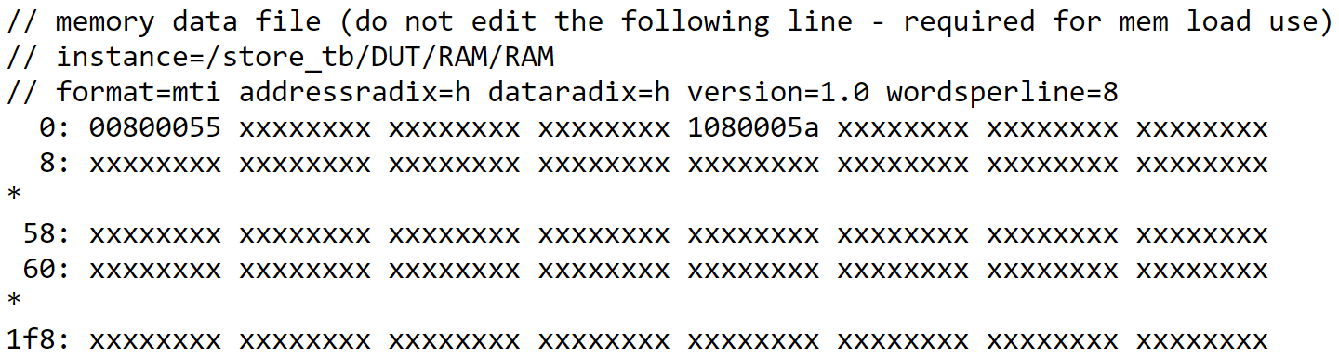

*Memory dump after ST Case 1*

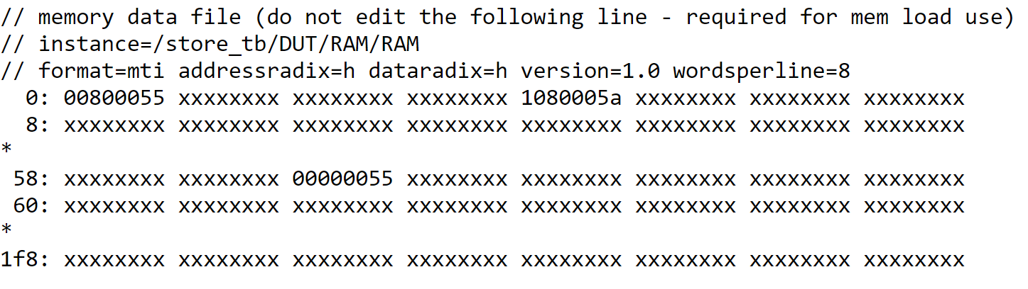

ST Case 2

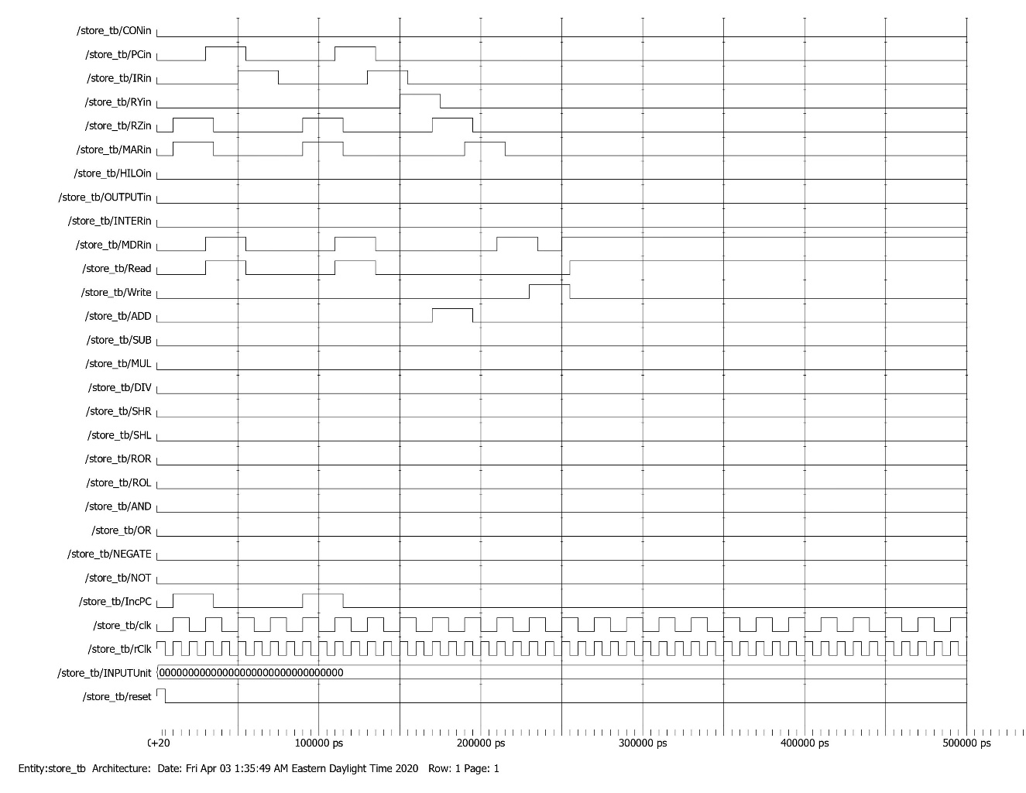

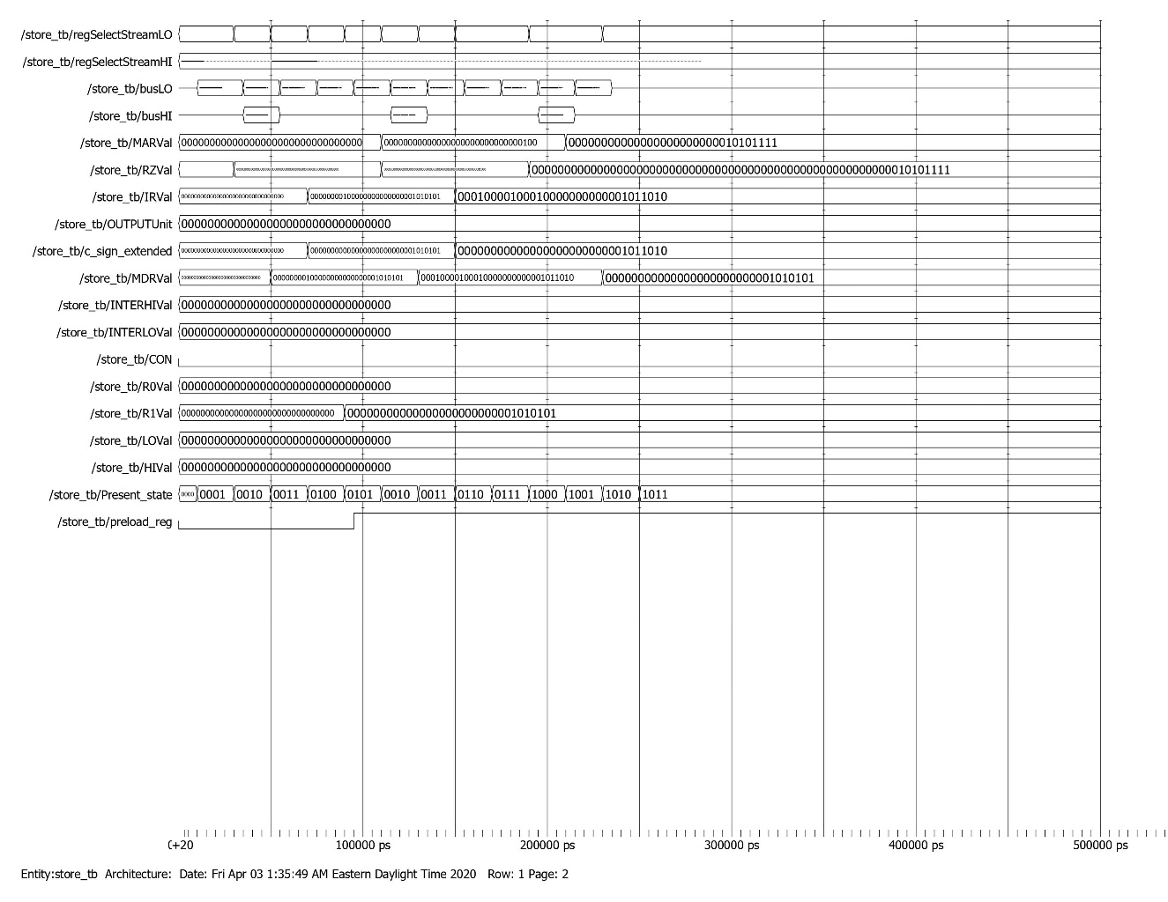

*Memory dump before ST Case 2*



*Memory dump after ST Case 2*

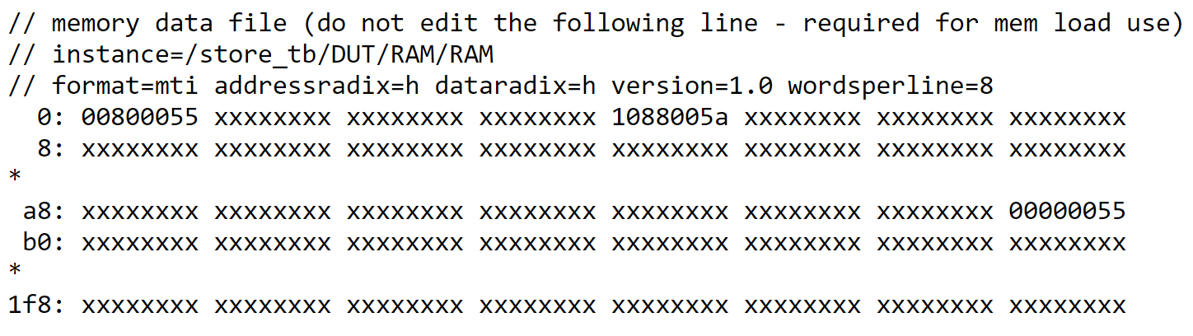

ADDI Testbench

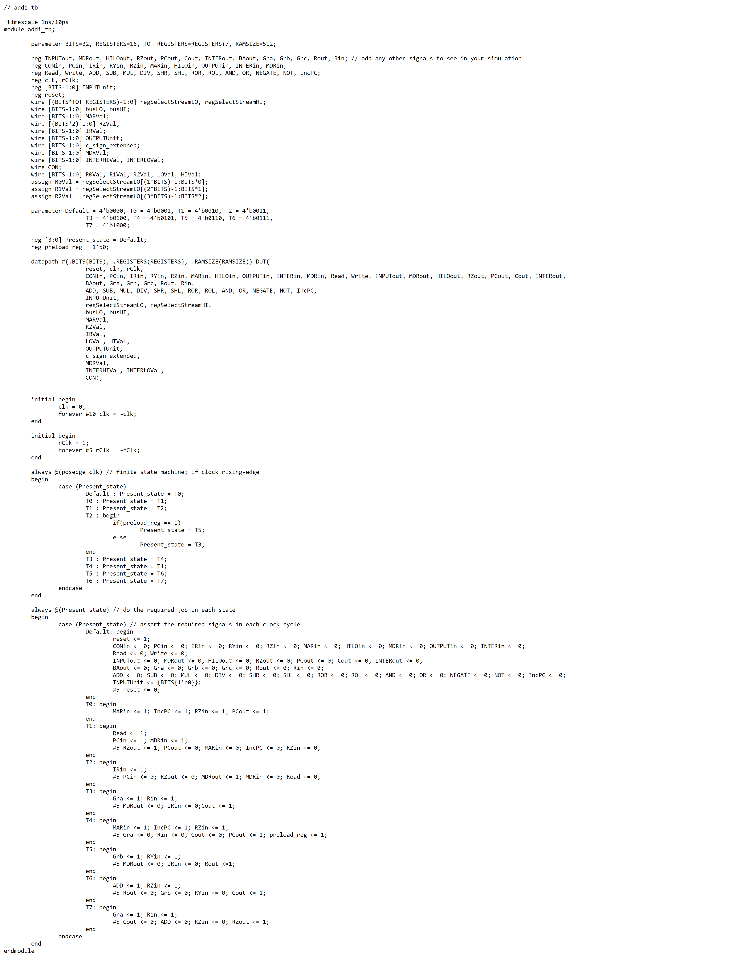

ADDI Waveform

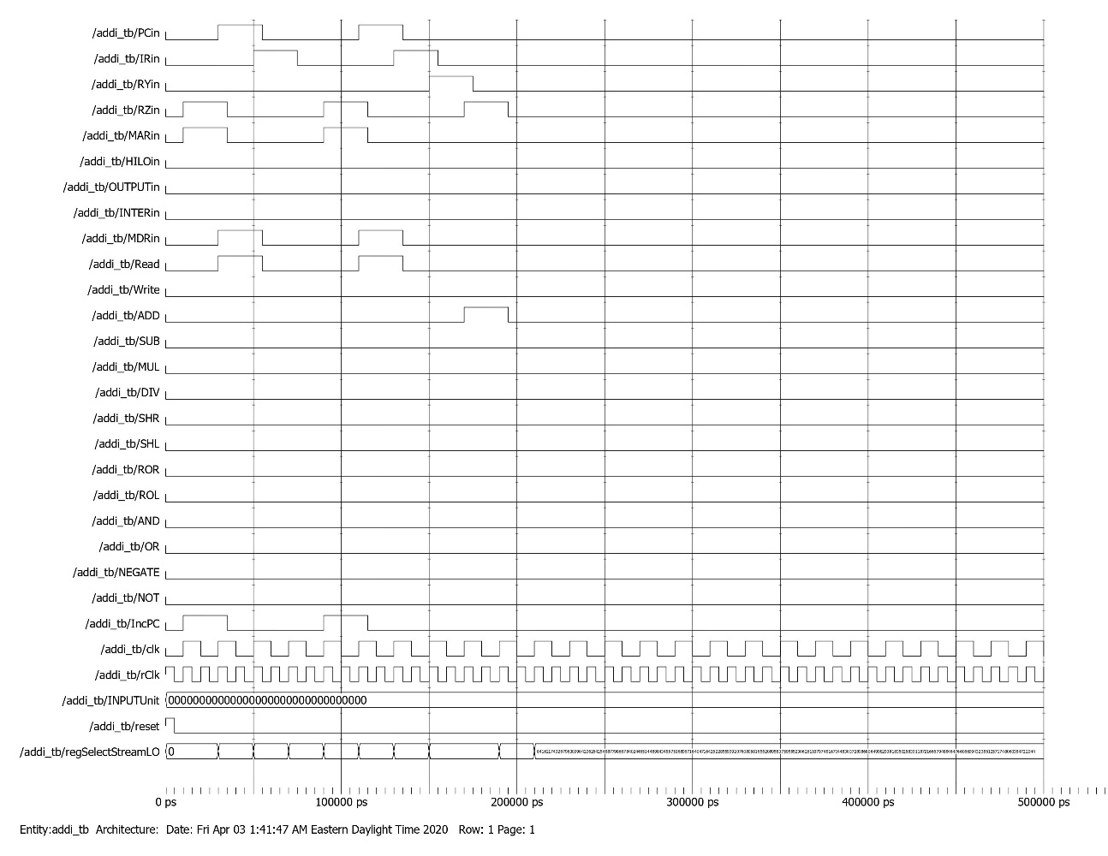

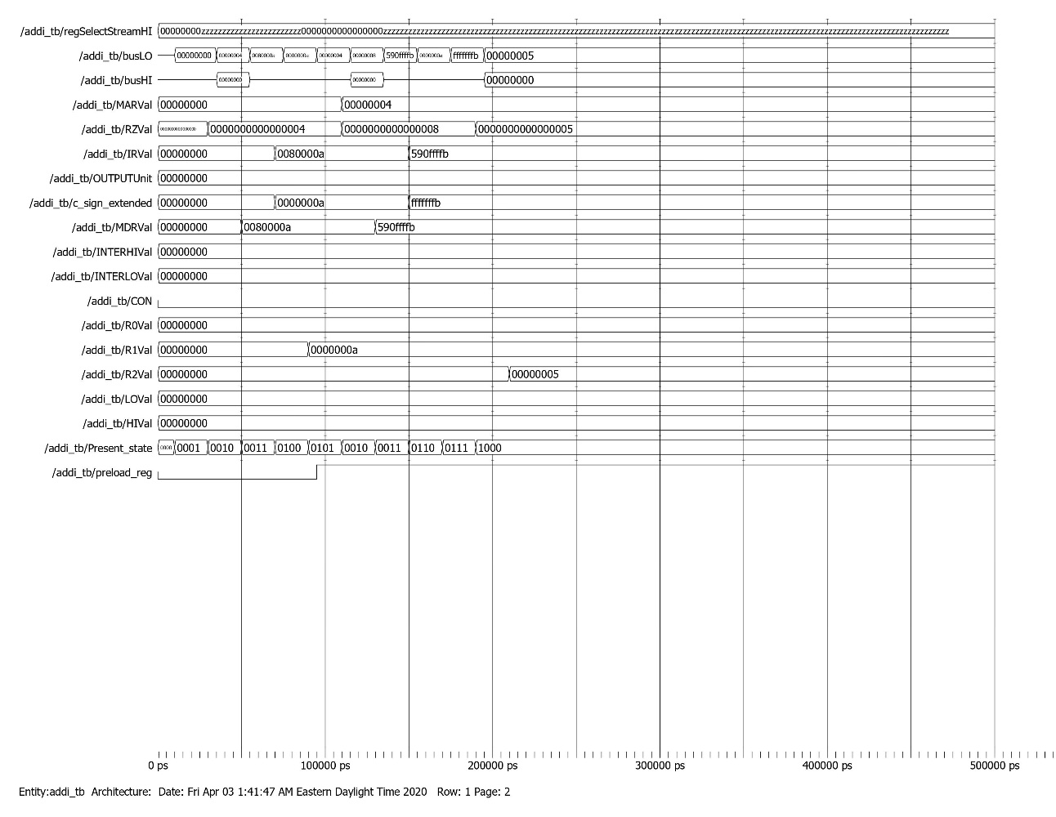

ANDI Testbench

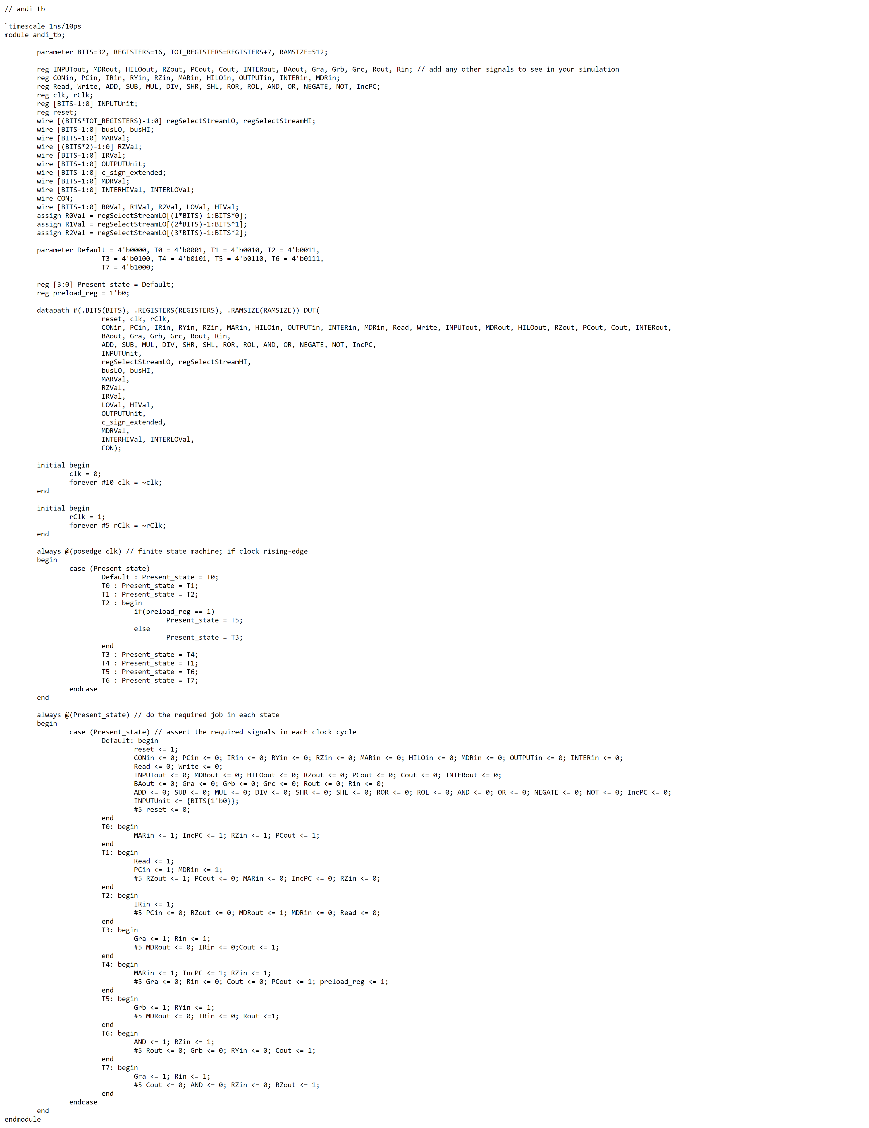

ANDI Waveform

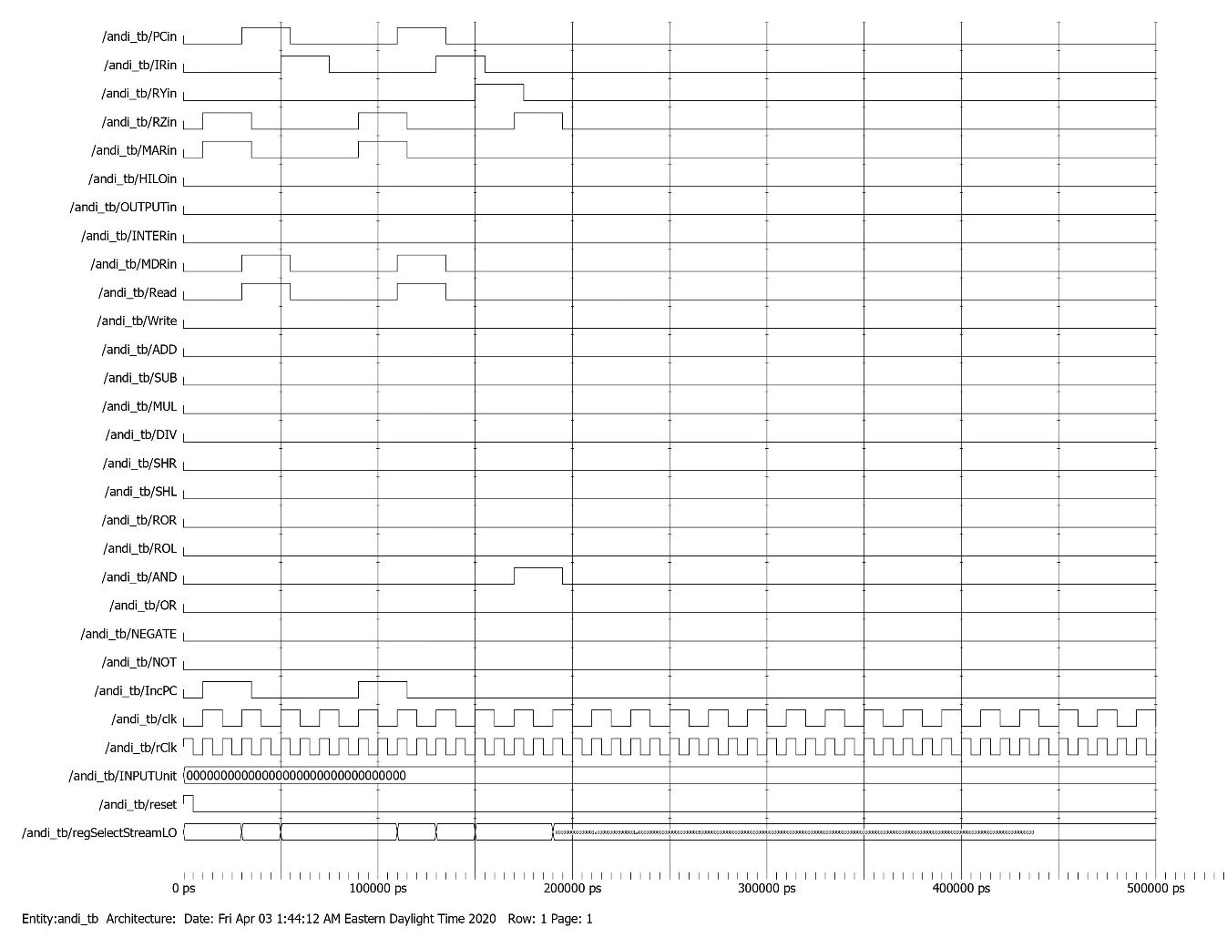

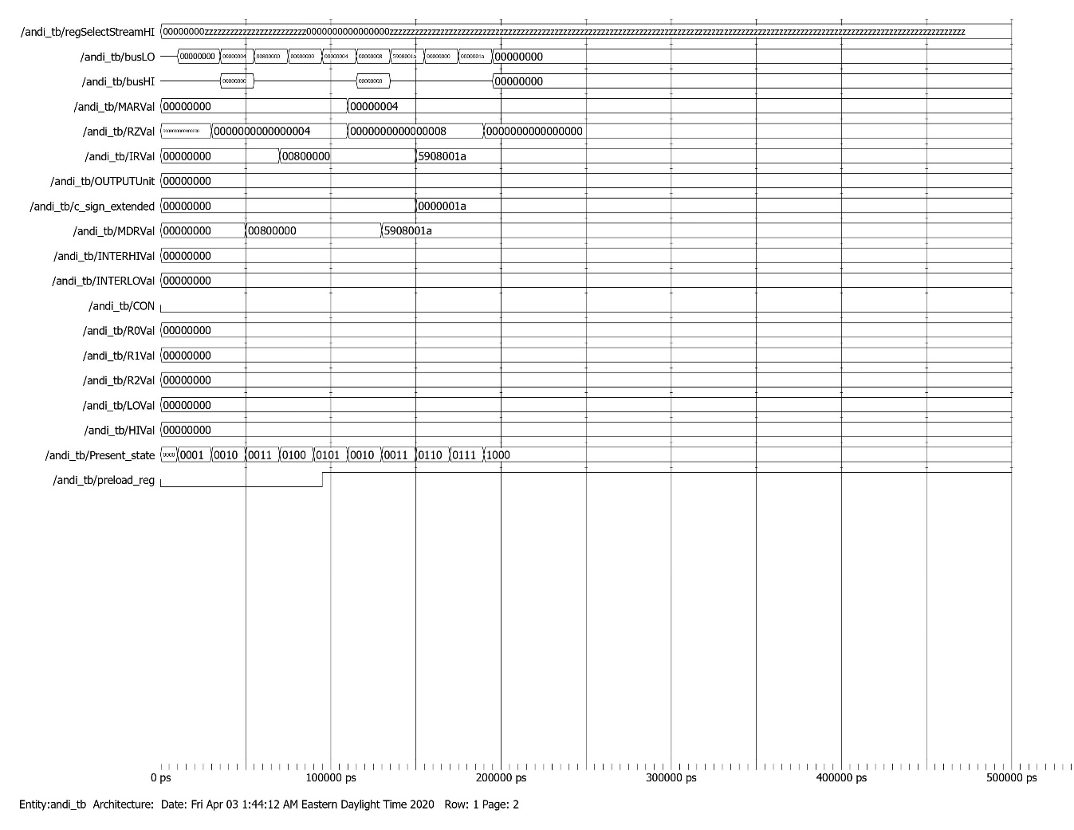

ORI Testbench

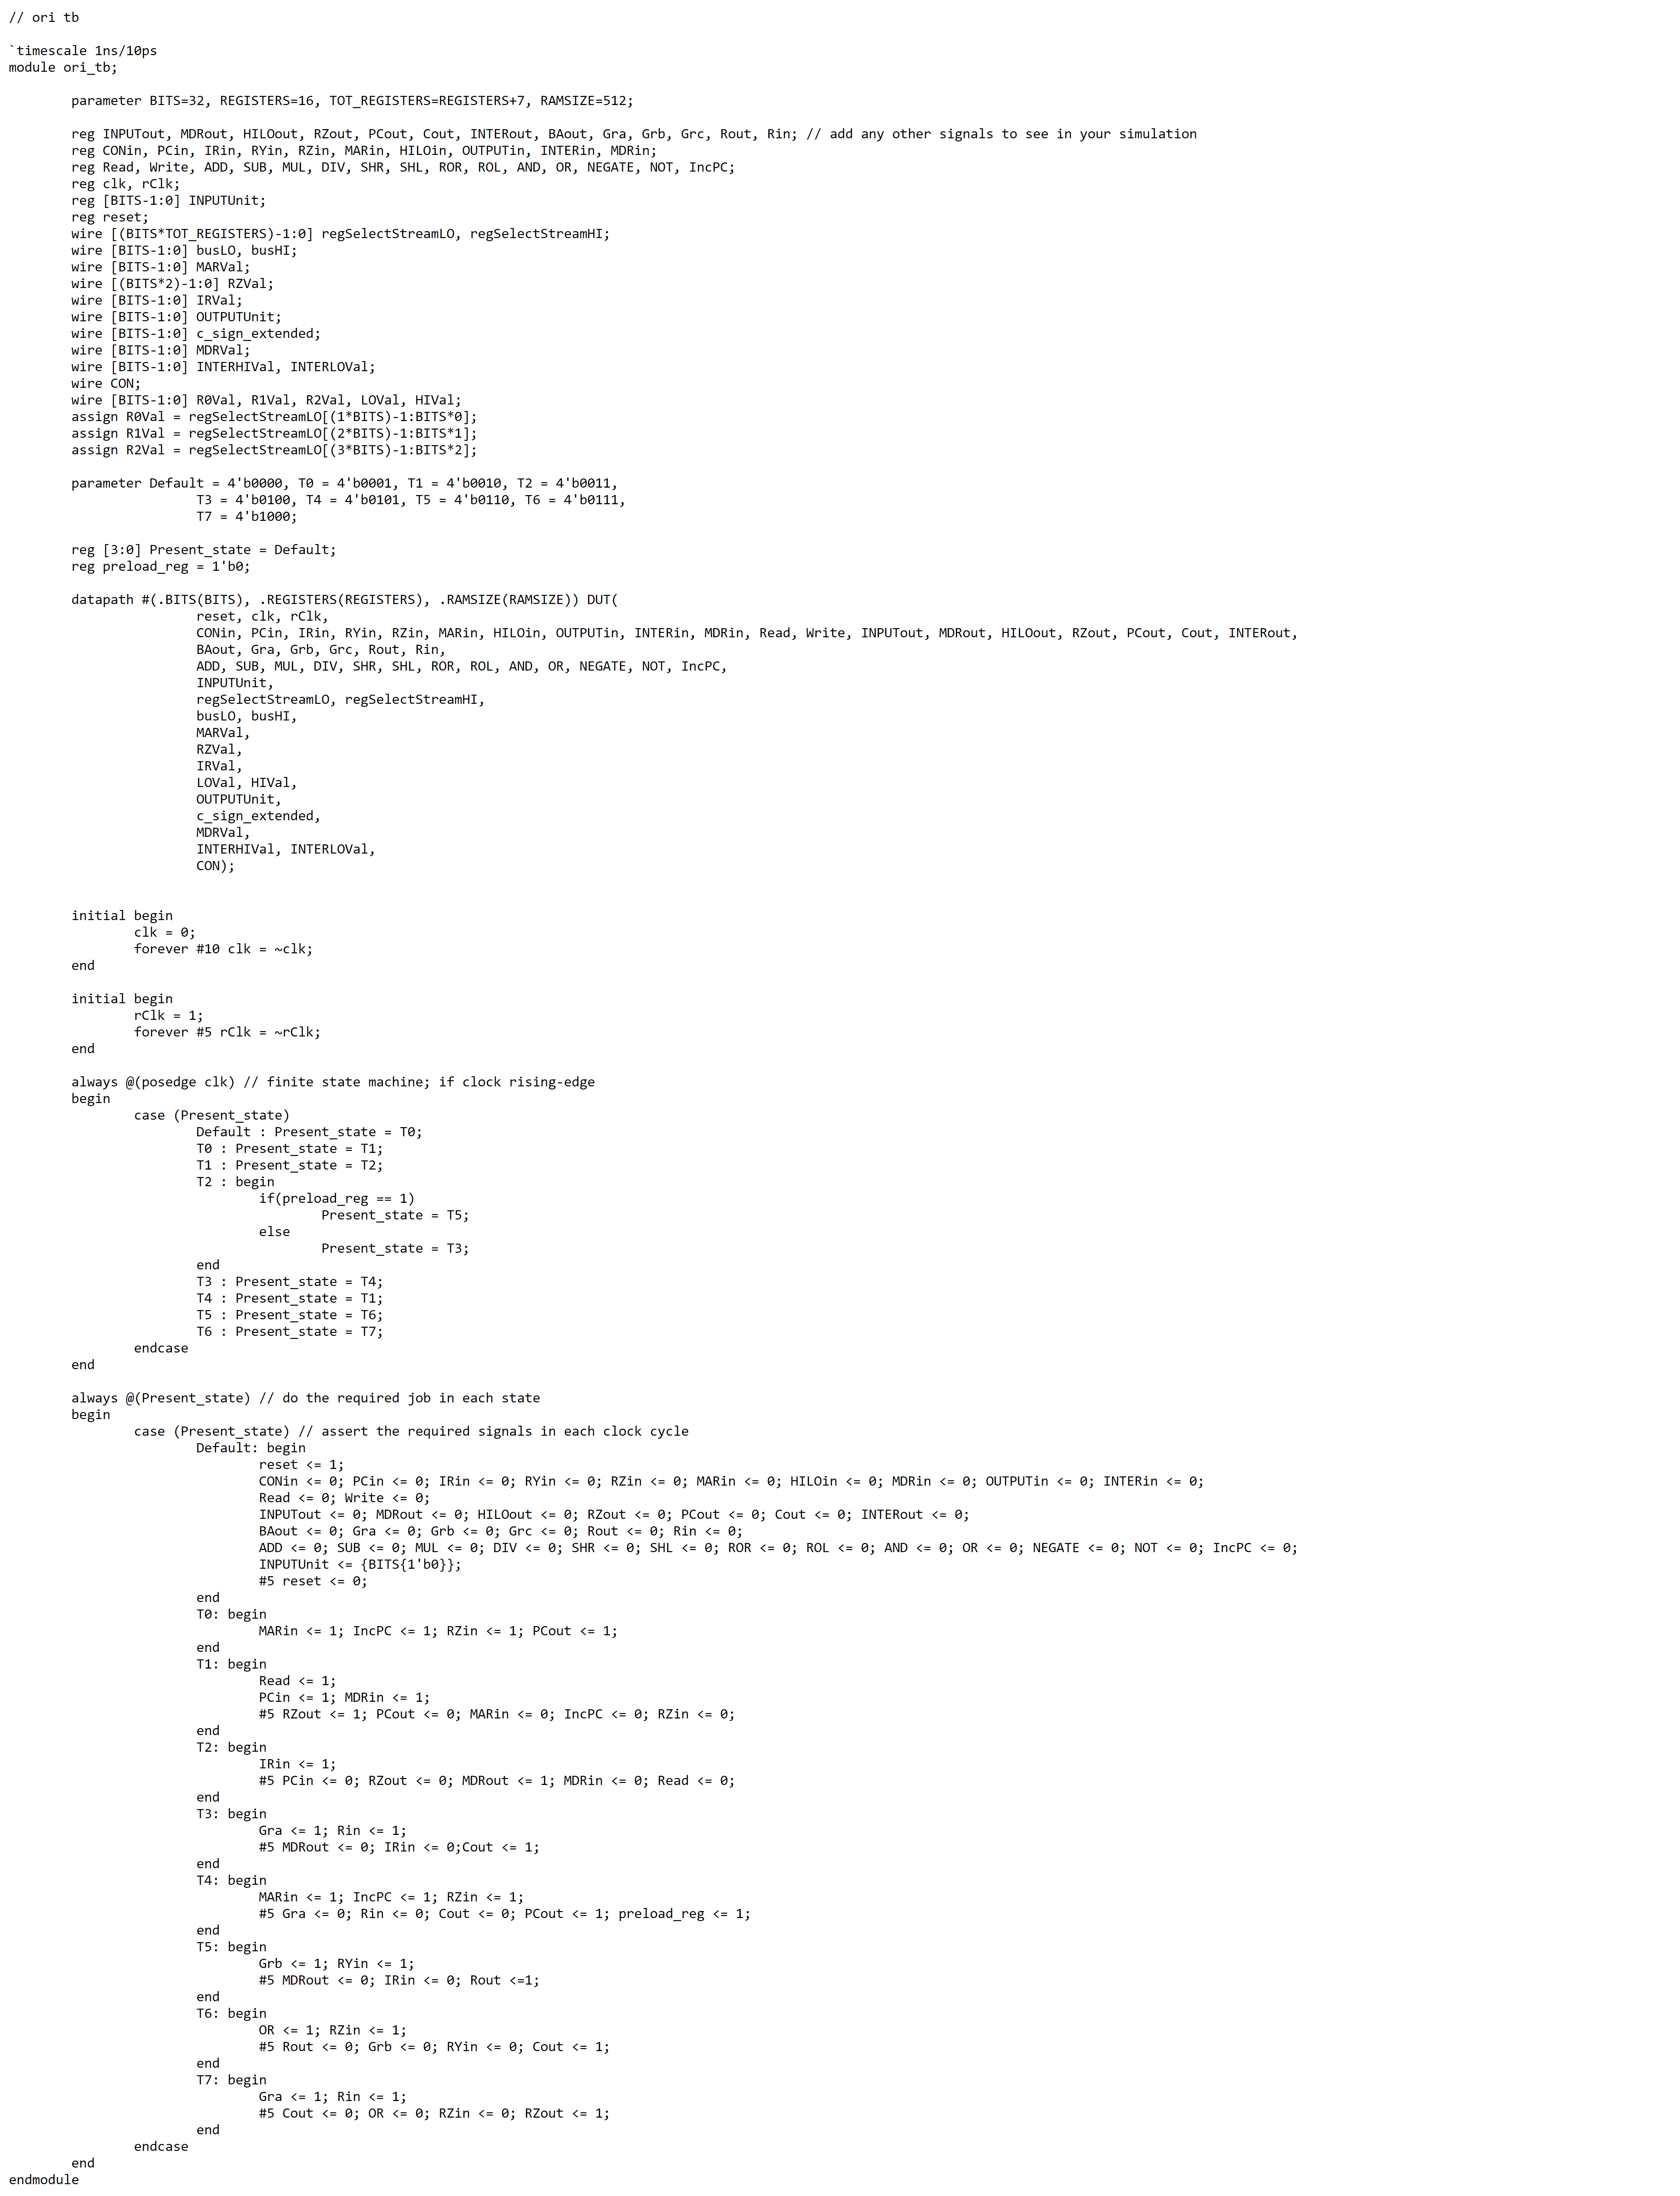

ORI Waveform

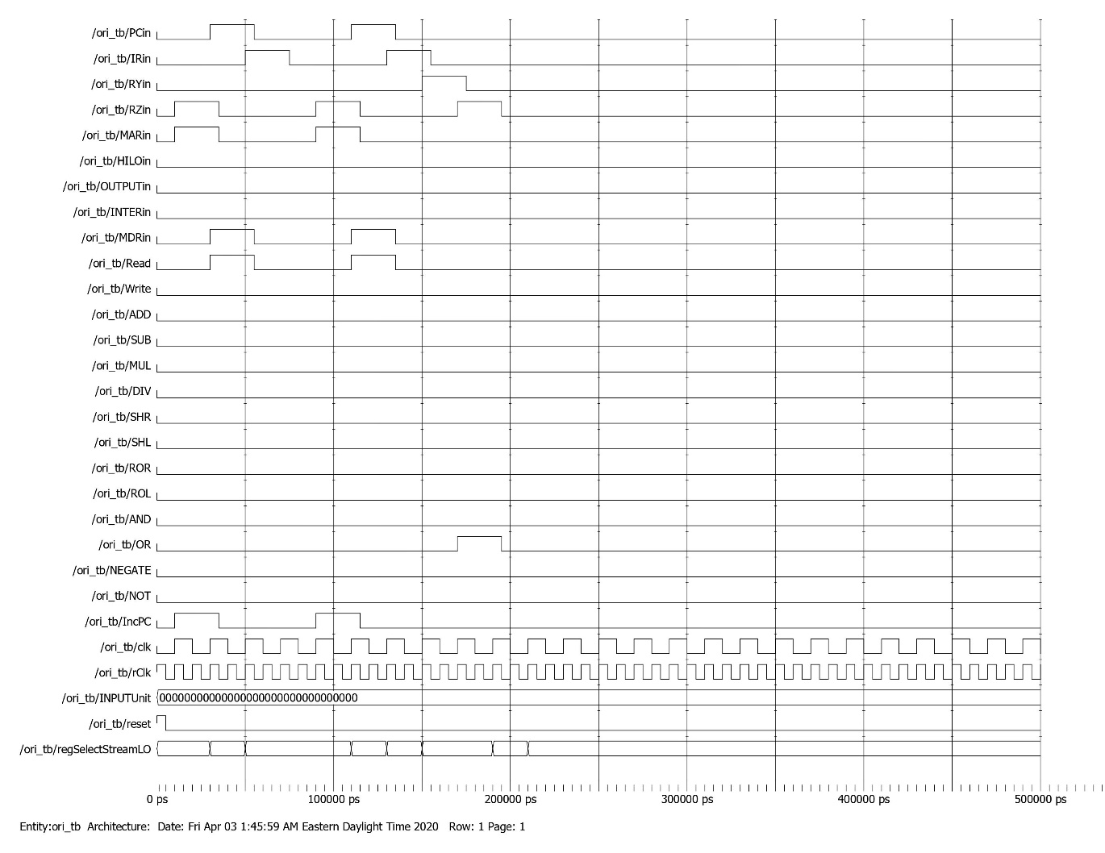

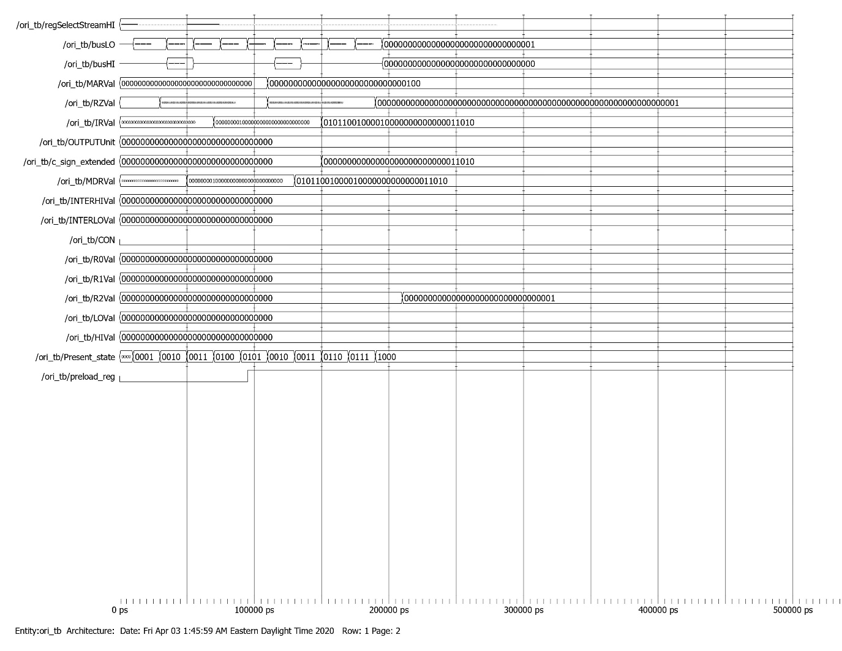

Branch Testbench

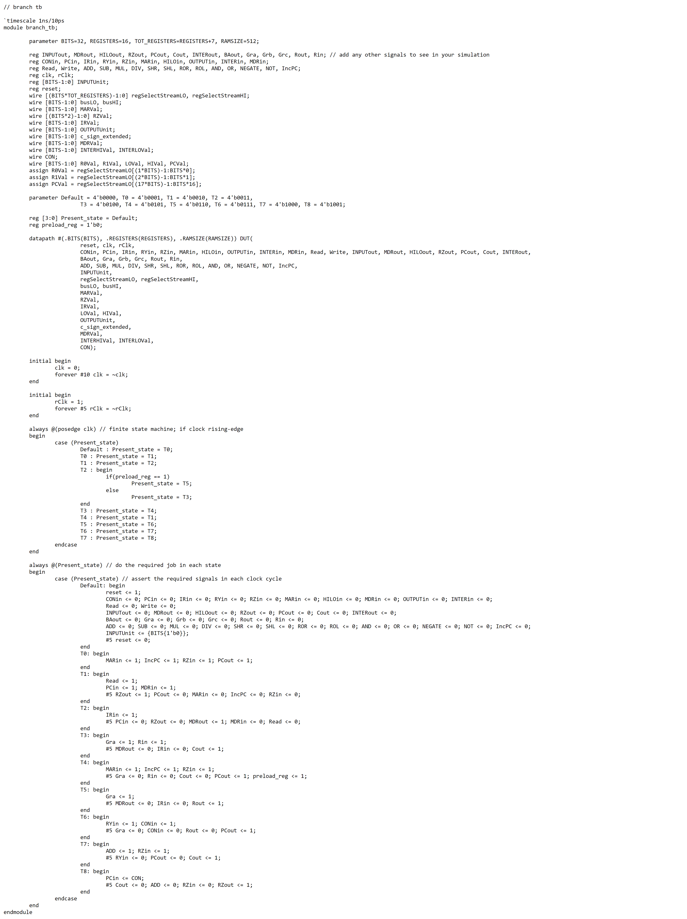

Branch Waveform

Branch Case 1

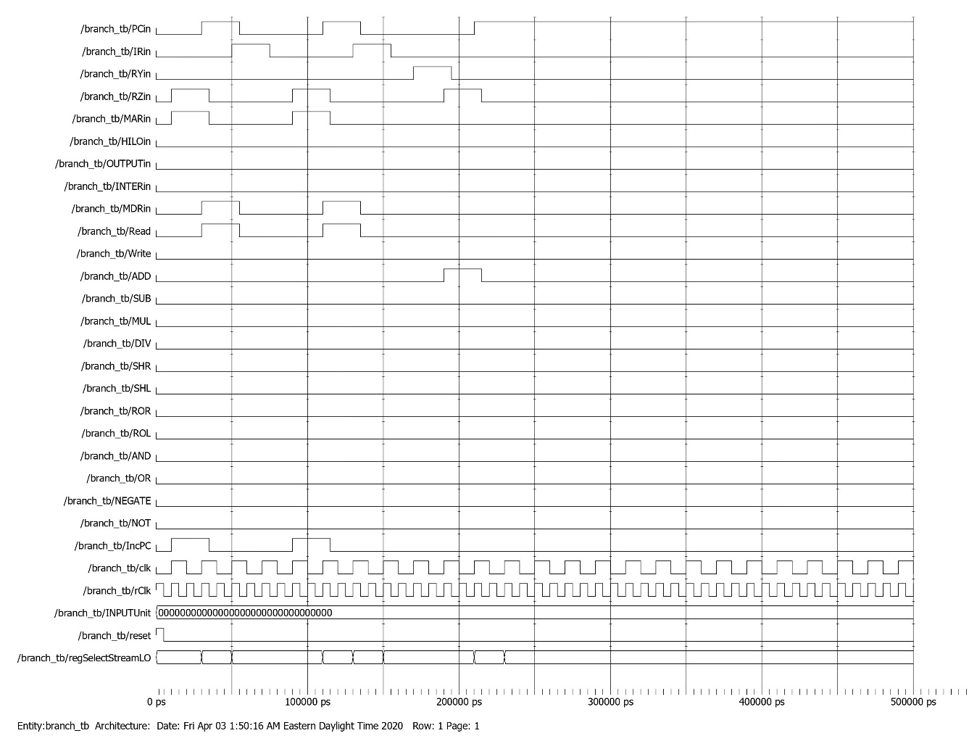

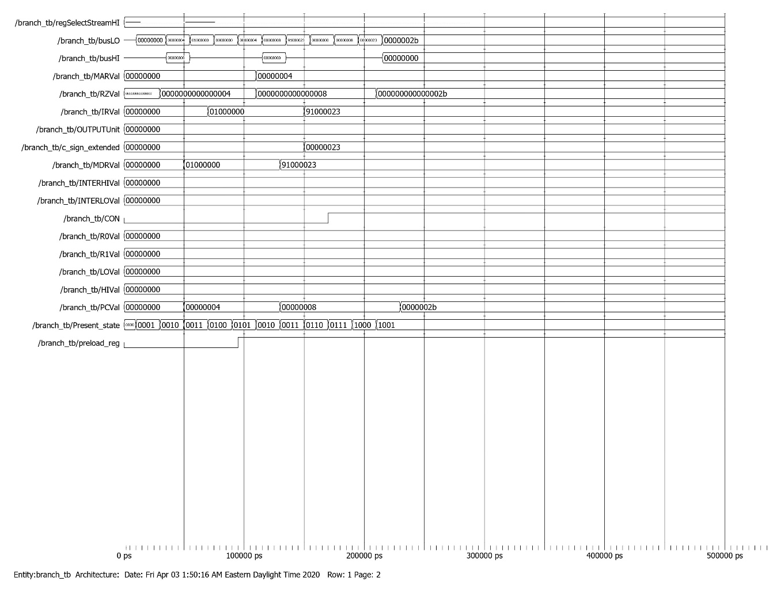

Branch Case 2

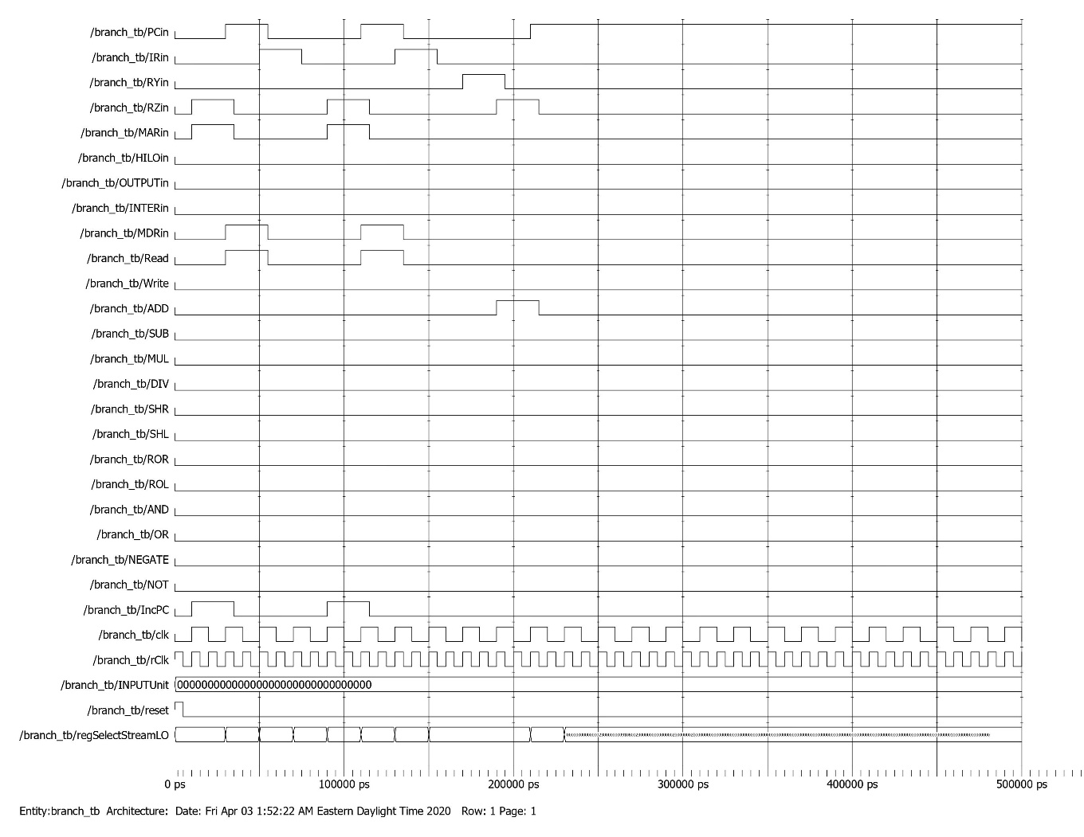

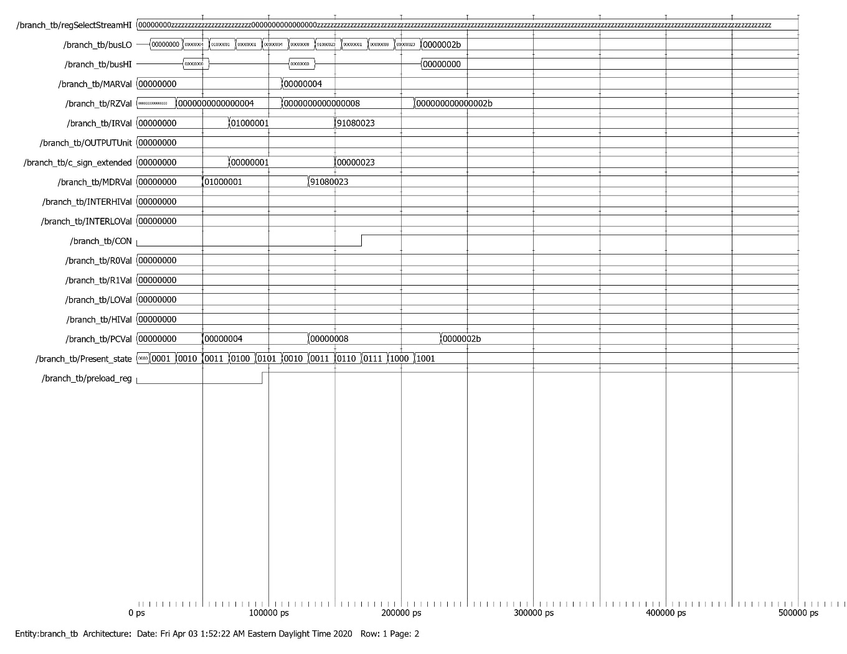

Branch Case 3

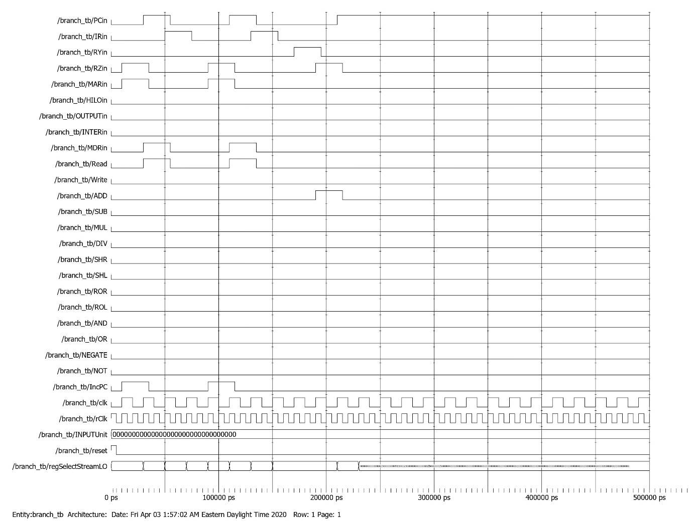

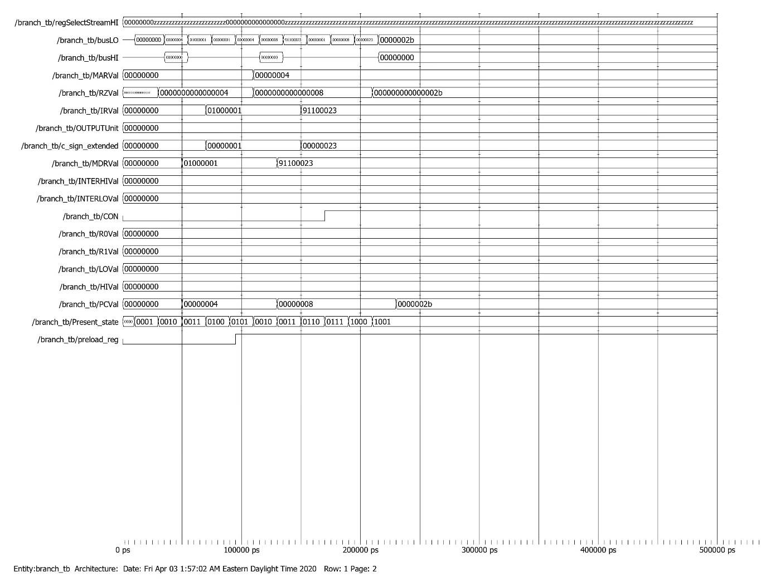

Branch Case 4

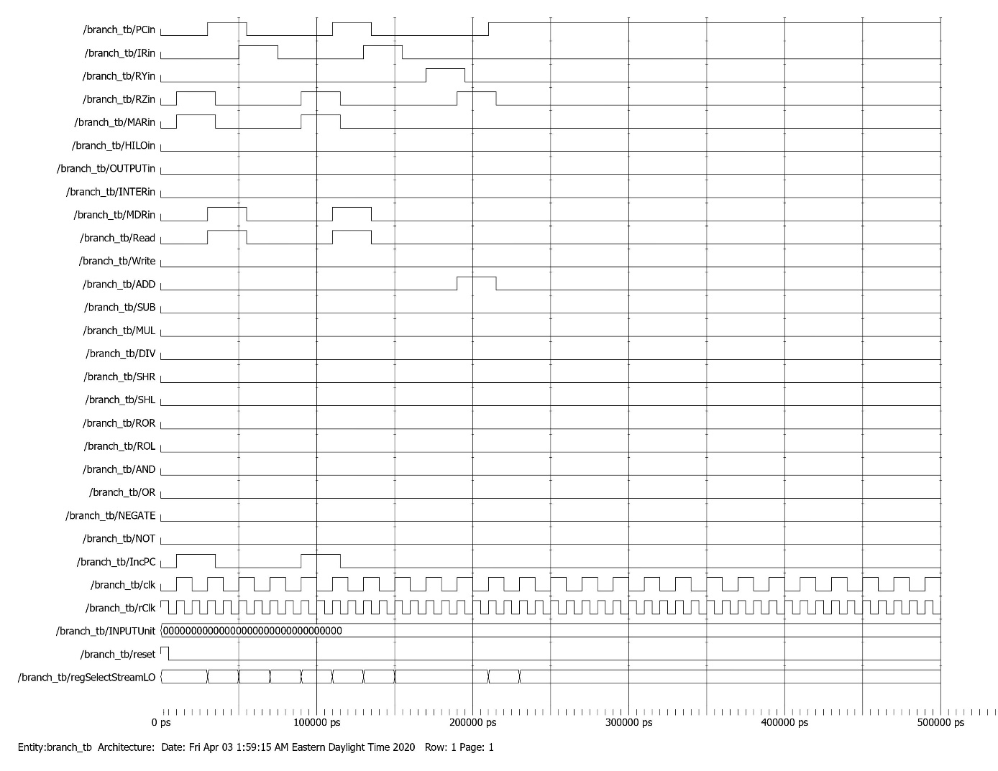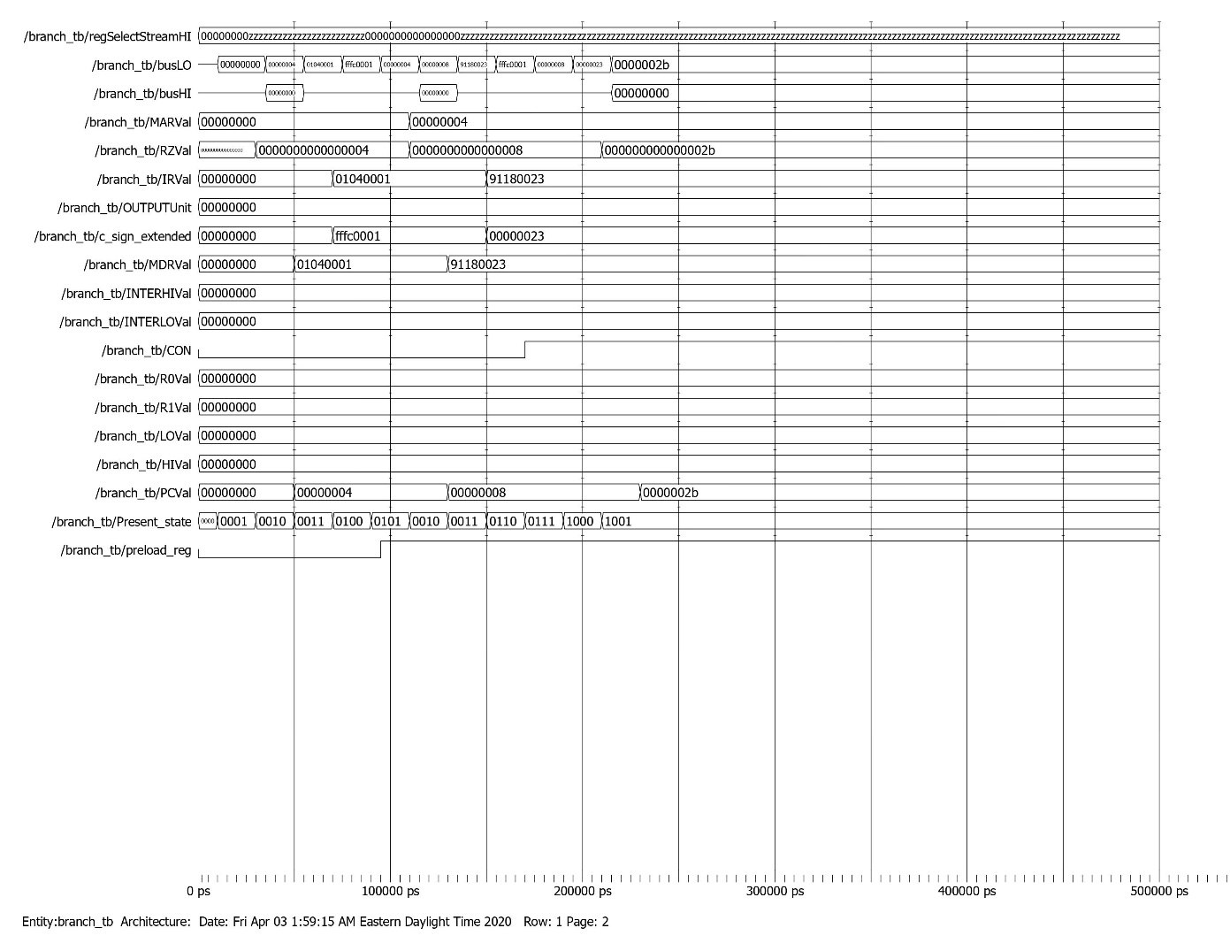

JR Testbench

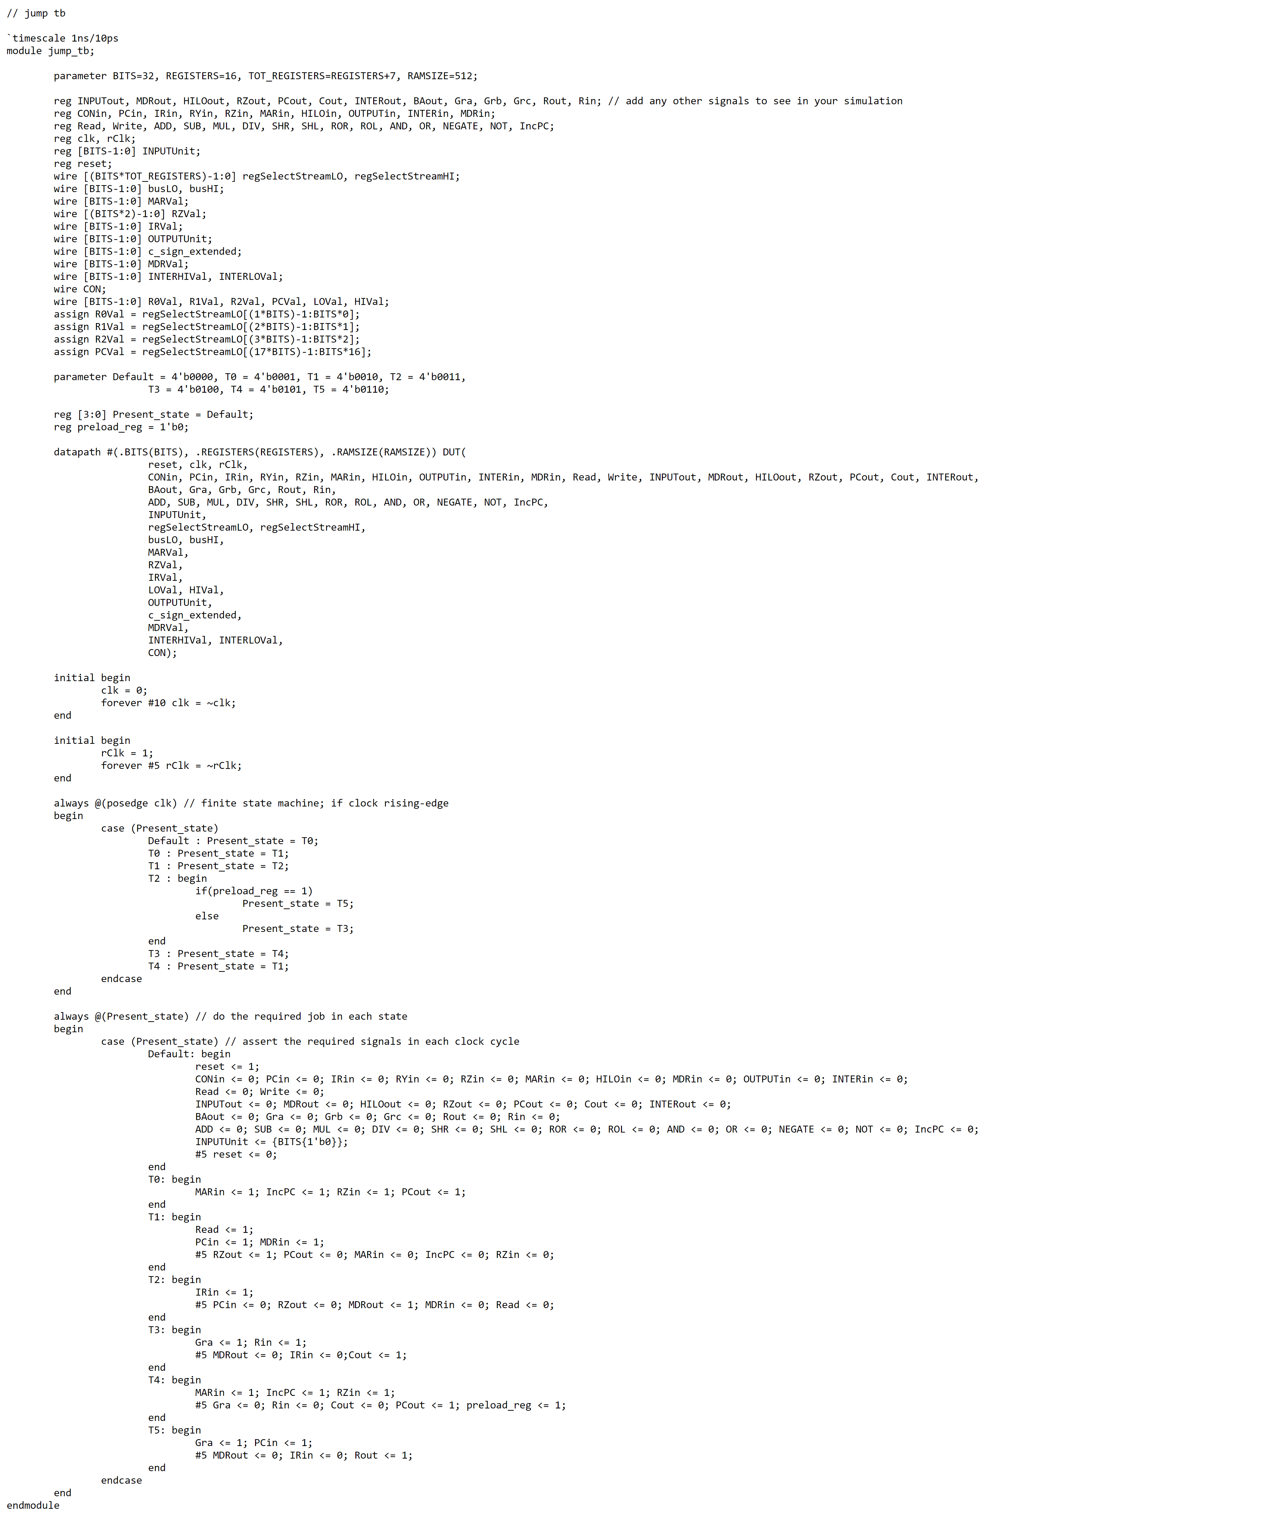

JR Waveform

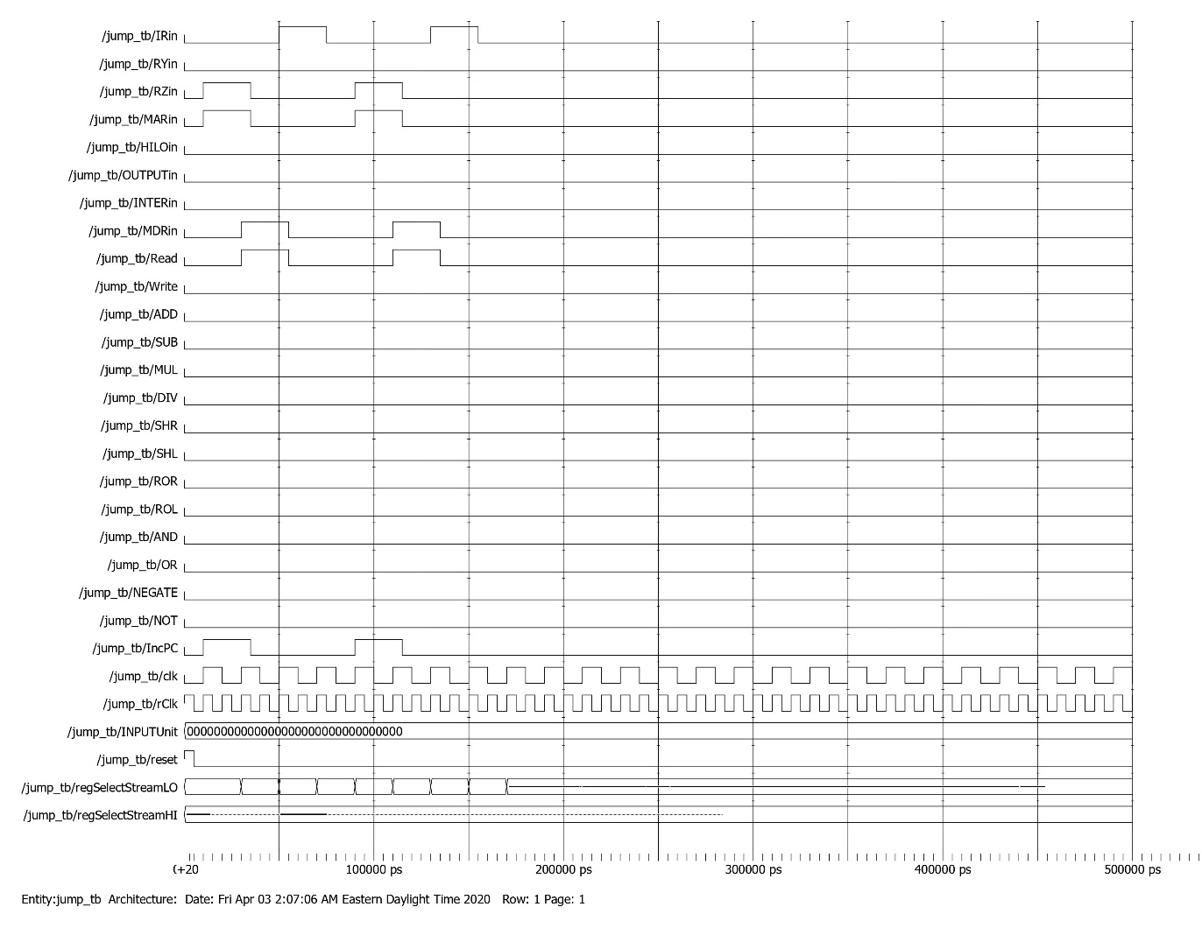

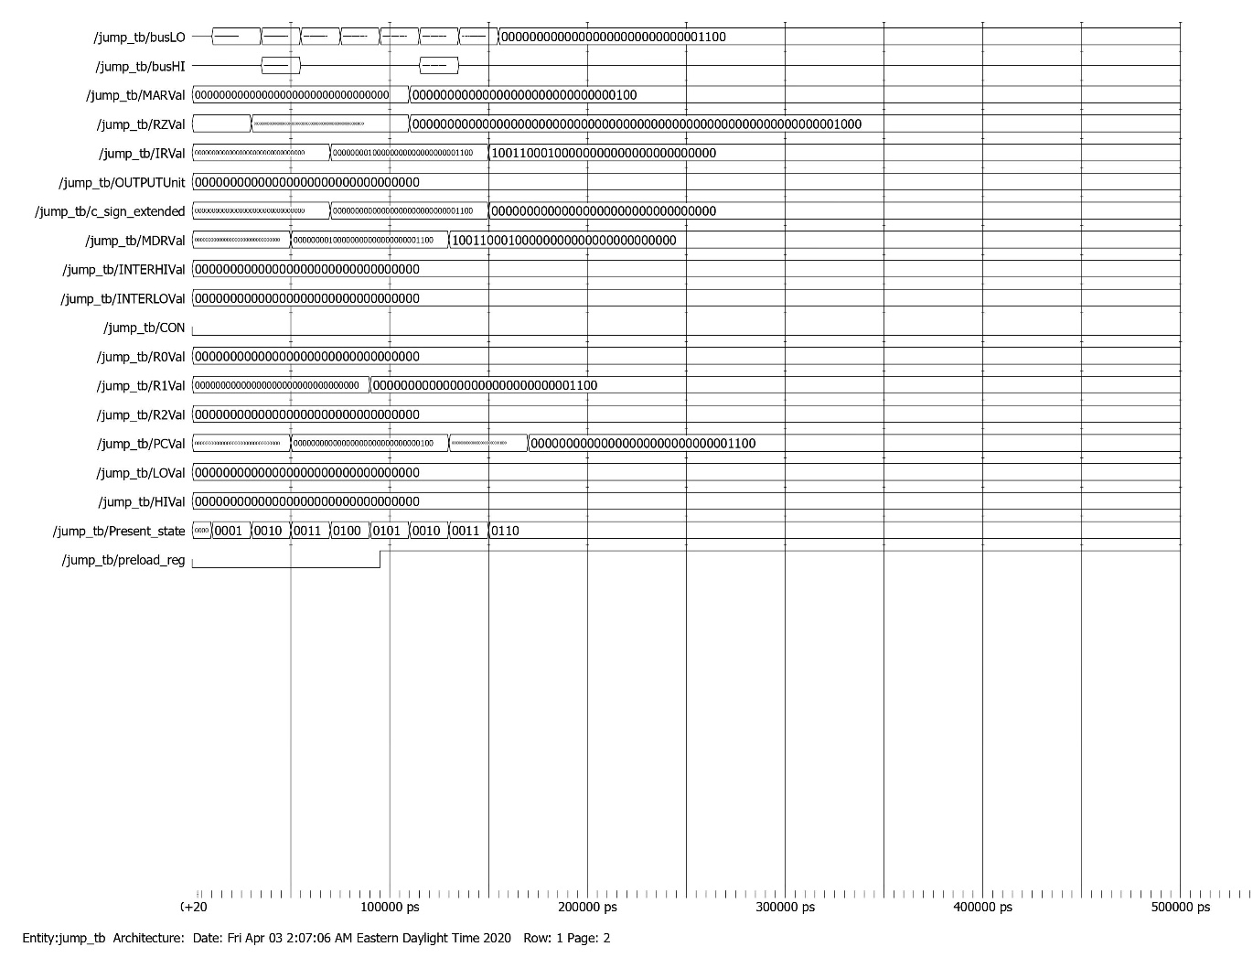

JAL Testbench

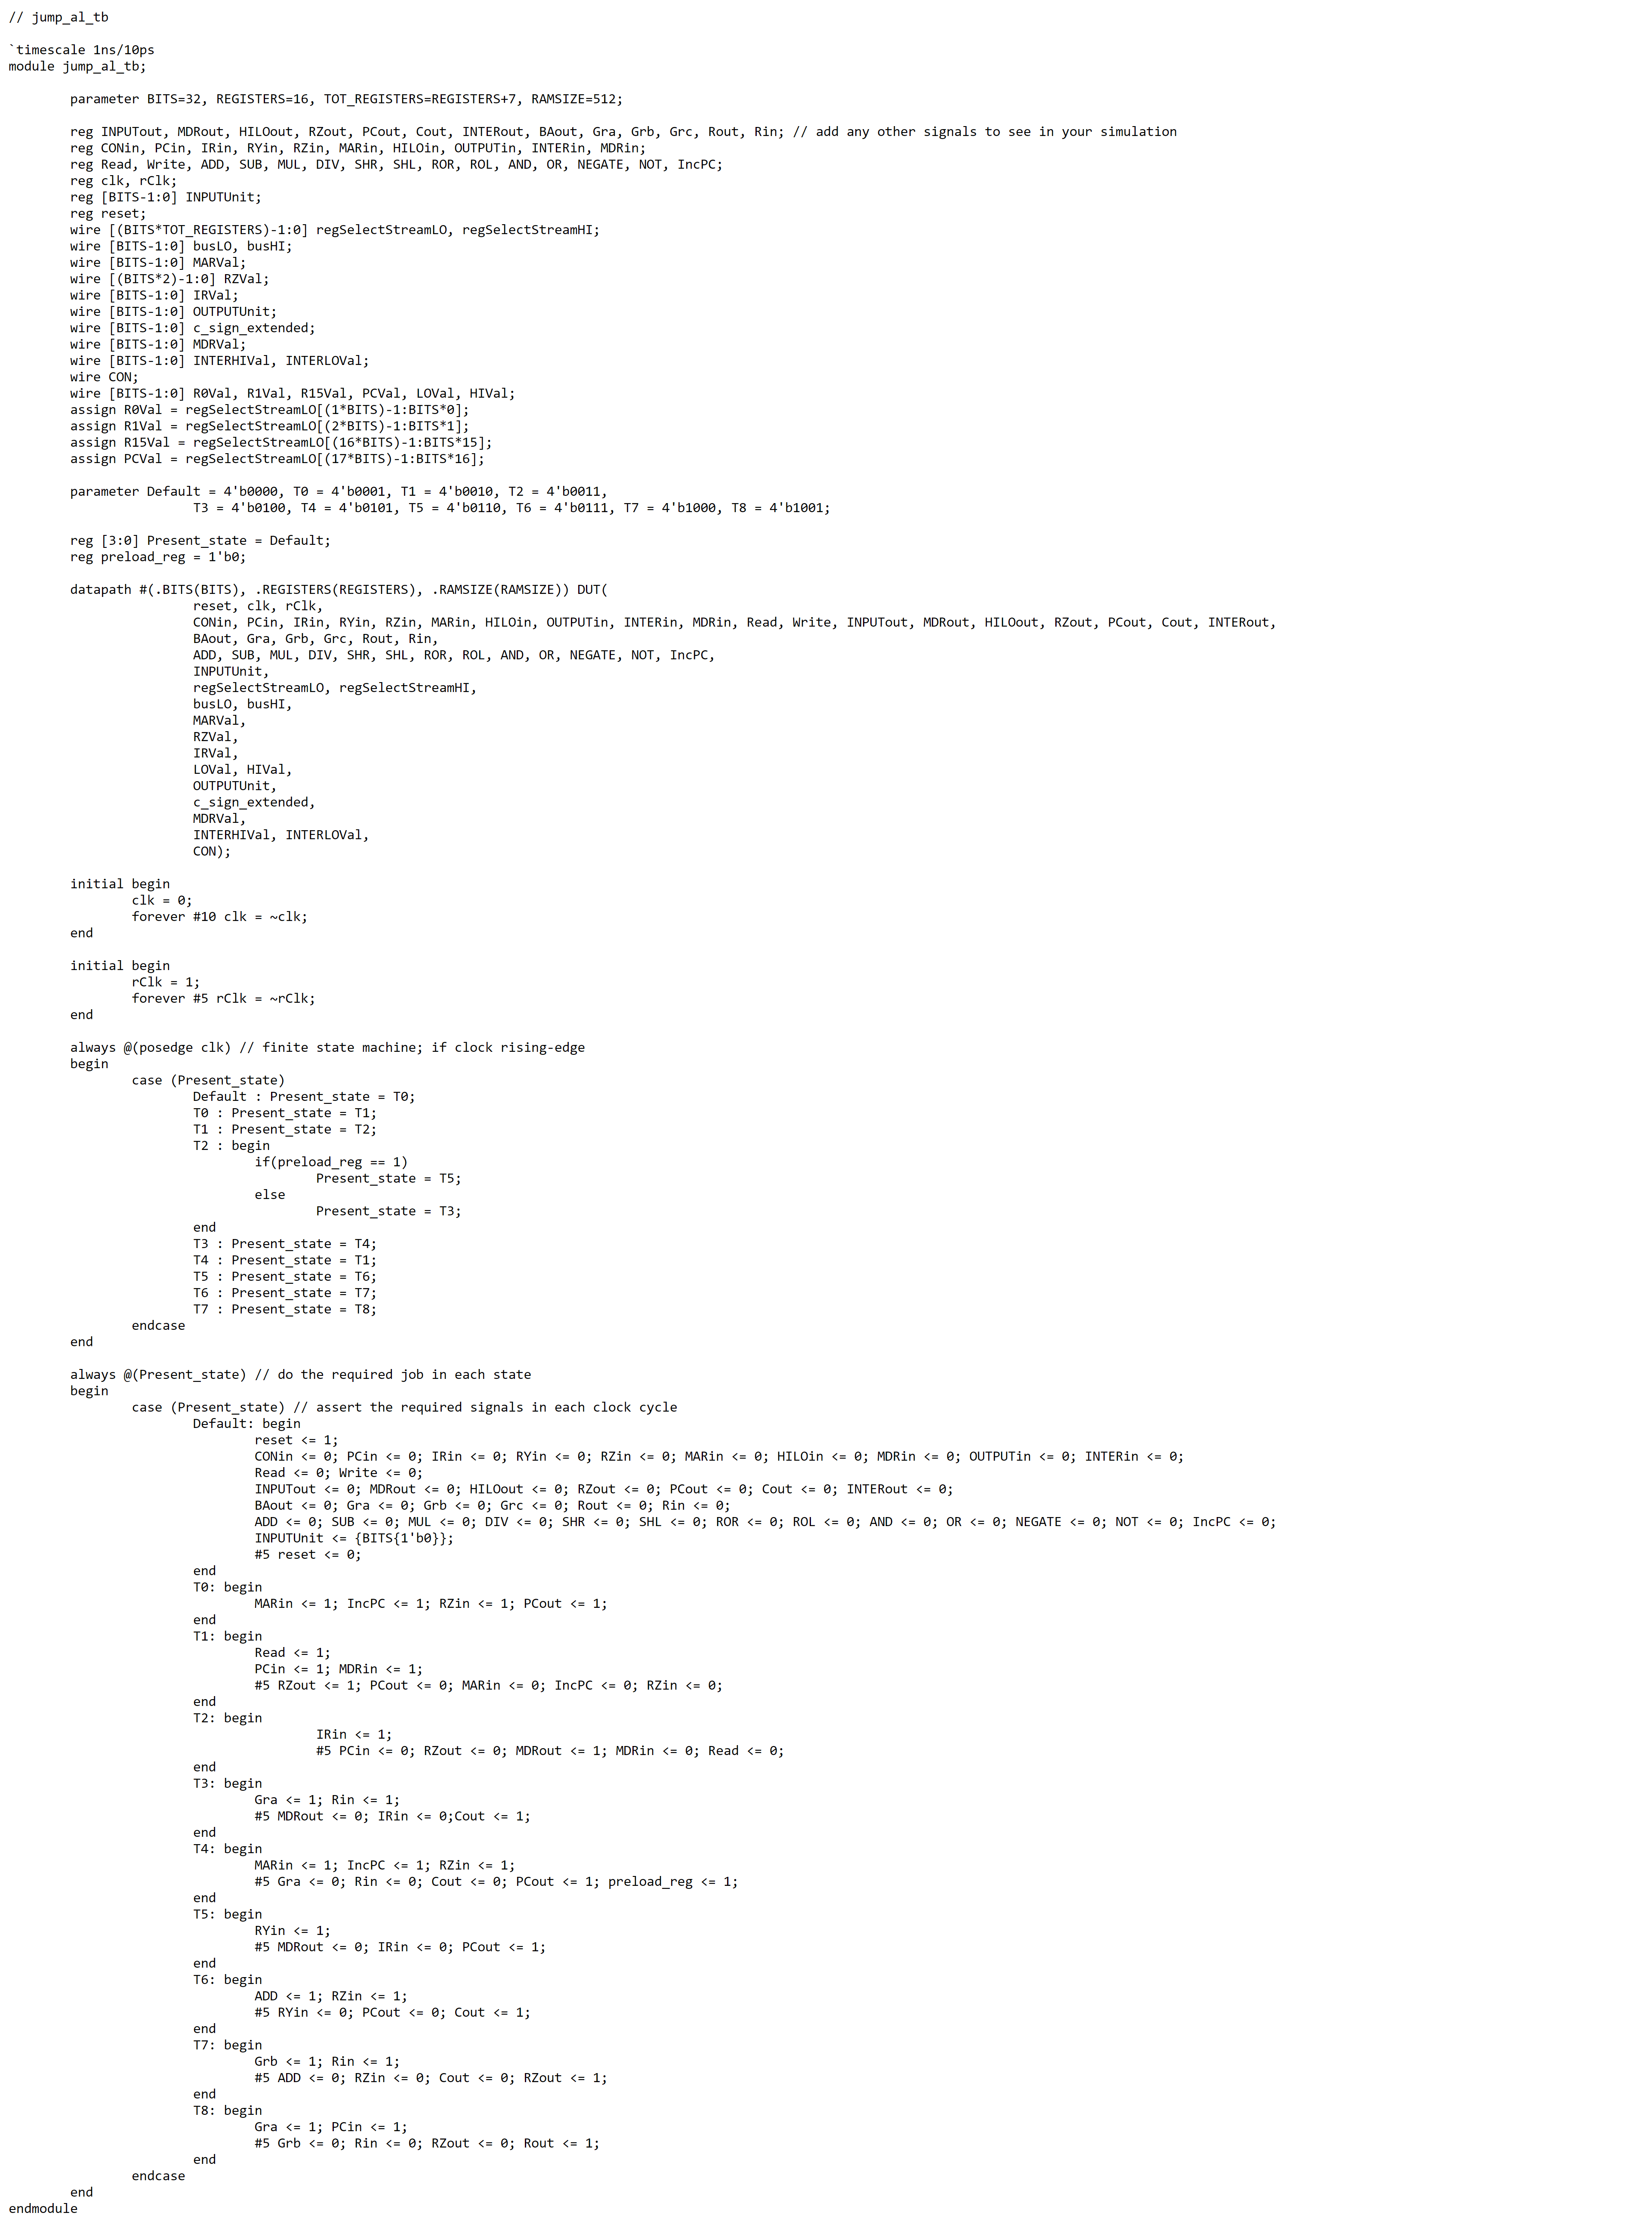

JAL Waveform

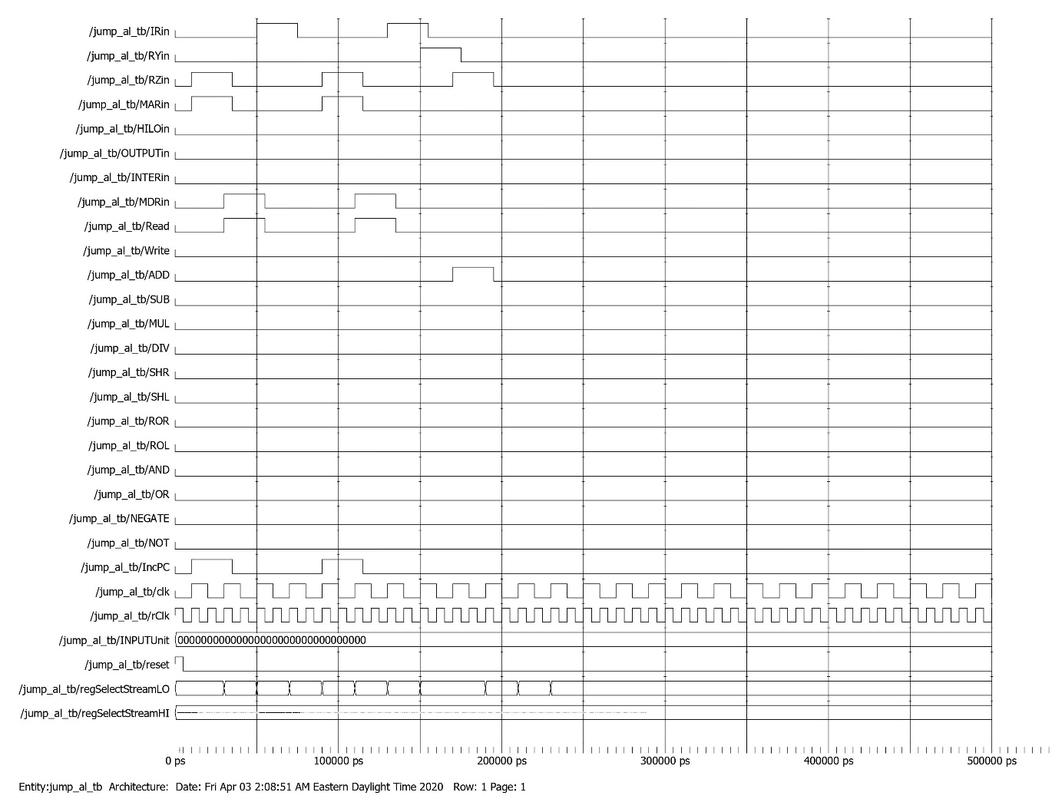

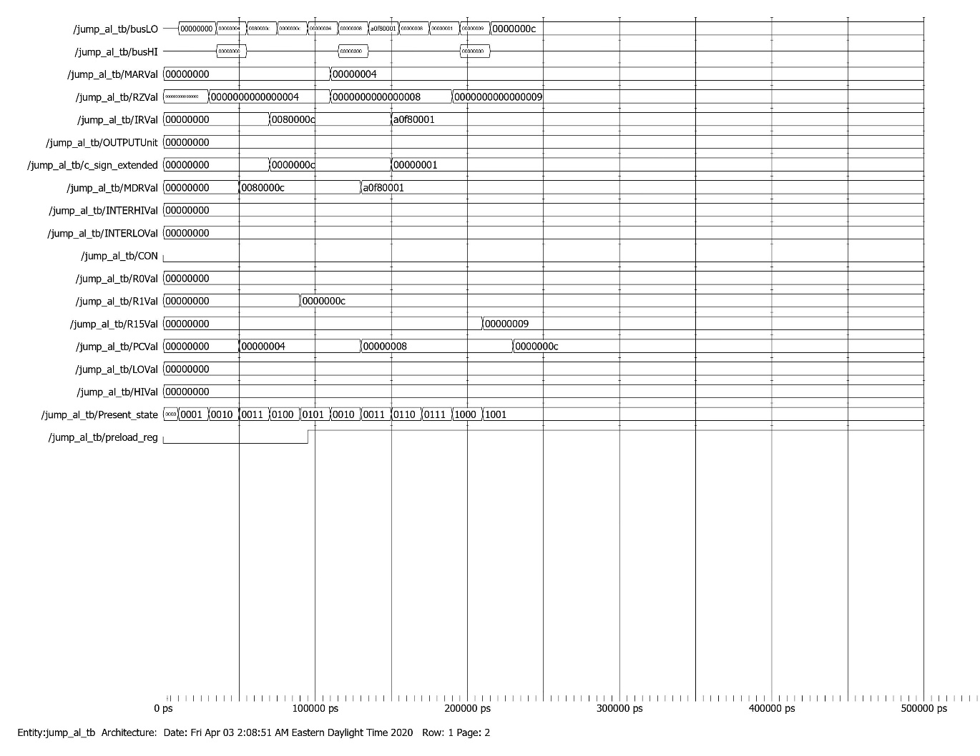

MFHI Testbench

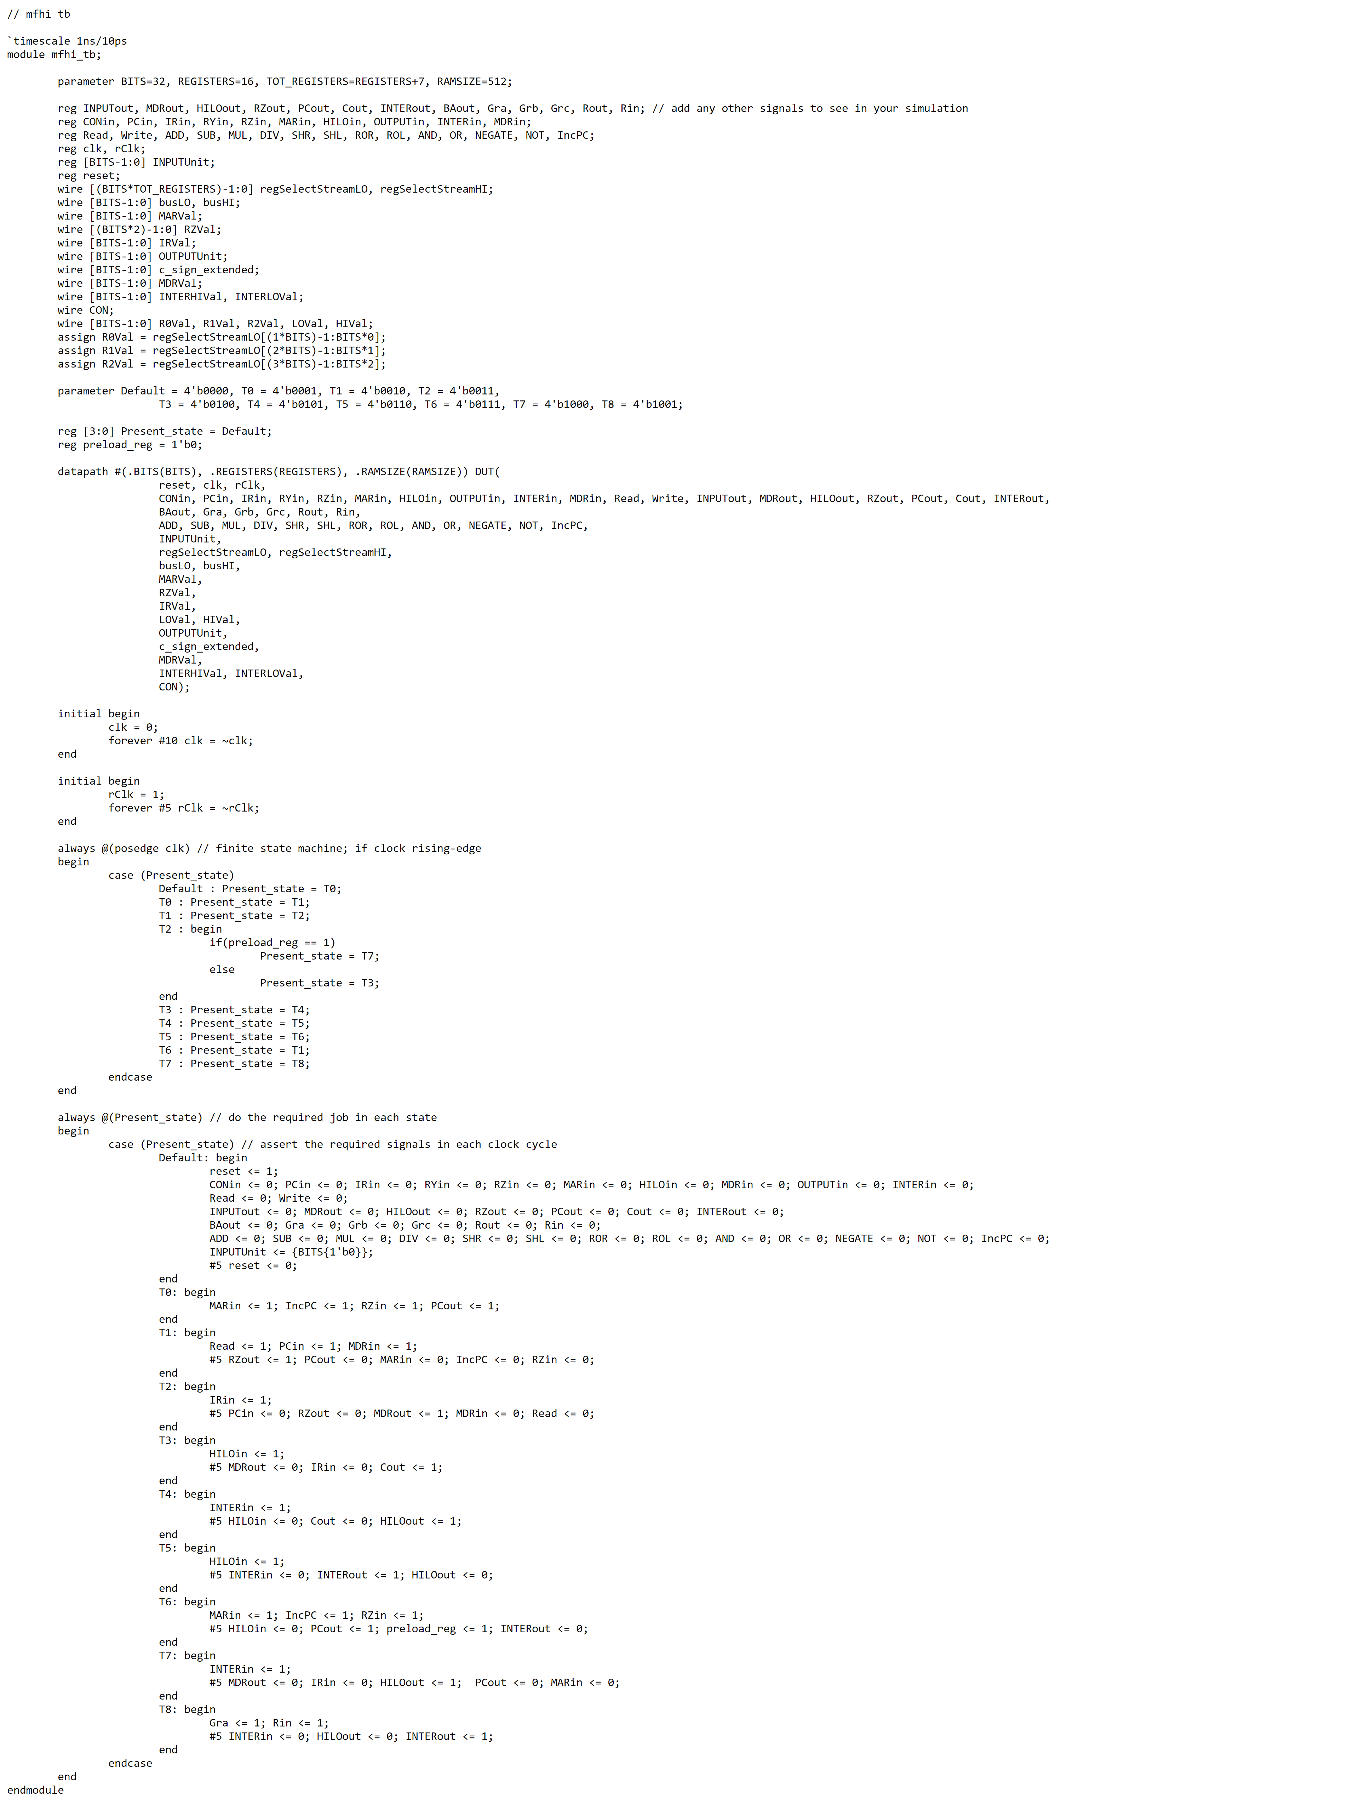

MFHI Waveform

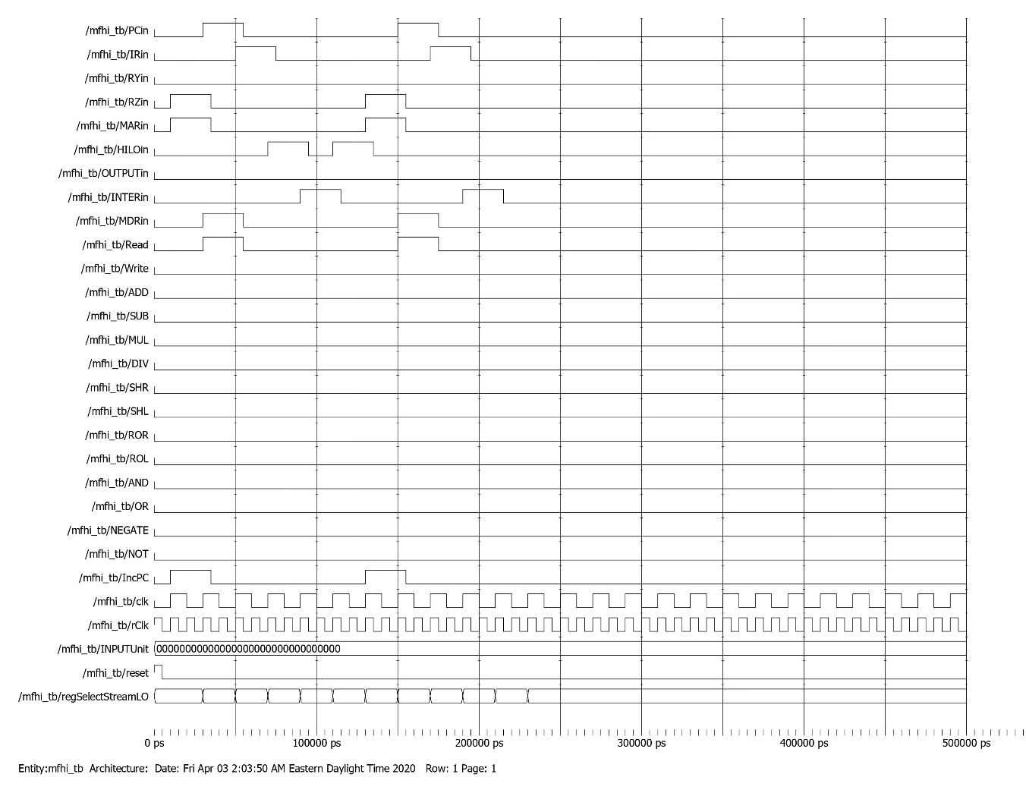

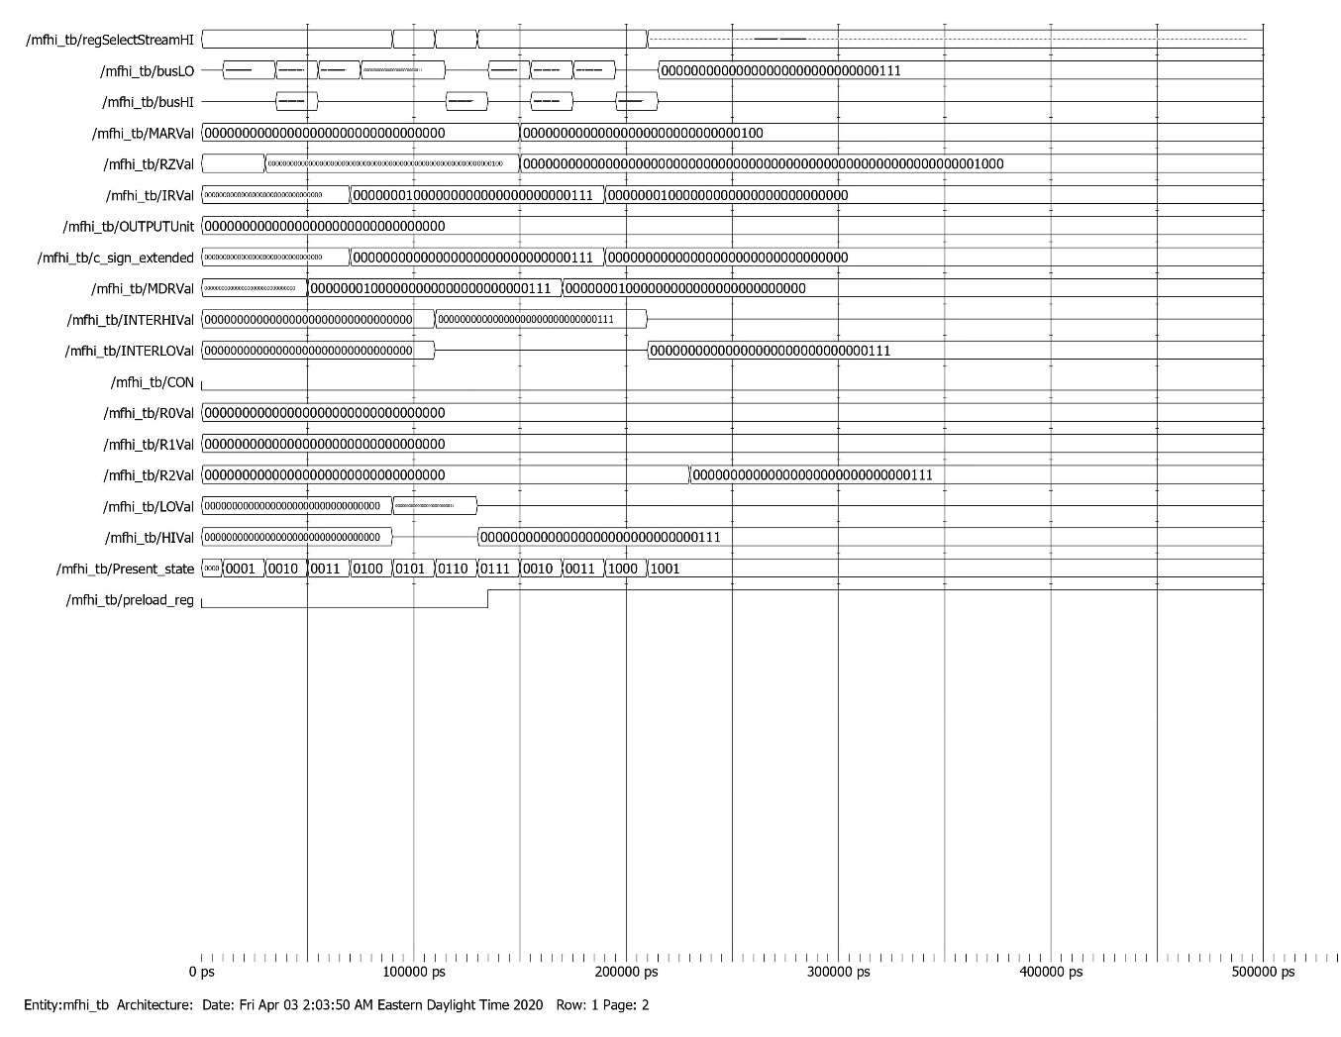

MFLO Testbench

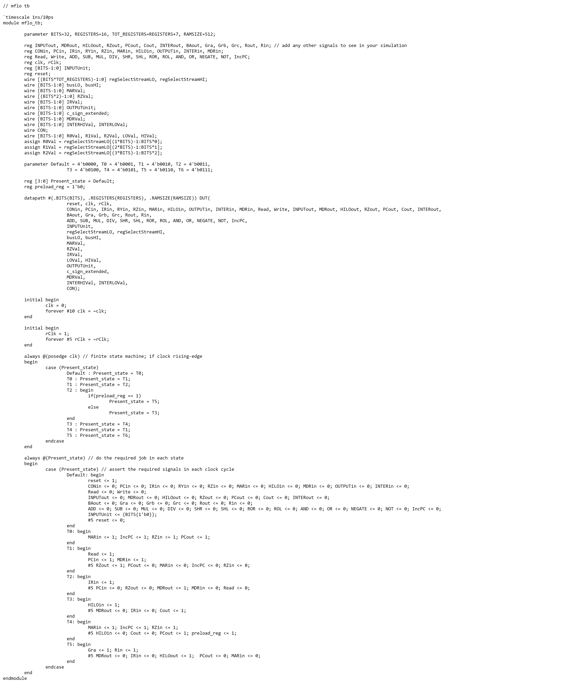

MFLO Waveform

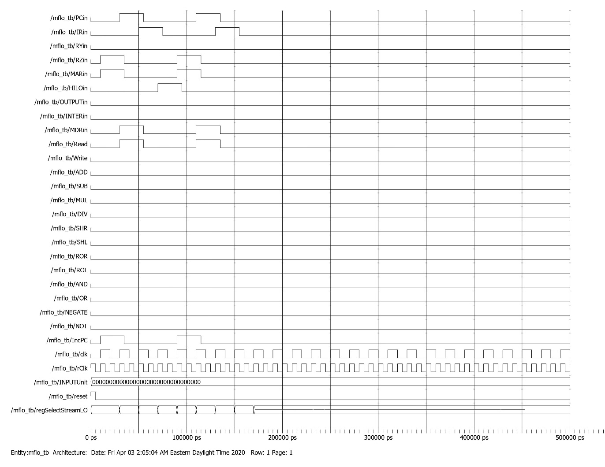

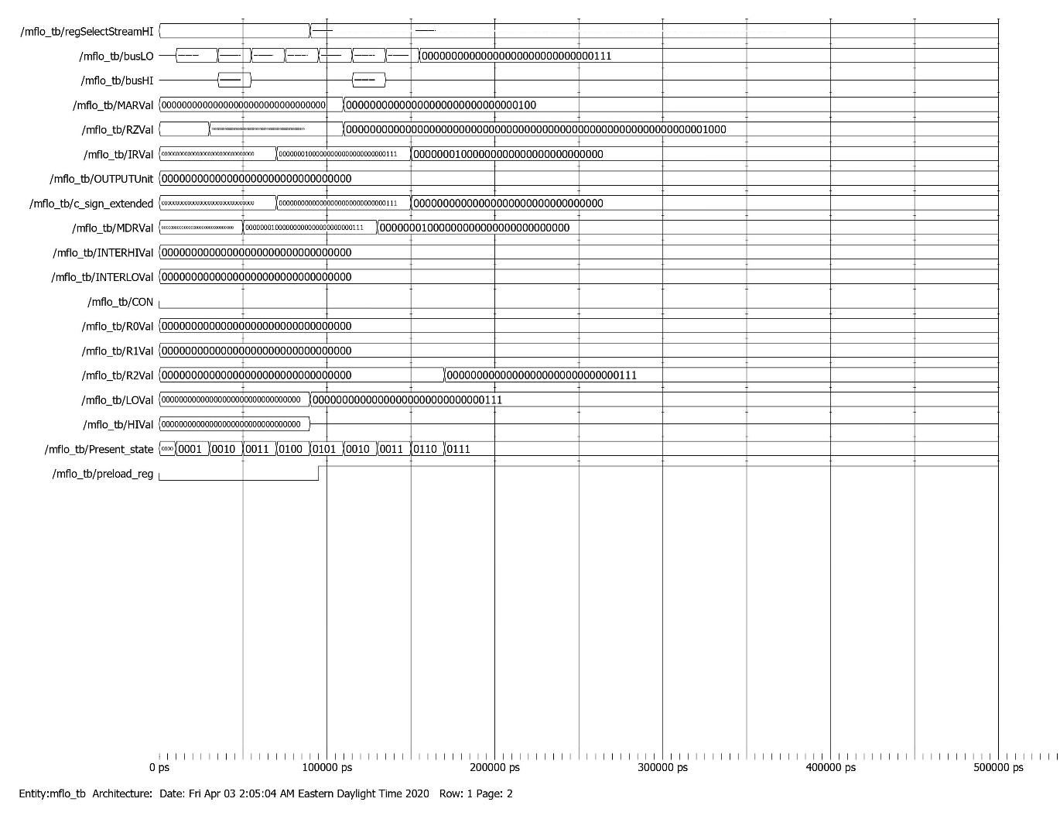

Input Testbench

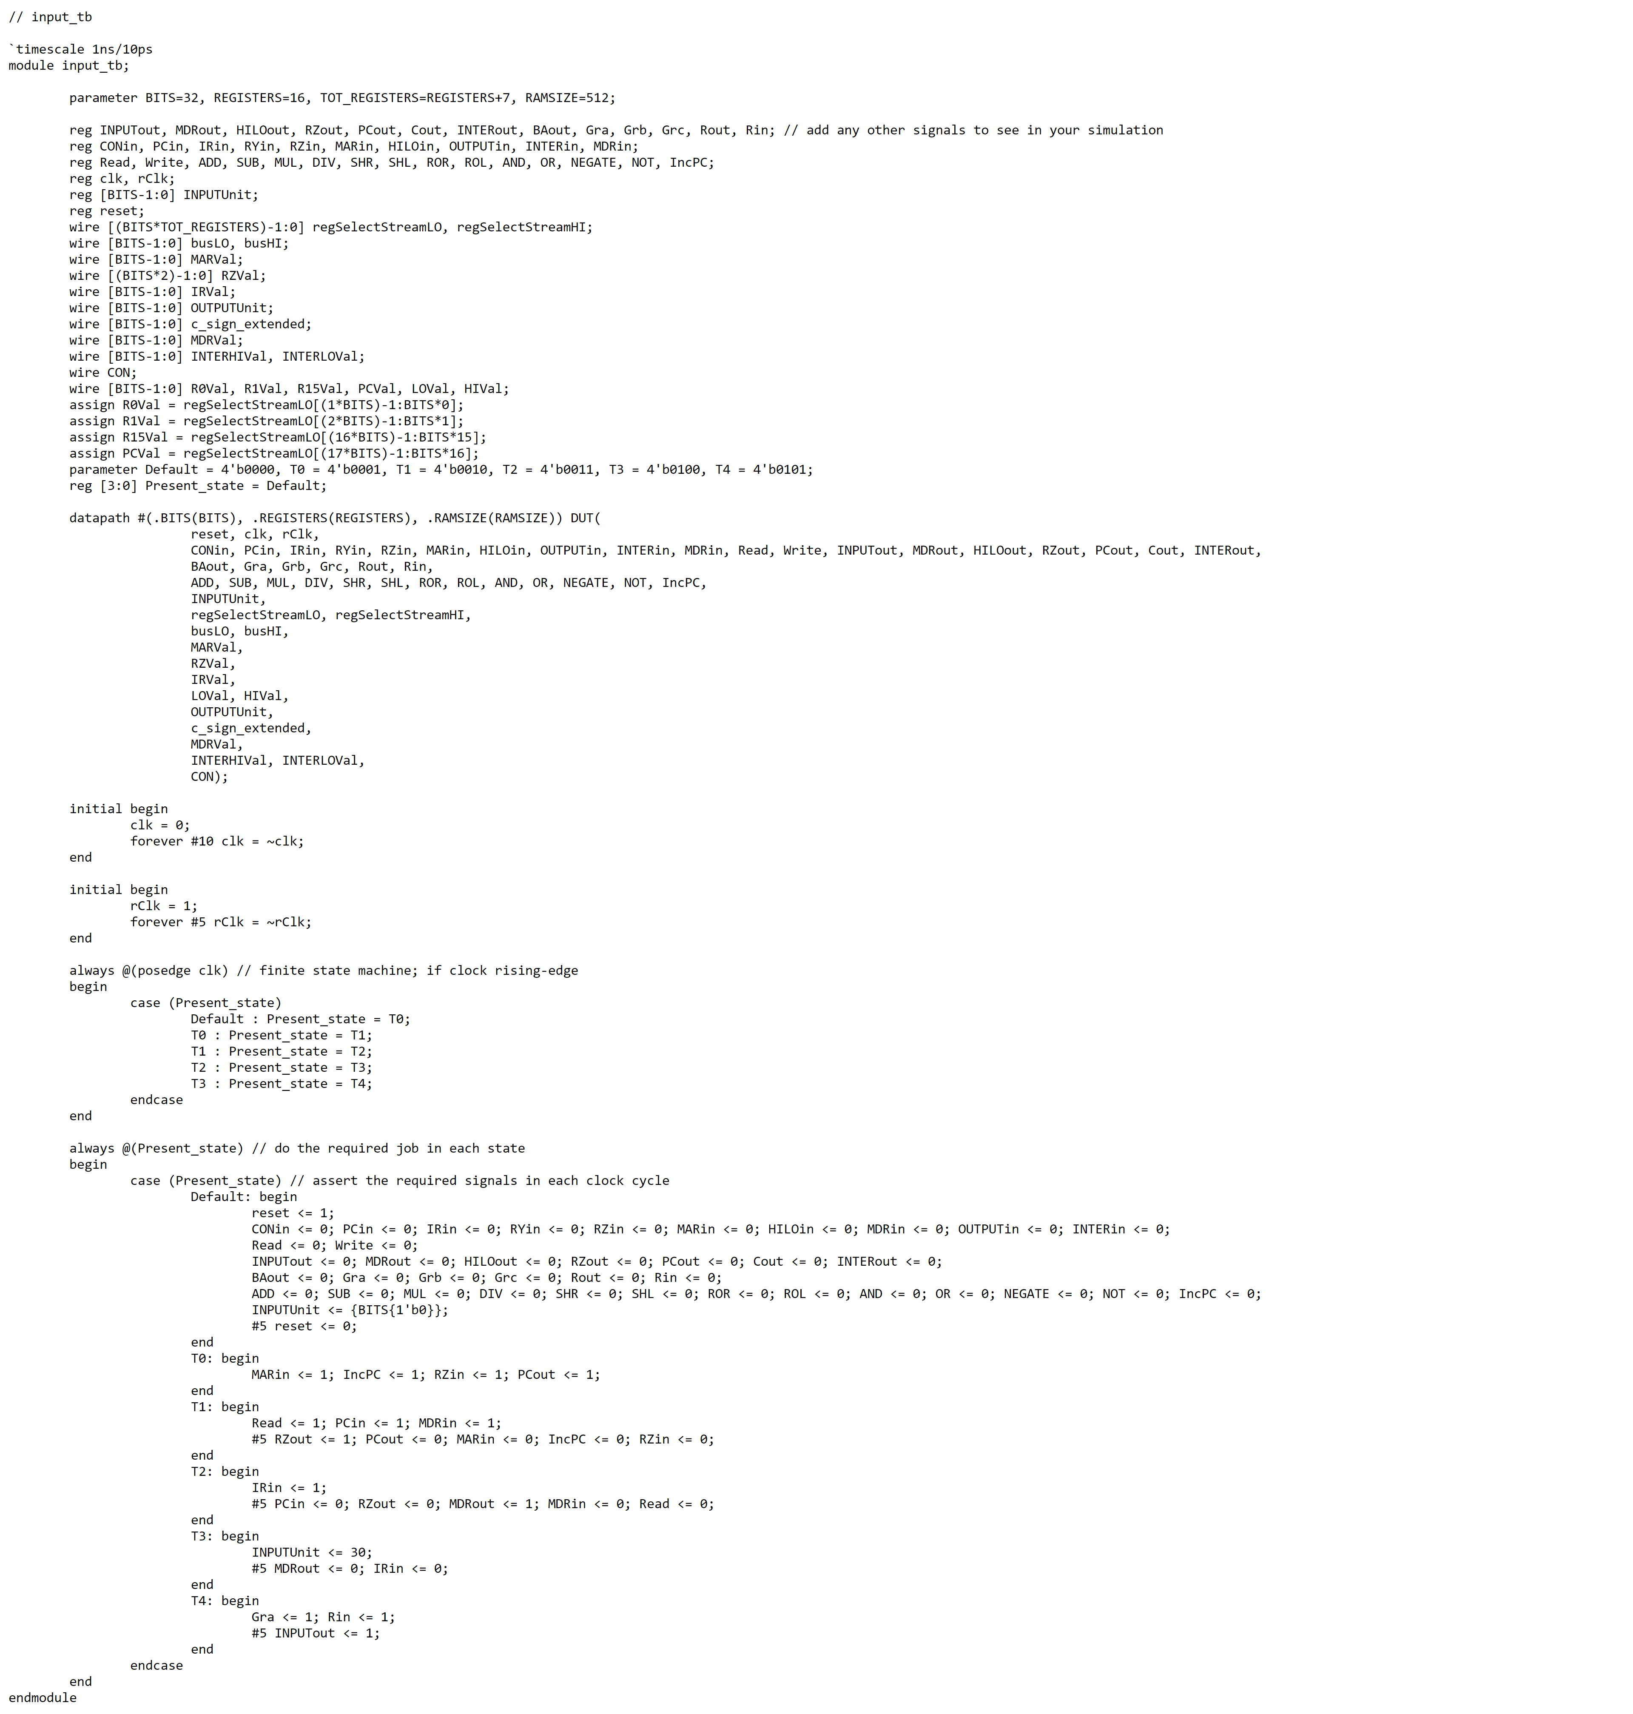

Input Waveform

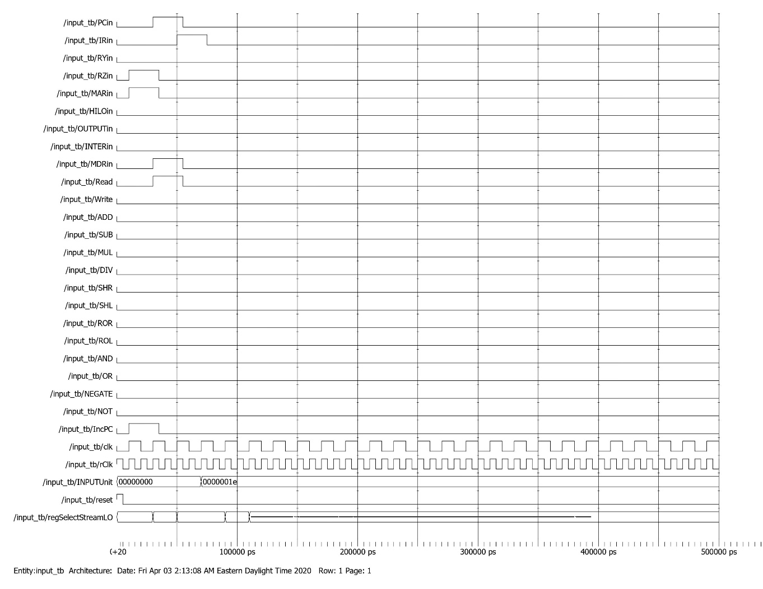

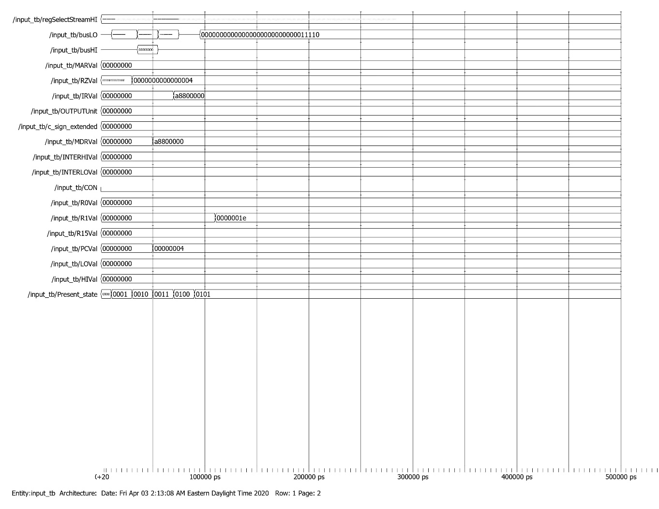

Output Testbench

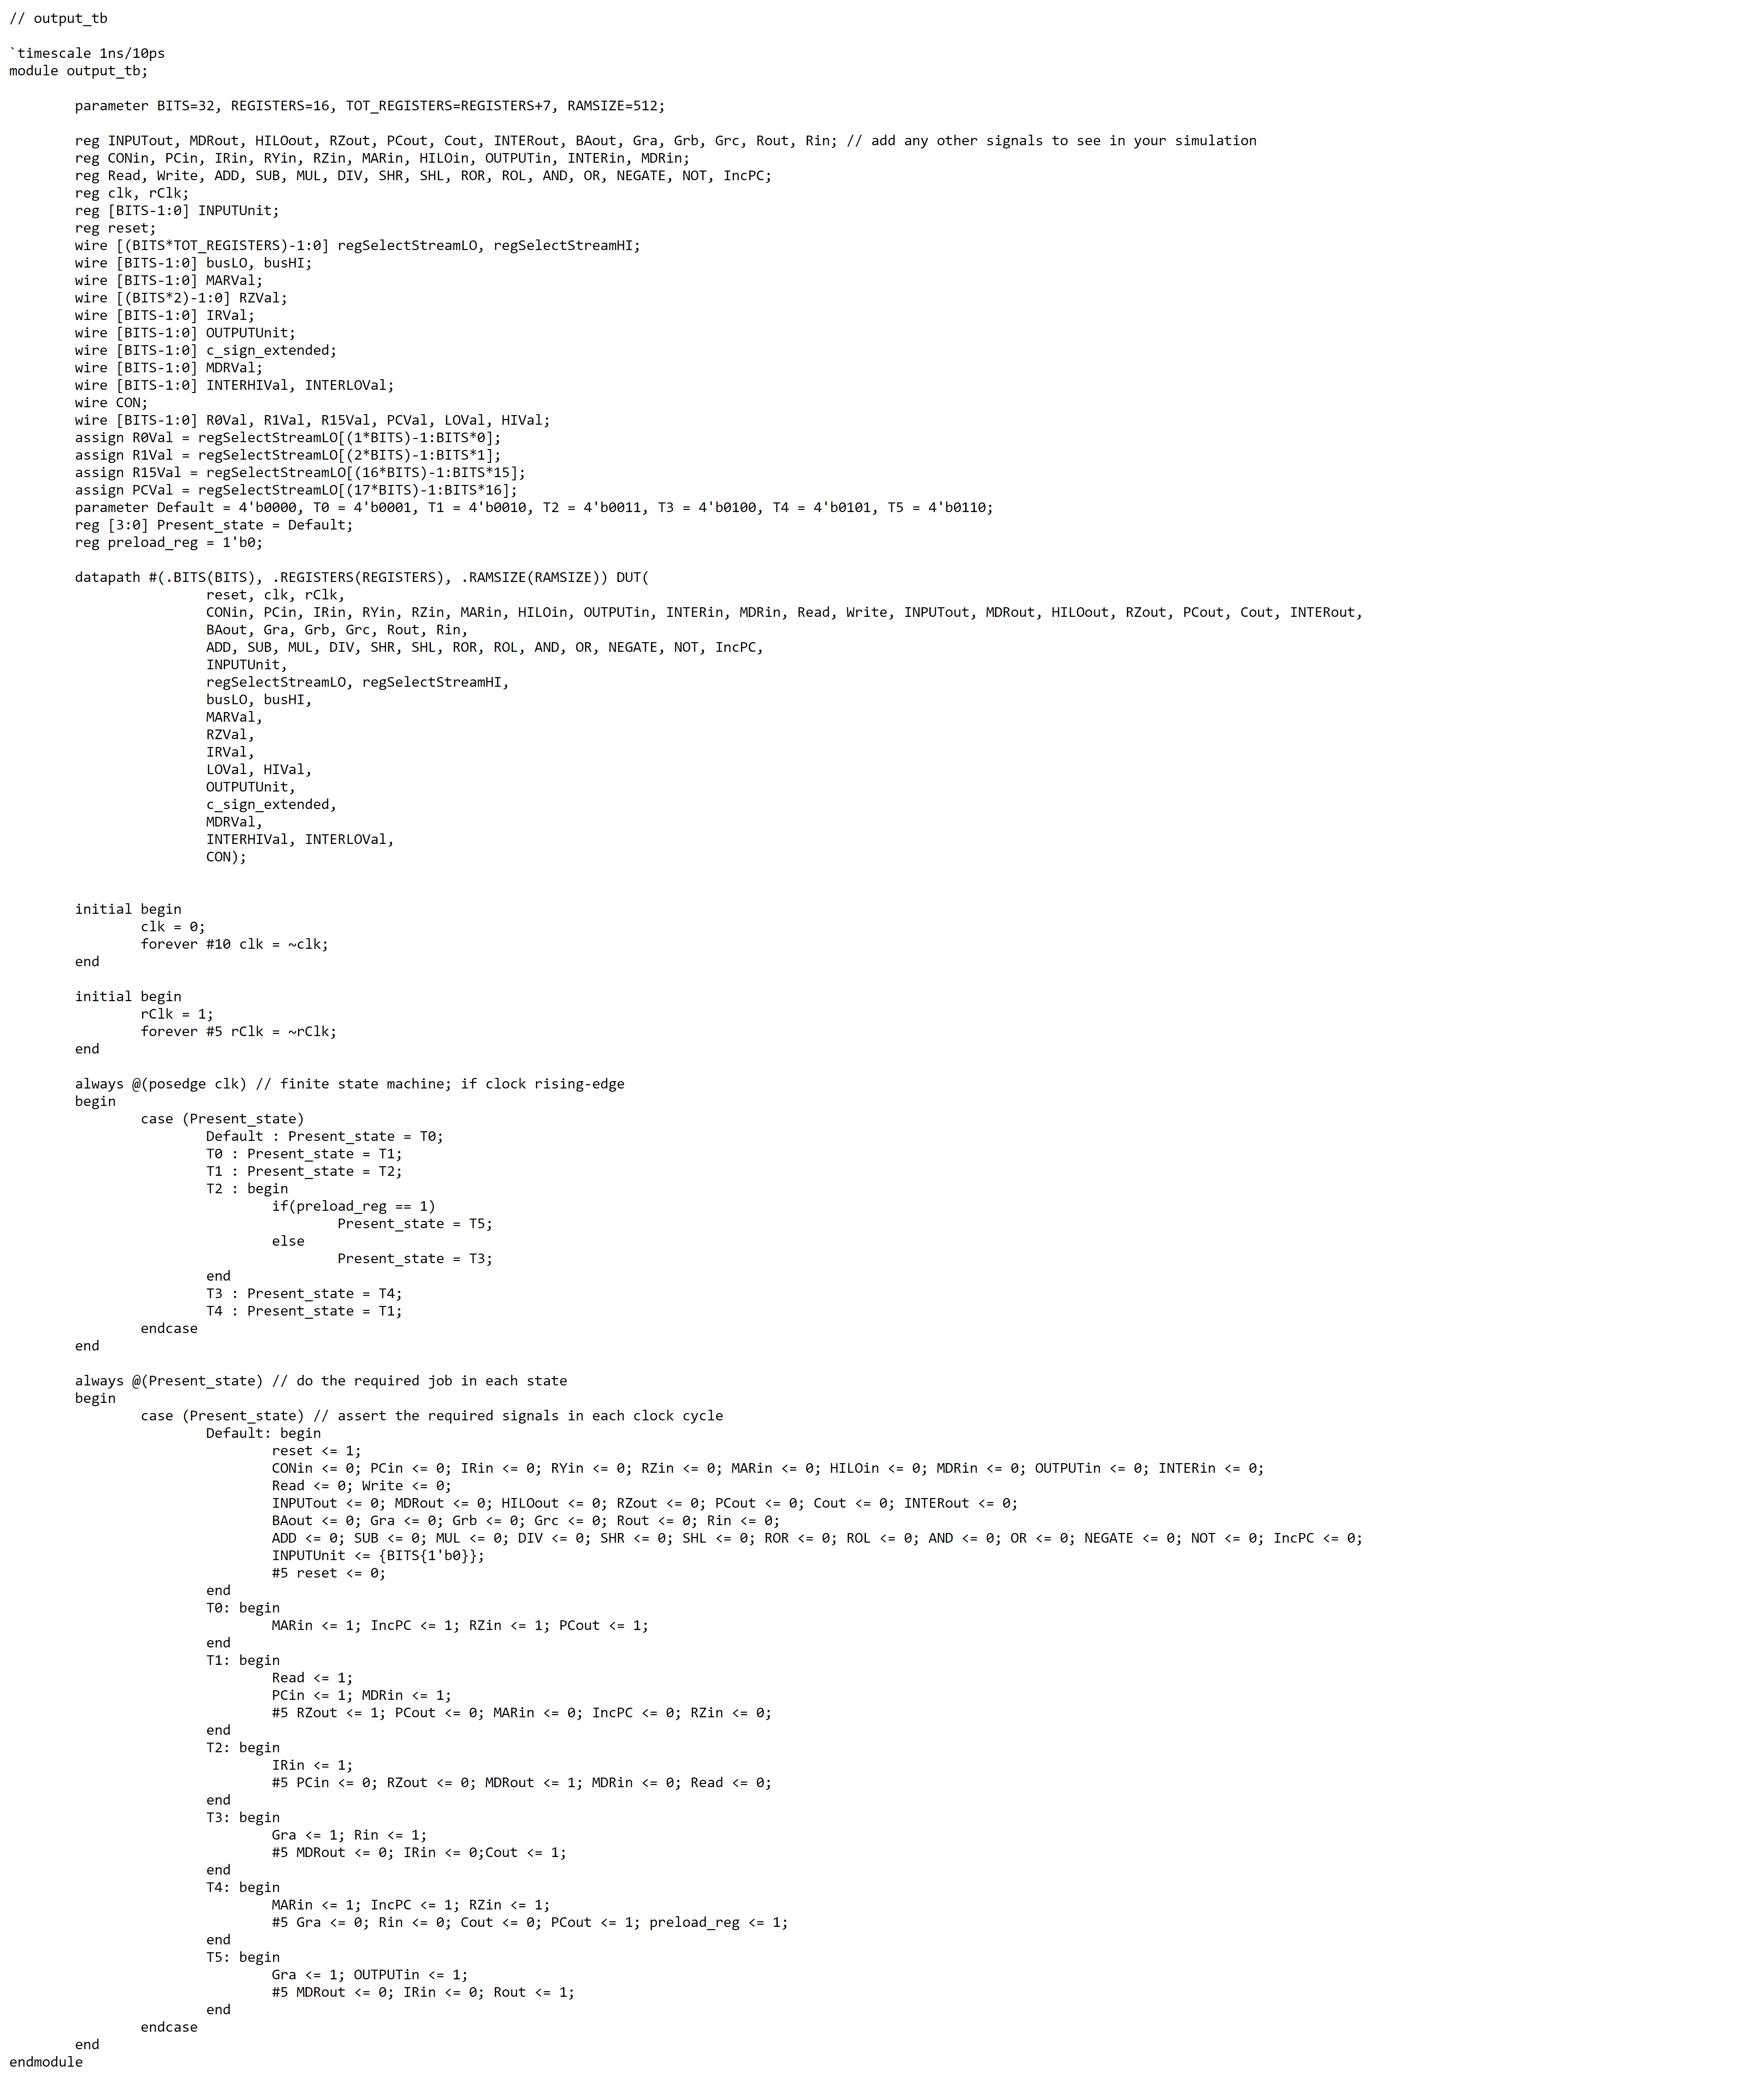

Output Waveform

